

# OBJECT ORIENTED PROGRAMMING LAB

**Submitted By-**

**Name-KRITI NIRANJAN**

**Roll.No-**R110219071

**SAP ID-**500075804

**Branch-** B.Tech CSE CCVT(2019-2023)

**Batch-B2**

**SEMESTER-** III

**Submitted to-**

Dr. Prakash Glollahalli Lingappa

School of Computer Science

**INDEX**

|  |  |  |  |  |
| --- | --- | --- | --- | --- |
| **S.No** | **Experiment** | **Date** | **Signature** | **Remarks** |
| 1. | Experiment-1  Introduction to JAVA Environment | 8-9-2020 |  |  |
| 2 | Experiment-2,3  Basic Java Programming | 8-9-2020 |  |  |
| 3 | Experiment-4  Inheritance | 17-9-2020 |  |  |
| 4 | Experiment -8  Strings Handling | 24-9-2020 |  |  |
| 5 | Experiment-6  Packages | 12-10-2020 |  |  |
| 6 | Experiment -7  Exceptions | 12-10-2020 |  |  |
| 7 | Experiment-9  Threads and Collections | 13-10-2020 |  |  |
| 8 | Experiment-5  Interface | 14-10-2020 |  |  |
| 9 | Experiment-10  JDBC | 19-11-2020 |  |  |
| 10 | Experiment-11  Servlet | 30-11-2020 |  |  |
| 11 | Experiment -12  JSP | 30-11-2020 |  |  |
|  |  |  |  |  |
|  |  |  |  |  |

**EXPERIMENT NO-1**

**TITLE:** Introduction to JAVA Environment

1. **Installation of JDK**

First, we will search **JDK 8 Download** and then we will click the Second link: **JAVA SE Development Kit 8 – Downloads**

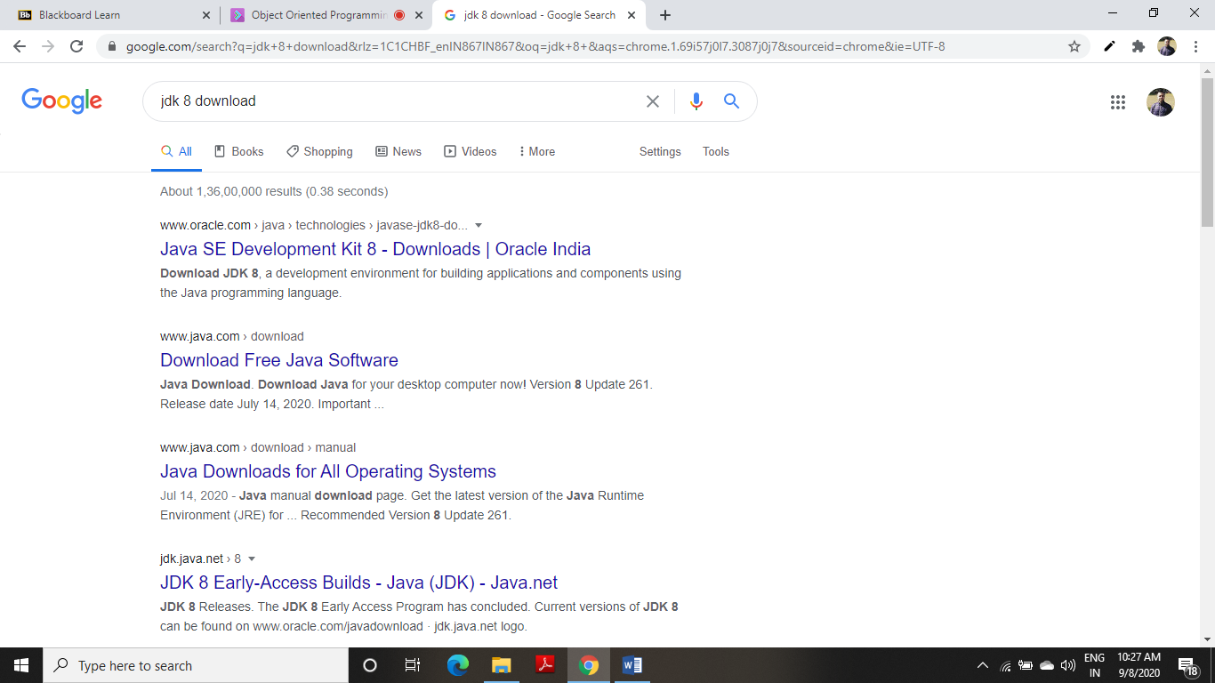

1. A Window will open of **JAVA SE Development Kit 8 Downloads**

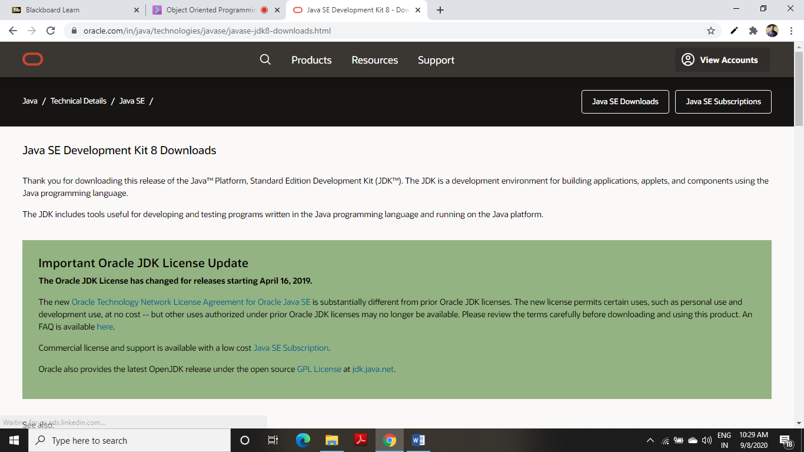

1. Now Scroll Down and Select **Windows *64 and Download**

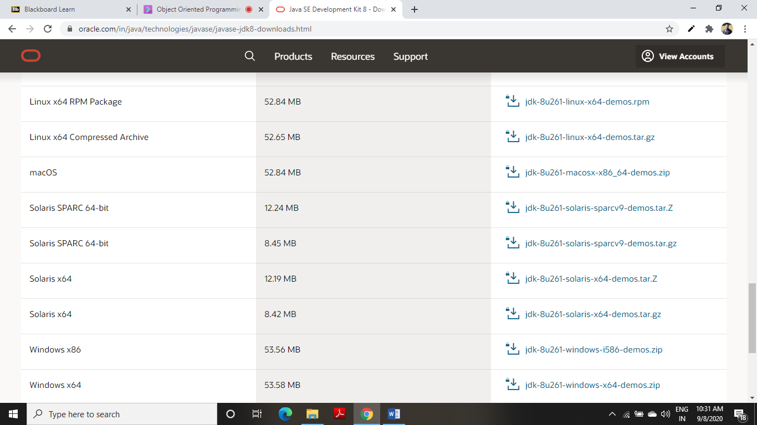

1. After Downloading JDK

Make Account on **ORACLE and SIGN IN**

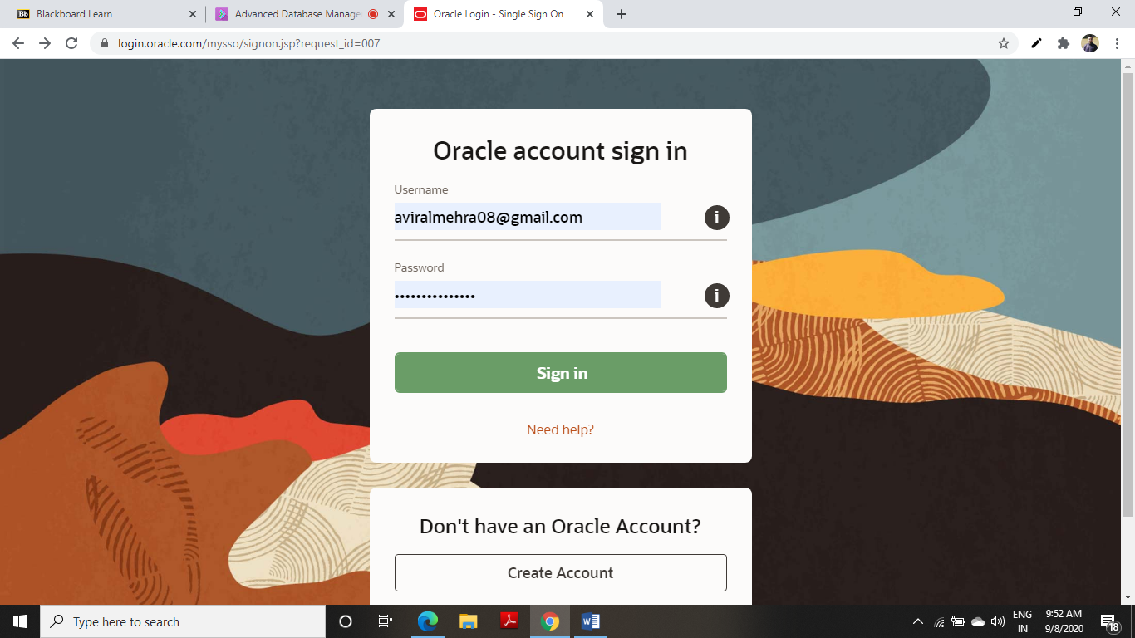

**2) Setting of PATH and CLASSPATH**

**Code a Program in NOTEPAD :**

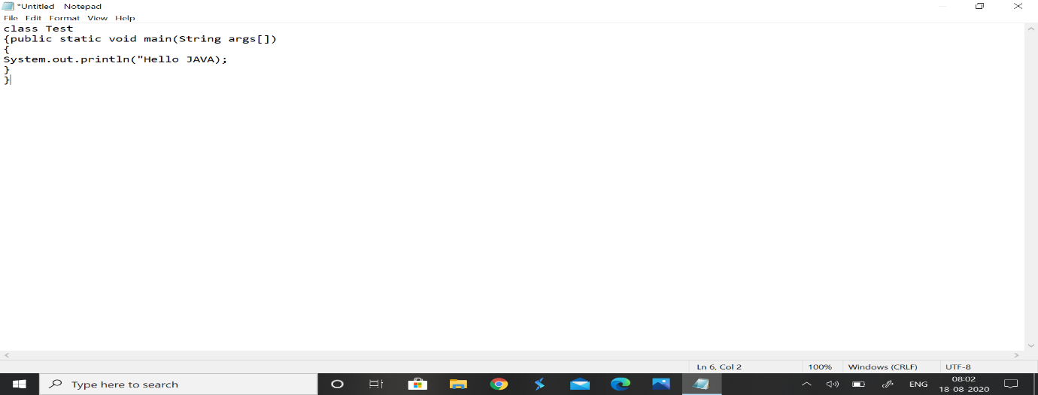

Now Click on **File->Save As->Local Disk(D:)->JAVA PROGRAMS-> Test.java**

Now Open **C0MMAND PROMPT**

1. **TEMPORARY PATH**

**Write the commands:**

#java

#set path= C:\Program Files\Java\jdk1.8.0_261\bin

#D:

#cd JAVA PROGRAMS

#javac Test.java

#java Test

**RESULT:** Hello JAVA

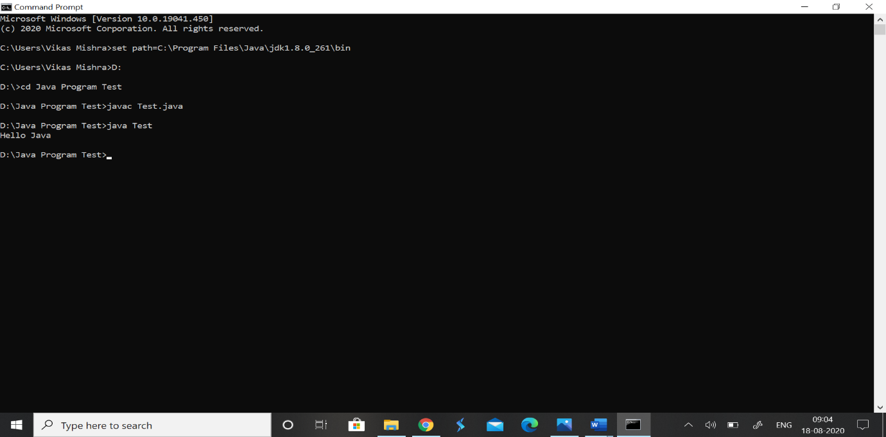

1. **PERMANENT PATH**

My PC-> Properties-> Advanced System Setting-> Environment Variables-> System Variables-> New..-> Type **path**-> Variable value-> **C:\Program Files\Java\jdk1.8.0_261\bin** -> OK-> OK-> OK

And close the window

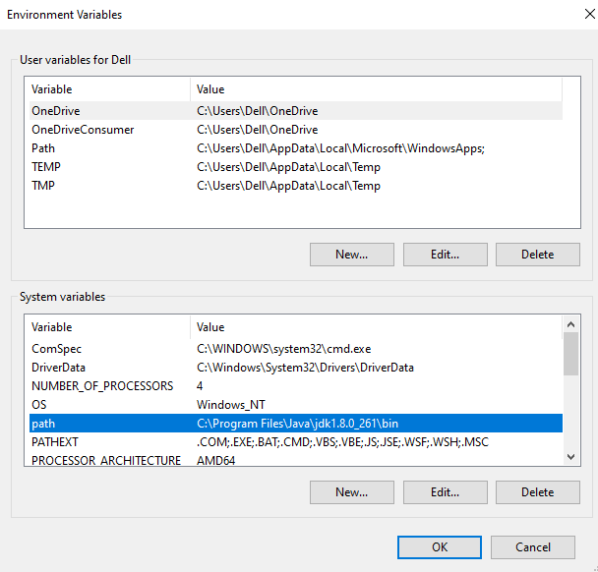

Now path is set Permanent and Now open **Command Prompt**

**Write the commands:**

#java

#D:

#cd JAVA PROGRAMS

#Javac Test.java

#java Test

**RESULT:** Hello JAVA

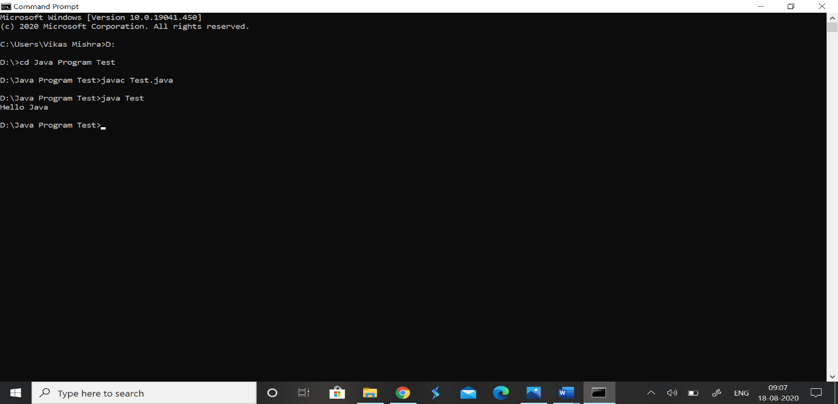

1. **Introduction to Eclipse**

Search for **eclipse.org** and click **Eclipse IDE for JAVA Developers**

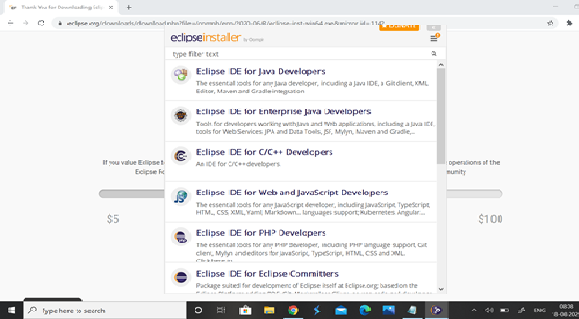

**Now Install it**

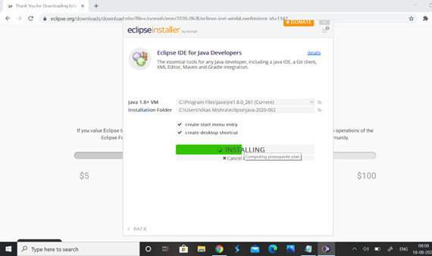

**LAUNCH ECLIPSE**

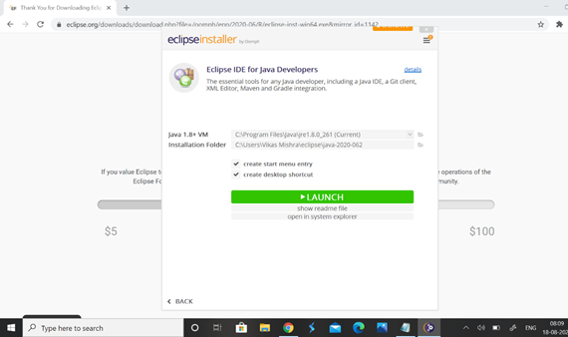

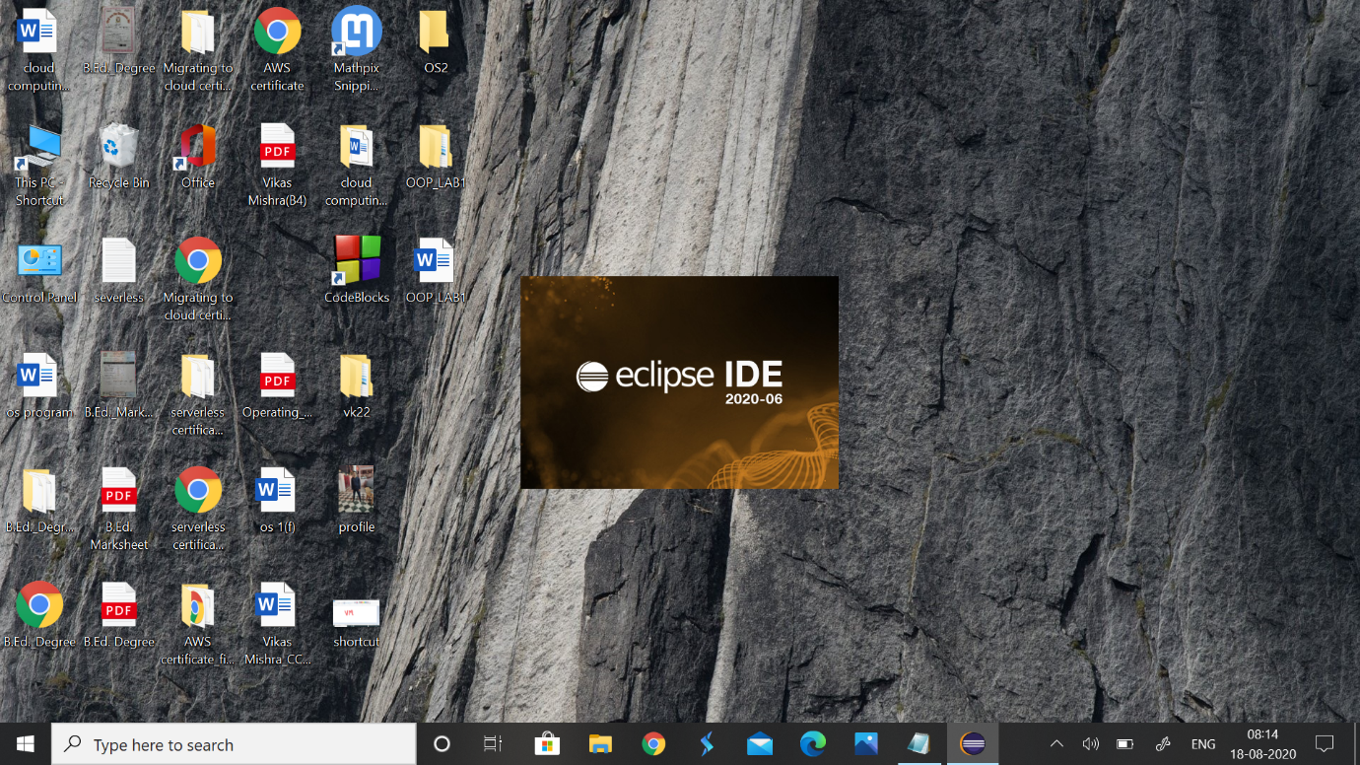

Go to File-> New..->Java Project-> Create->Project Name->Name

Modifiers as **public**

AND START DOING CODING

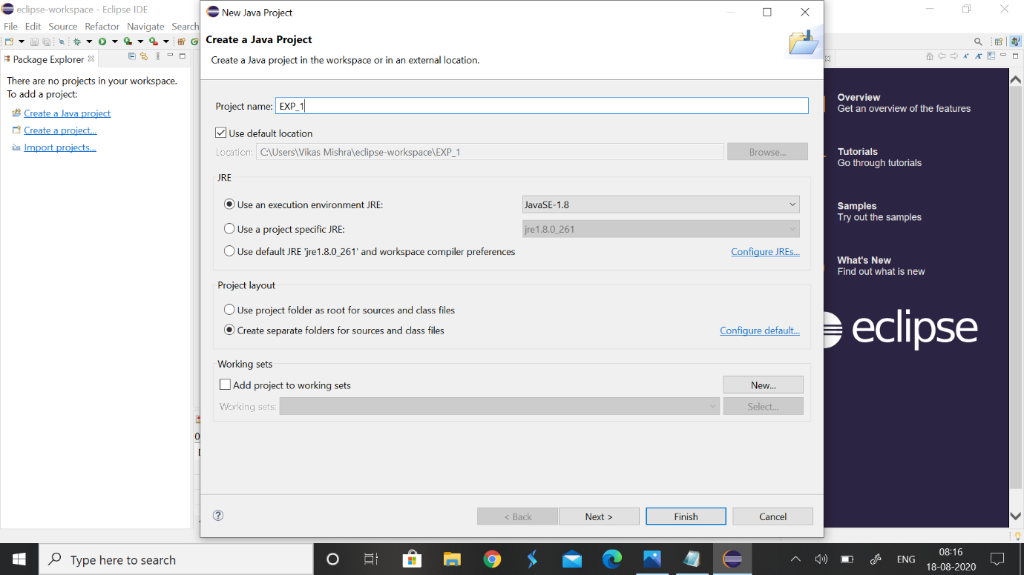

**EXPERIMENT NO -2,3**

**TITLE:** Basic Java Programming

**1.Write a program to find the largest of 3 numbers**

**CODE**

**public** **class** LargestNumber {

**public** **static** **void** main(String[] args) {

**int** i=5;

**int** j=6;

**int** k=10;

**if**(i>j && i>k) {

System.***out***.println("i is greater "+i);

}

**else** **if**(j>i && j>k) {

System.***out***.println("j is greater "+j);

}

**else**{

System.***out***.println("k is greater "+k);

}

}

}

**OUTPUT**

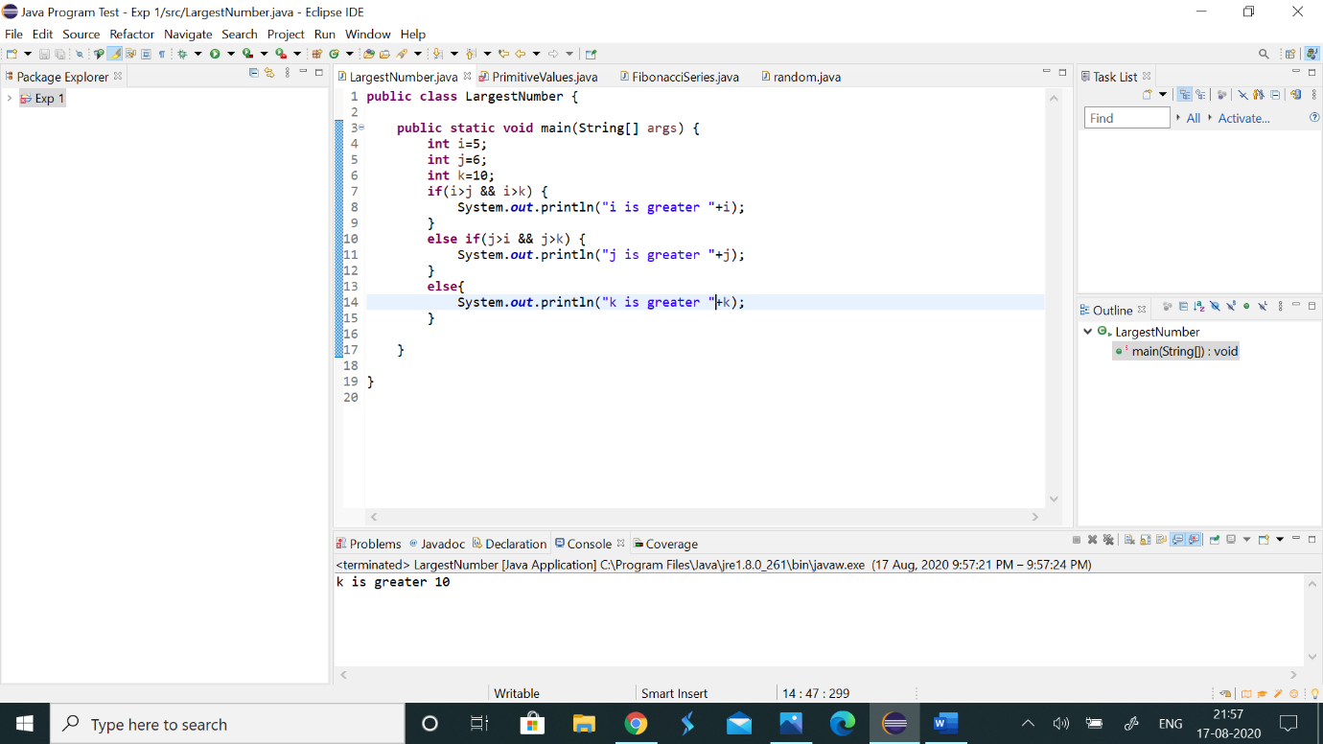

**2.Write a program to add two number using command line arguments**

**CODE**

**import** java.lang.*;

**public** **class** Addition

{

**public** **static** **void** main(String args[])

{

**int** a=Integer.*parseInt*(args[0]);

**int** b=Integer.*parseInt*(args[1]);

**int** c=a+b;

System.***out***.println("First number is:"+a);

System.***out***.println("Second number is:"+b);

System.***out***.println("Addition of two no is:"+c);

}

}

**OUTPUT**

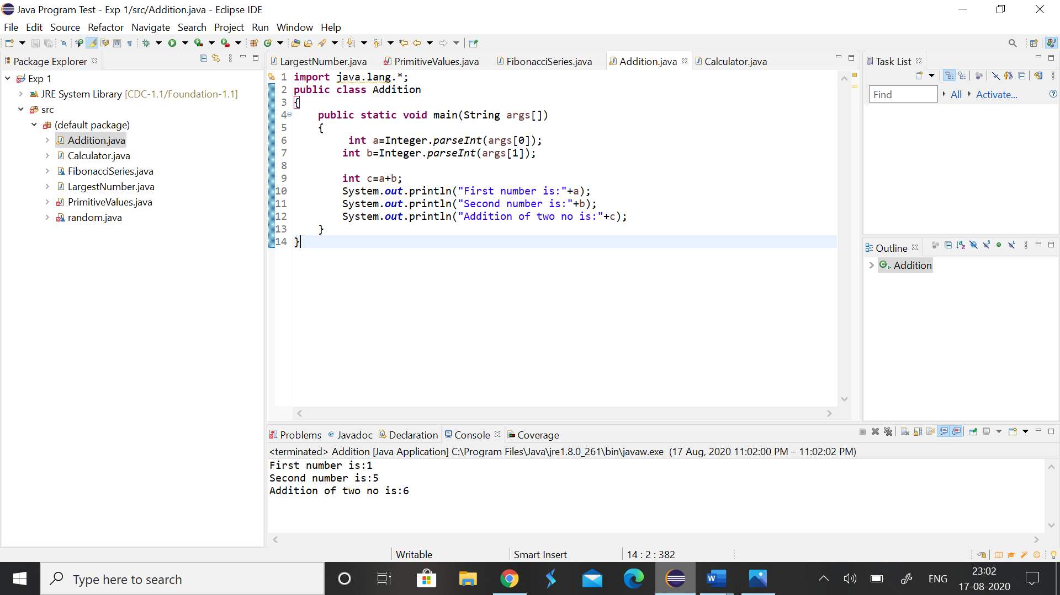

**3.Write a program to print Fibonacci series using loop.**

**CODE**

**class** FibonacciSeries{

**public** **static** **void** main(String args[])

{

**int** n1=0,n2=1,n3,i,count=20;

System.***out***.print(n1+" "+n2);

**for**(i=2;i<count;++i)

{

n3=n1+n2;

System.***out***.print(" "+n3);

n1=n2;

n2=n3;

}

}

}

**OUTPUT**

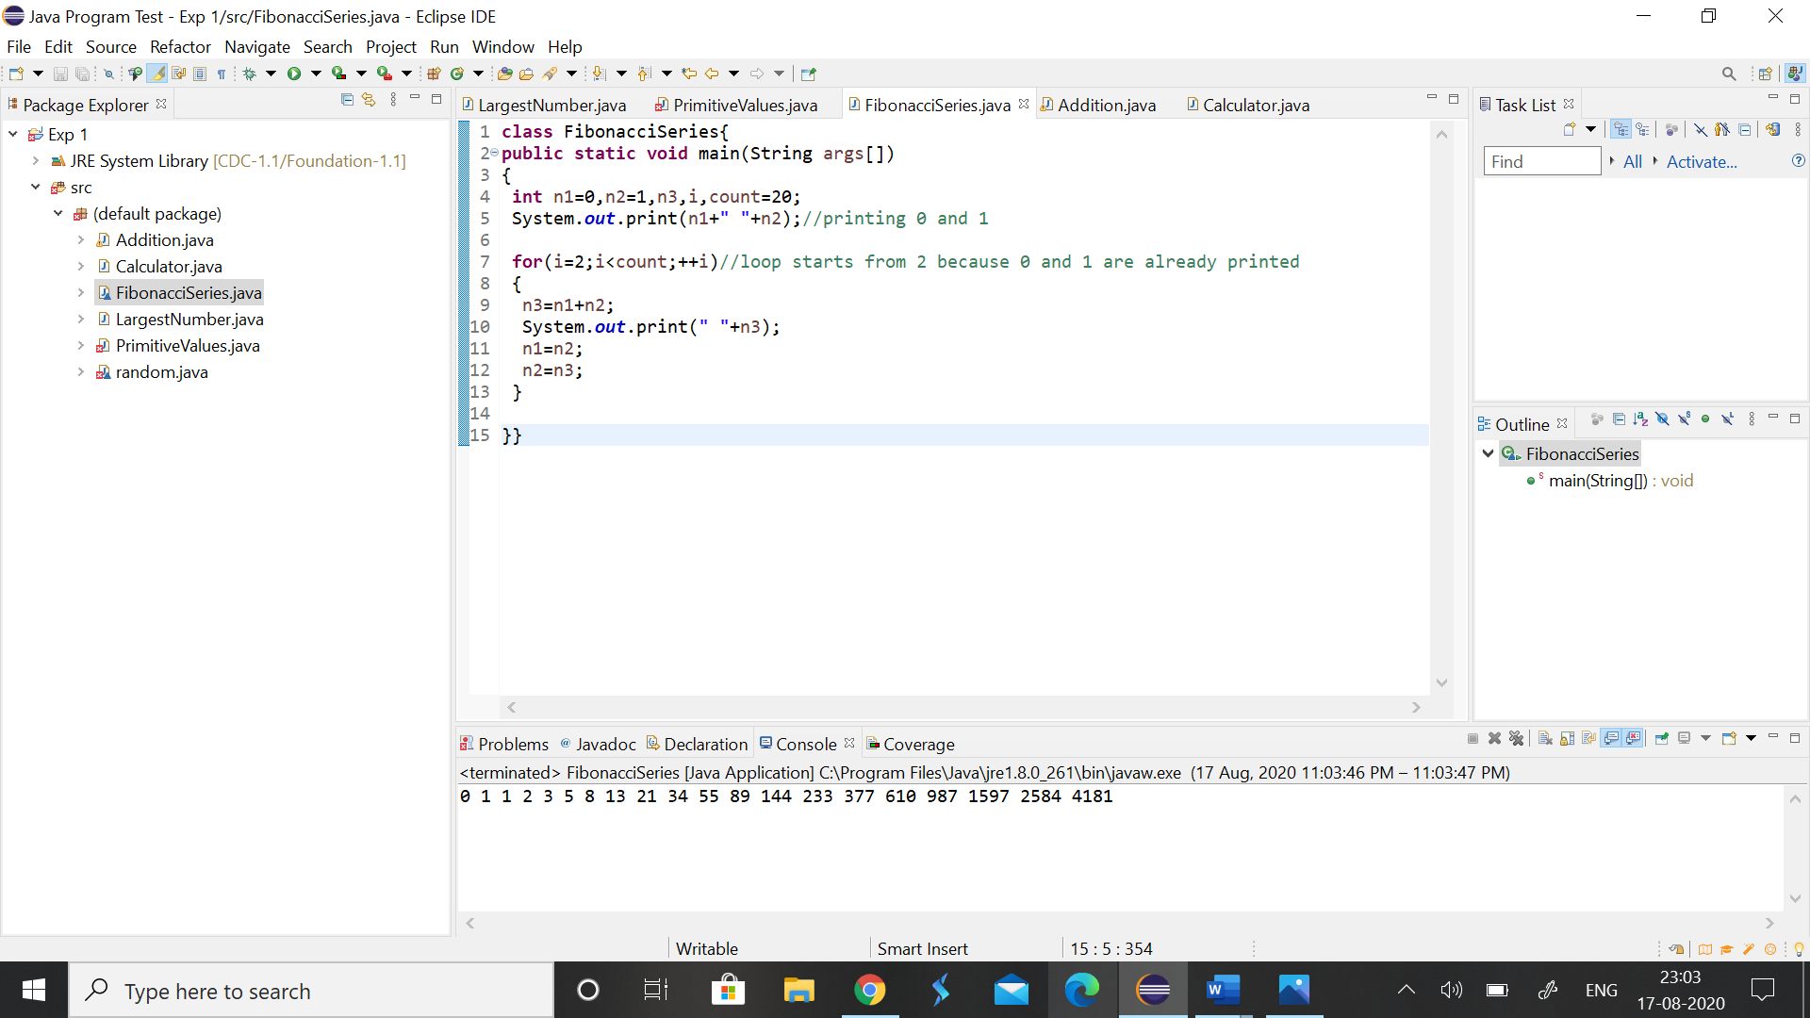

**4.Write a program to implement a command line calculator.**

**CODE**

**public** **class** Calculator {

**public** **static** **void** main(String[] args) {

**int** num1=Integer.*parseInt*(args[0]);

**int** num2=Integer.*parseInt*(args[1]);

**int** a=Integer.*parseInt*(args[2]);

System.***out***.println("First value : "+num1);

System.***out***.println("Second value : "+num2);

System.***out***.println("choice for calculation : "+a);

**switch**(a)

{

**case** 1:

System.***out***.println( "addition of two number: "+(num1+num2));

**break**;

**case** 2:

System.***out***.println( "subtraction of two number: "+(num1-num2));

**break**;

**case** 3:

System.***out***.println( "multiplication of two number: "+(num1*num2));

**break**;

**case** 4:System.***out***.println( "division of two number: "+(num1/num2));

**break**;

**default**:System.***out***.println("wrong choice");

**break**;

}

}

}

**OUTPUT**

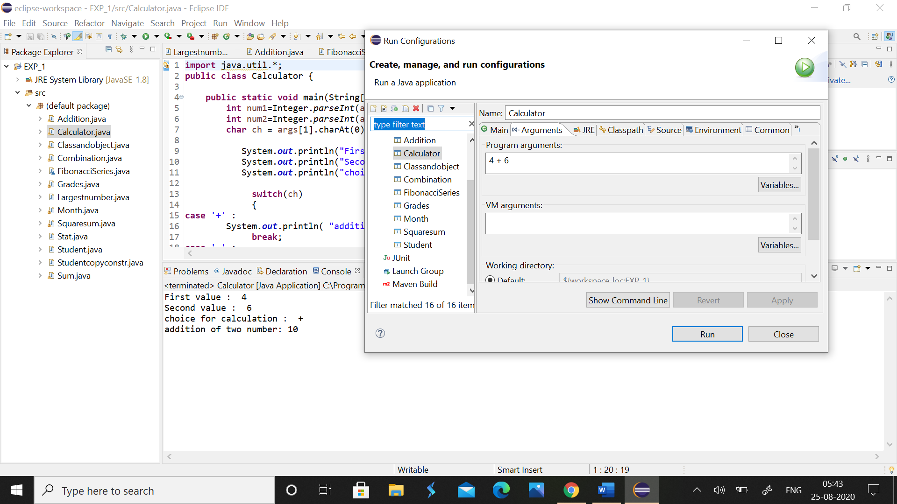

**5.Write a program using classes and objects in java**

**CODE**

**import** java.util.*;

**public** **class** Classandobject

{

**int** id;

**double** marks;

String name;

**void** student1(**int** i,**double** m,String n){

id=i;

marks=m;

name=n;

**if**(marks>60)

{

System.***out***.println("name is: "+ name);

System.***out***.println("Passed");

System.***out***.println("Student id is "+id);

}

**else**

{

System.***out***.println("name is: "+ name);

System.***out***.println("not Passed");

System.***out***.println("Student id is "+id);

}

}

**public** **static** **void** main(String[] args)

{

Classandobject obj=**new** Classandobject();

Scanner sc =**new** Scanner(System.***in***);

System.***out***.println("Enter the student's name");

String name=sc.nextLine();

System.***out***.println("Enter the student's id");

**int** id=sc.nextInt();

System.***out***.println("Enter the student's marks");

**double** marks=sc.nextDouble();

System.***out***.println("Enter the student's name");

obj.student1(id,marks,name);

}

}

**OUTPUT**

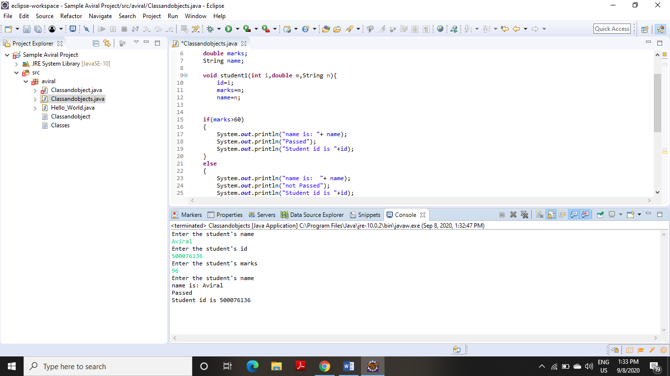

**6.** **Write a program to accept 10 student’s marks in an array, arrange it into ascending order, convert into the following grades and print marks and grades in the tabular form.**

**Between 40 and 50 : PASS**

**Between 51 and 75 : MERIT**

**and above : DISTINCTION**

**CODE**

**import** java.util.*;

**import** java.io.*;

**public** **class** Grades {

**public** **static** **void** main(String[] args) {

**int** temp;

**int** arr[] = **new** **int**[10];

Scanner sc=**new** Scanner(System.***in***);

System.***out***.println("Enter the marks greater than or equal to 40");

**for**(**int** i=0;i<10;i++) {

arr[i]=sc.nextInt();}

**for** (**int** i = 0; i < 10; i++)

{

**for** (**int** j = i + 1; j < 10; j++) {

**if** (arr[i] > arr[j])

{

temp = arr[i];

arr[i] = arr[j];

arr[j] = temp;

}

}

}

**for**(**int** i=0;i<10;i++) {

**if**(arr[i]>=40&&arr[i]<=50) {

System.***out***.println(arr[i]+" "+":PASS");}

**else** **if**(arr[i]>=51&&arr[i]<=75) {

System.***out***.println(arr[i]+" "+":MERIT");

}

**else** **if**(arr[i]>75) {

System.***out***.println(arr[i]+" "+":DISTINCTION");

}

**else** {

System.***out***.println("INVALID INPUT FAIL");

}

}

}

}

**OUTPUT**

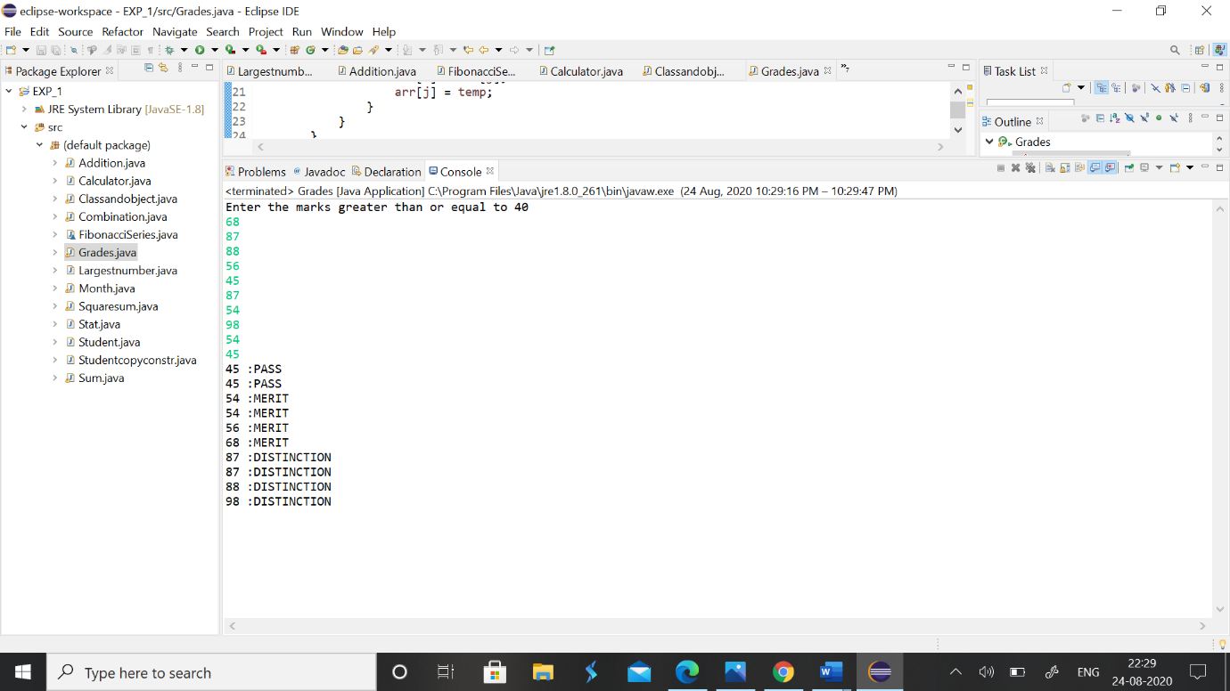

**7.** **Write a program to accept three digits (i.e. 0 - 9) and print all its possible combinations. (For example if the three digits are 1, 2, 3 than all possible combinations are : 123, 132, 213, 231, 312, 321.)**

**CODE**

**import** java.util.*;

**import** java.io.*;

**public** **class** Combination {

**public** **static** **void** main(String[] args) {

**int** arr[]=**new** **int**[3];

Scanner sc=**new** Scanner(System.***in***);

System.***out***.println("Enter the 3 numbers of which possible combinations we want to generate");

**for**(**int** i=0;i<3;i++) {

arr[i]=sc.nextInt();

}

**for**(**int** i=0;i<3;i++) {

**for**(**int** j=0;j<3;j++) {

**for**(**int** k=0;k<3;k++) {

**if**(i!=j&&j!=k&&k!=i) {

System.***out***.println(arr[i]+""+arr[j]+""+arr[k]);

}

}

}

}

}

}

**OUTPUT**

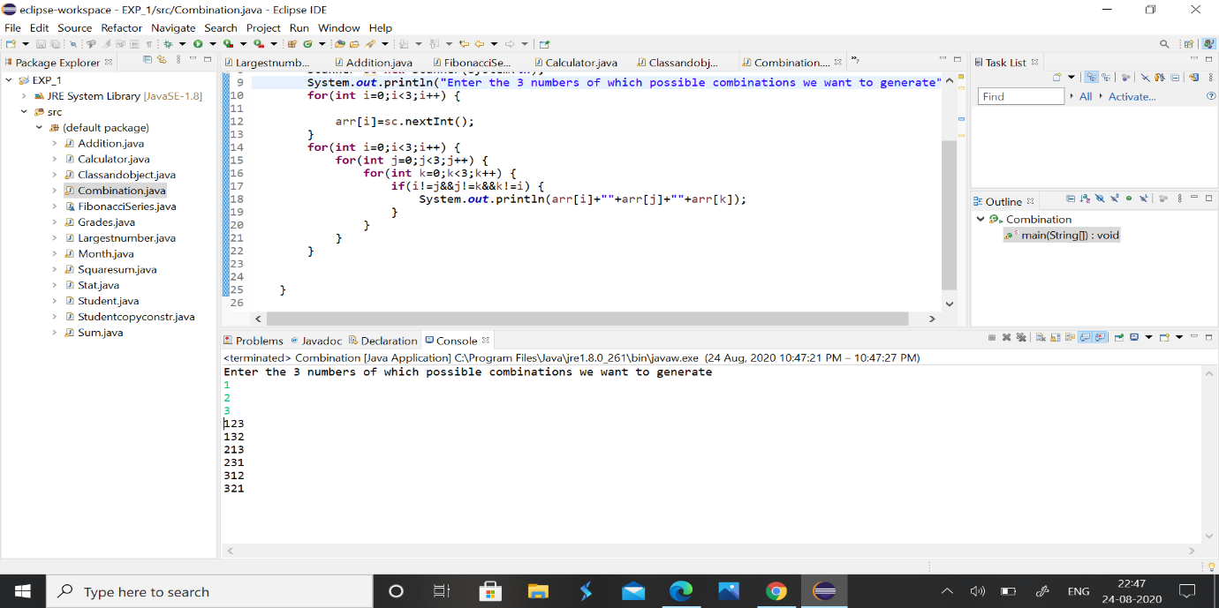

**8.** **Write a Java Program to accept 10 numbers in an array and compute the square of each number. Print the sum of these numbers.**

**CODE**

**import** java.util.*;

**import** java.io.*;

**public** **class** Squaresum {

**public** **static** **void** main(String[] args) {

**int** sum=0;

**int** arr[]=**new** **int**[10];

Scanner sc=**new** Scanner(System.***in***);

System.***out***.println("Enter ten numbers");

**for**(**int** i=0;i<10;i++) {

arr[i]=sc.nextInt();

}

**for**(**int** i=0;i<10;i++) {

sum=sum+(arr[i]*arr[i]);

}

System.***out***.println("Sum of these squares of ten numbers is "+sum);

}

}

**OUTPUT**

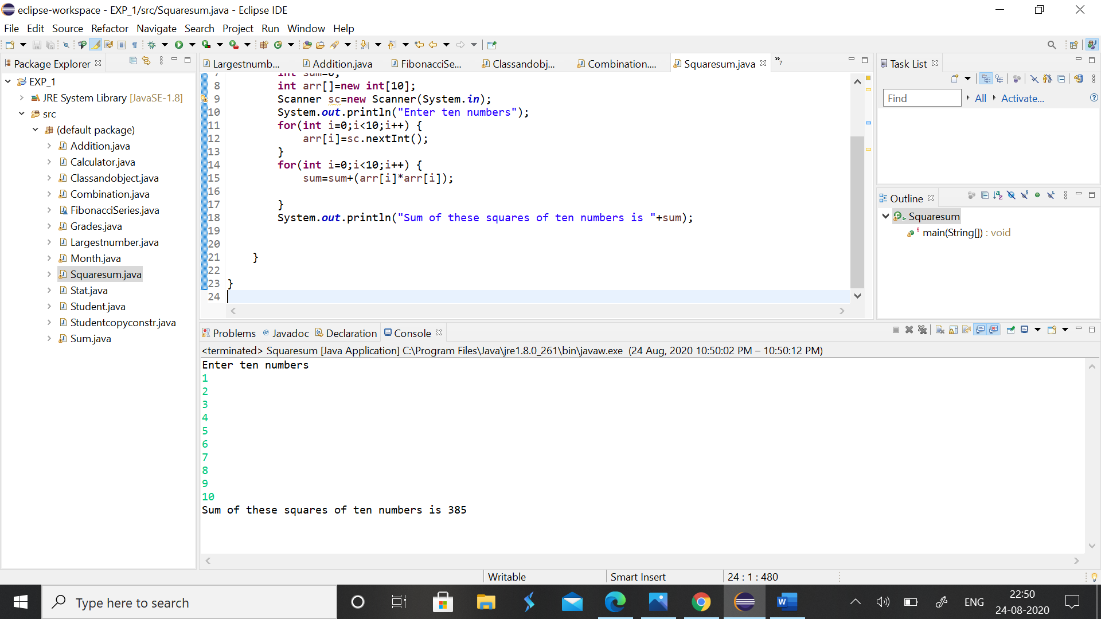

**9.** **Write a program to input a number of a month (1 - 12) and print its equivalent name of the month.( e.g 1 to Jan, 2 to Feb. 12 to Dec.)**

**CODE**

**import** java.util.*;

**import** java.io.*;

**public** **class** Month {

**public** **static** **void** main(String[] args) {

Scanner sc =**new** Scanner(System.***in***);

String month[]= {"January","February","March","April","May","June","July","August","September","October","November","December"};

System.***out***.println("Enter the month number:");

**int** num=sc.nextInt();

**if**(num>=1&&num<=12) {

System.***out***.println(num+" is "+month[num-1]);}

**else** {

System.***out***.println("Entered a wrong number to print the equivalent month");

}

}

}

**OUTPUT**

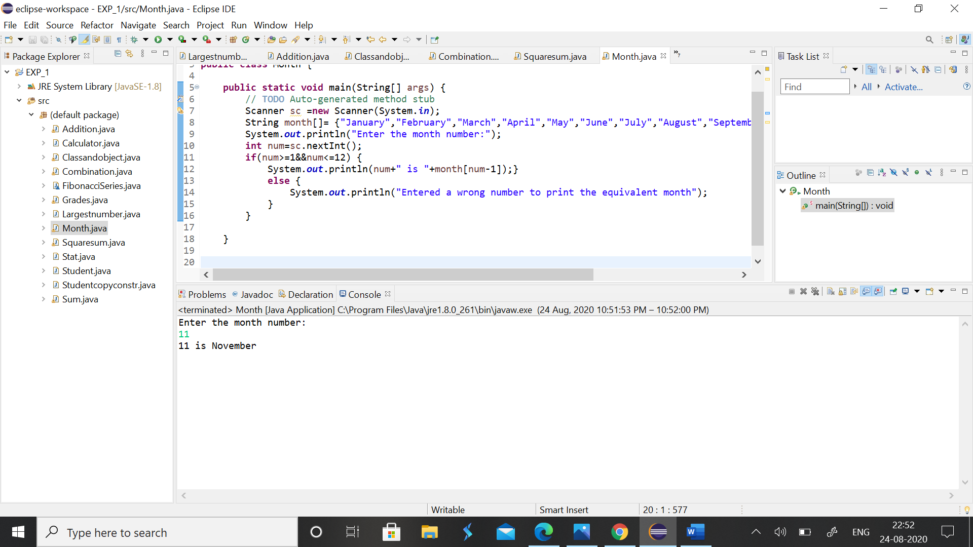

**10.** **Write a program to find the sum of all integers greater than 40 and less than 250 that are divisible by 5.**

**CODE**

**import** java.util.*;

**import** java.io.*;

**public** **class** Sum {

**public** **static** **void** main(String[] args) {

**int** sum=0;

**for**(**int** i=41;i<250;i++)

{

**if**(i%5==0)

sum+=i;

}

System.***out***.println("Sum of all integers greater than 40 and less than 250 that are divisible\r\n" +

"by 5 is\n"+sum);

}

}

**OUTPUT**

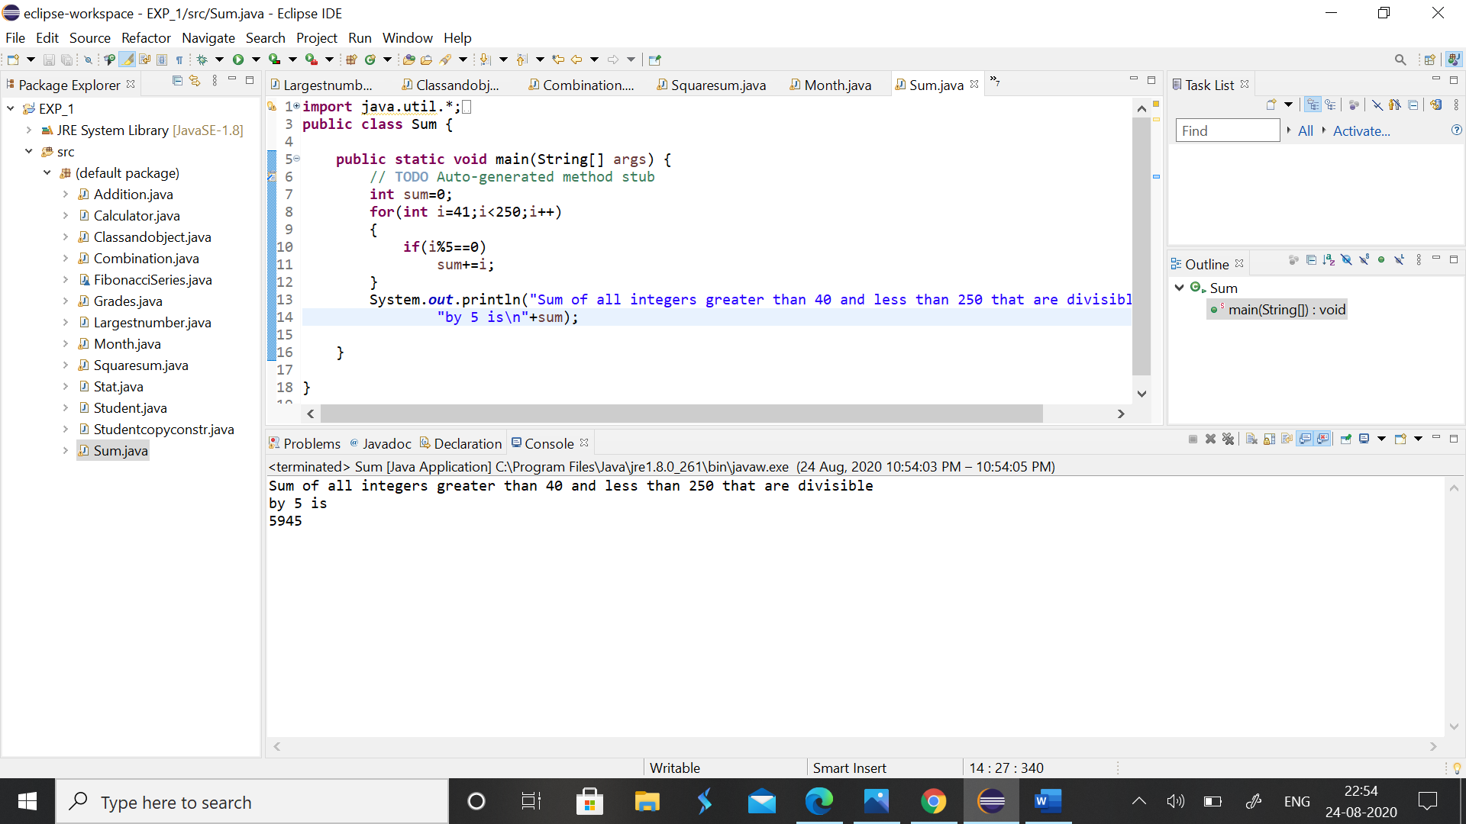

**EXPERIMENT NO– 4**

**TITLE**: Inheritance

**1. Write a program in Java to create a Player class. Inherit the classes Cricket _Player, Football _Player and Hockey_ Player from Player class.**

**CODE**

**package** aviral;

**public** **class** c {

**public** **static** **void** main(String args[])

{

criket_player c=**new** criket_player("Ameer","criket",25);

football_player f=**new** football_player("arun","foot ball",25);

hockey_player h=**new** hockey_player("Ram","hockey",25);

c.show();

f.show();

h.show();

}

}

**class** Player

{

String name;

**int** age;

Player(String n,**int** a)

{ name=n; age=a; }

**void** show()

{

System.***out***.println("\n");

System.***out***.println("Player name : "+name);

System.***out***.println("Age : "+age);

}

}

**class** criket_player **extends** Player

{

String type;

criket_player(String n,String t,**int** a)

{

**super**(n,a);

type=t;

}

**public** **void** show()

{

**super**.show();

System.***out***.println("Player type : "+type);

}

}

**class** football_player **extends** Player

{

String type;

football_player(String n,String t,**int** a)

{

**super**(n,a);

type=t;

}

**public** **void** show()

{

**super**.show();

System.***out***.println("Player type : "+type);

}

}

**class** hockey_player **extends** Player

{

String type;

hockey_player(String n,String t,**int** a)

{

**super**(n,a);

type=t;

}

**public** **void** show()

{

**super**.show();

System.***out***.println("Player type : "+type);

}

}

**OUTPUT**

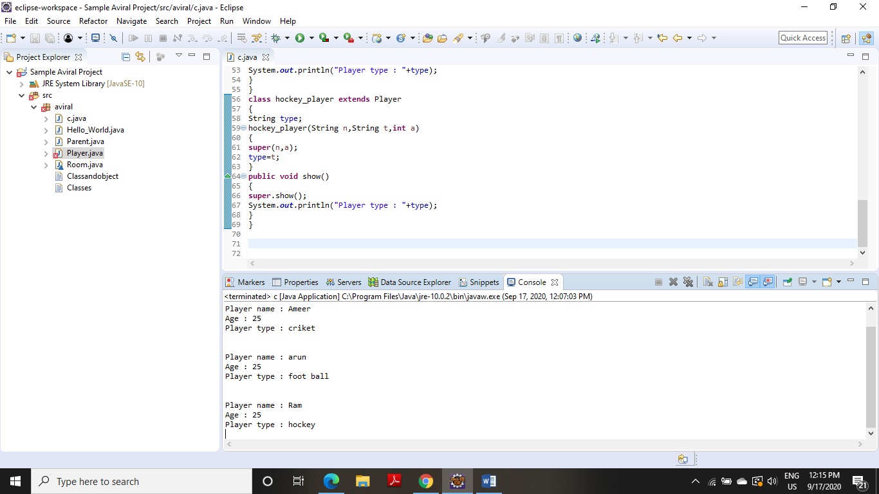

**2. Write a Java program to show that private member of a super class cannot be accessed from derived classes.**

**CODE**

**package** aviral;

**public** **class** R

{

**public** **static** **void** main(String args[])

{

class_room cr=**new** class_room(10,20,15);

**int** a1=cr.area();

**int** v1=cr.volume();

System.***out***.println("Area of Room : "+a1);

System.***out***.println("Volume of Room : "+v1);

}

}

**class** room

{

**private** **int** l,b;

room(**int** x,**int** y)

{ l=x; b=y;}

**int** area()

{**return**(l*b);

}

}

**class** class_room **extends** room

{

**int** h;

class_room(**int** x,**int** y,**int** z)

{

**super**(x,y);

h=z;

}

**int** volume()

{

**return**(area()*h);

}

}

**OUTPUT**

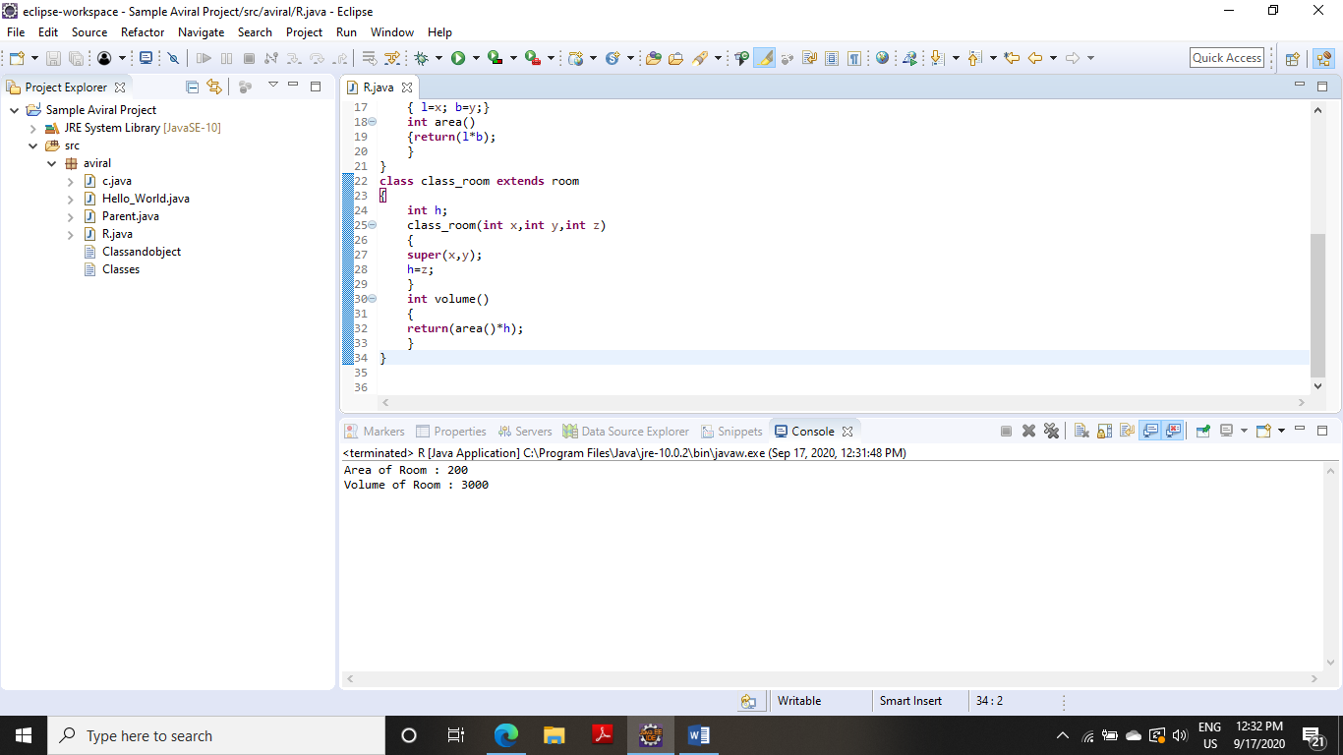

**3. Write a class Worker and derive classes DailyWorker and SalariedWorker from it. Every worker has a name and a salary rate. Write method ComPay (int hours) to compute the week pay of every worker. A Daily Worker is paid on the basis of the number of days he/she works. The Salaried Worker gets paid the wage for 40 hours a week no matter what the actual hours are. Test this program to calculate the pay of workers. You are expected to use the concept of polymorphism to write this program.**

**CODE**

**package** aviral;

**class** W

{

**public** **static** **void** main(String args[])

{

dailyworker d=**new** dailyworker(254,"Arjun",75);

salariedworker s=**new** salariedworker(666,"Unni",100);

d.compay(45);

s.compay();

}

}

**class** worker

{

String name;

**int** empno;

worker(**int** no,String n)

{ empno=no; name=n; }

**void** show()

{

System.***out***.println("\n--------------------------");

System.***out***.println("Employee number : "+empno);

System.***out***.println("Employee name : "+name);

}

}

**class** dailyworker **extends** worker

{

**int** rate;

dailyworker(**int** no,String n,**int** r)

{

**super**(no,n);

rate=r;

}

**void** compay(**int** h)

{

show();

System.***out***.println("Salary : "+rate*h);

}

}

**class** salariedworker **extends** worker

{

**int** rate;

salariedworker(**int** no,String n,**int** r)

{

**super**(no,n);

rate=r;

}

**int** hour=40;

**void** compay()

{

show();

System.***out***.println("Salary : "+rate*hour);

}

}

**OUTPUT** 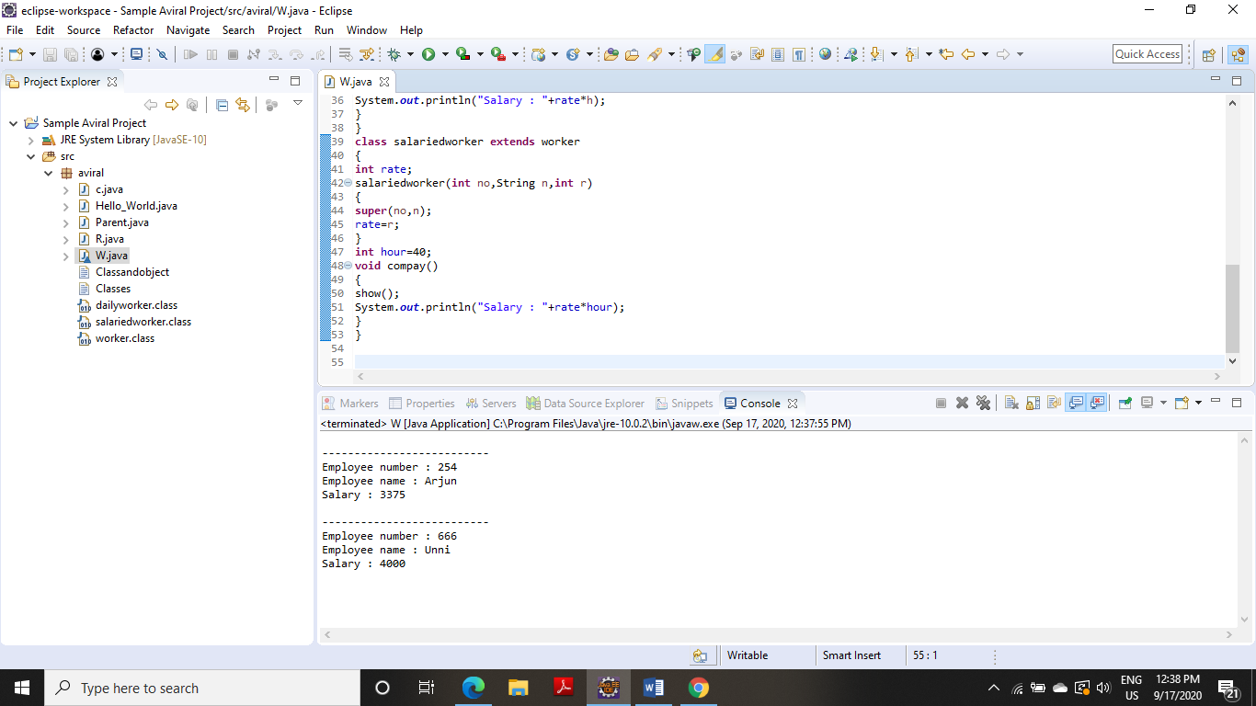

**4. Consider the trunk calls of a telephone exchange. A trunk call can be ordinary, urgent or lightning. The charges depend on the duration and the type of the call. Write a program using the concept of polymorphism in Java to calculate the charges.**

**CODE**

**import** java.util.Scanner;

**class** Telephone{

**int** callnumber;

String calltype;

Telephone(**int** c,String s){

callnumber = c;

calltype = s;

}

**void** show() {

System.***out***.println("call number"+" "+callnumber);

System.***out***.println("call type"+" "+calltype);

}

}

**class** Ordinary **extends** Telephone{

**float** cost;

Ordinary(**int** c,String s,**float** co){

**super**(c,s);

**this**.cost = co;

}

**void** charge(**double** time) {

**super**.show();//calling show() of parent class

System.***out***.println("call charges"+" "+cost*time);

}

}

**class** Urgent **extends** Telephone{

**float** cost;

Urgent(**int** c,String s,**float** co){

**super**(c,s);

**this**.cost = co;

}

**void** charge(**double** time) {

**super**.show();

System.***out***.println("call charges"+" "+cost*time);

}

}

**class** Lightening **extends** Telephone{

**float** cost;

Lightening(**int** c,String s,**float** co){

**super**(c,s);

**this**.cost = co;

}

**void** charge(**double** time) {

**super**.show();

System.***out***.println("call charges"+" "+cost*time);

}

}

**public** **class** Exp_4_4 {

**public** **static** **void** main(String[] args) {

// **TODO** Auto-generated method stub

Scanner sc=**new** Scanner(System.***in***);

**int** a,no;

**double** t;

System.***out***.println("Enter 1 for ordinary call,2 for urgent call or 3 for lightening call");

a=sc.nextInt();

**switch**(a) {

**case** 1:

System.***out***.println("Enter the number to which call is to be made");

no=sc.nextInt();

Ordinary obj1 = **new** Ordinary(no,"ordinary call",3);

System.***out***.println("Enter the duration of the call");

t=sc.nextDouble();

obj1.charge(t);

**break**;

**case** 2:

System.***out***.println("Enter the number");

no=sc.nextInt();

Urgent obj2=**new** Urgent(no,"Urgent call",4);

System.***out***.println("Enter the duration of the call");

t=sc.nextDouble();

obj2.charge(t);

**break**;

**case** 3:

System.***out***.println("Enter the number");

no=sc.nextInt();

Lightening obj3 = **new** Lightening(no,"Lightening call",5);

System.***out***.println("Enter the duration of the call");

t=sc.nextDouble();

obj3.charge(t);

}

}

}

**OUTPUT**

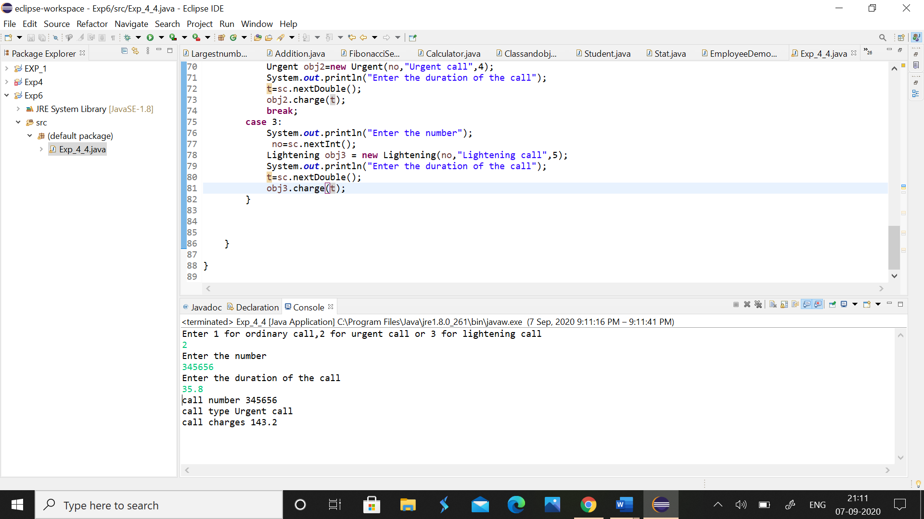

**5. Design a class employee of an organization. An employee has a name, empid, and salary. Write the default constructor, a constructor with parameters (name, empid, and salary) and methods to return name and salary. Also write a method increaseSalary that raises the employee’s salary by a certain user specified percentage. Derive a subclass Manager from employee. Add an instance variable named department to the manager class. Supply a test program that uses theses classes and methods**.

**CODE**

**import** java.util.Scanner;

**class** Employee{

**int** empid;

String name;

**double** salary;

Employee(){

System.***out***.println("This is employee default constructor");

}

Employee(**int** emid,String name,**double** salary){

**this**.empid = emid;

**this**.name = name;

**this**.salary = salary;

}

String name()

{

**return** name;

}

**double** salary()

{

**return** salary;

}

**void** increase_salary(**int** i) {

**double** x;

x=((salary*i)/100)+salary;

System.***out***.print("Increased salary ="+" "+x);

}

}

**class** Manager **extends** Employee{

String department;

Manager(**int** e,String n,**double** sal,String d){

**super**(e,n,sal);

department = d;

}

**void** display() {

Scanner sc=**new** Scanner(System.***in***);

System.***out***.println("Name of the employee"+" "+**super**.name());

System.***out***.println("salary of a employee"+" "+**super**.salary());

System.***out***.print("department is"+ " "+ department+"\n");

System.***out***.println("Enter the percentage by which a salary is to be increased");

**int** ps=sc.nextInt();

**super**.increase_salary(ps);

}

}

**public** **class** Exp_5_5 {

**public** **static** **void** main(String[] args) {

Scanner sc=**new** Scanner(System.***in***);

System.***out***.println("Enter the name of the employee");

String name=sc.nextLine();

System.***out***.println("Enter the id of the employee");

**int** id=sc.nextInt();

System.***out***.println("Enter the salary of the employee");

**double** sal=sc.nextDouble();

Manager M = **new** Manager(id,name,sal,"CS");

M.display();

}

}

**OUTPUT**

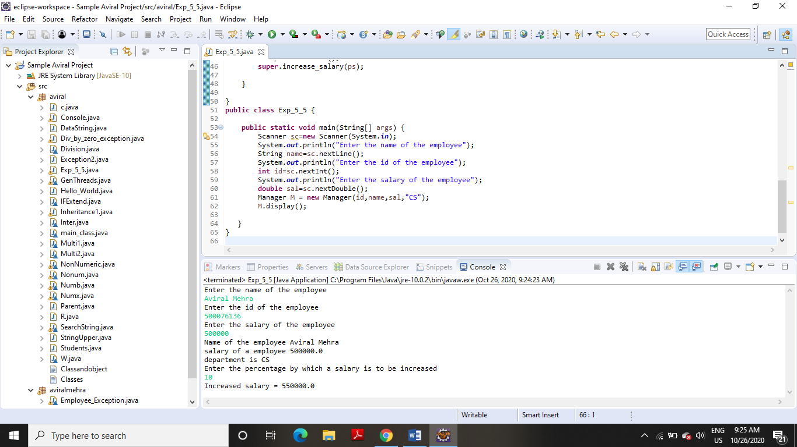

**EXPERIMENT NO– 8**

**TITLE:** String handling

**1. Write a program for searching strings for the first occurrence of a character or substring and for the last occurrence of a character or substring.**

**CODE**

**package** aviral;

**import** java.util.*;

**class** SearchString

{

**public** **static** **void** main(String args[])

{

**int** len1,len2,last=0;

Scanner sc=**new** Scanner(System.***in***);

System.***out***.println("Enter the string:");

String s1=sc.nextLine();

System.***out***.println("Enter searching string:");

String s2=sc.nextLine();

len1=s1.length();

len2=s2.length();

**for**(**int** i=0;i<=(len1-len2);i++)

{

**if**(s1.substring(i,len2+i).equals(s2))

{

**if**(last==0)

System.***out***.println("first occurance is at possition :"+(i+1));

last=i+1;

}

}

**if**(last!=0)

System.***out***.println("last occurance is at possition :"+last);

**else**

System.***out***.println("the string is not found");

}

}

**OUTPUT**

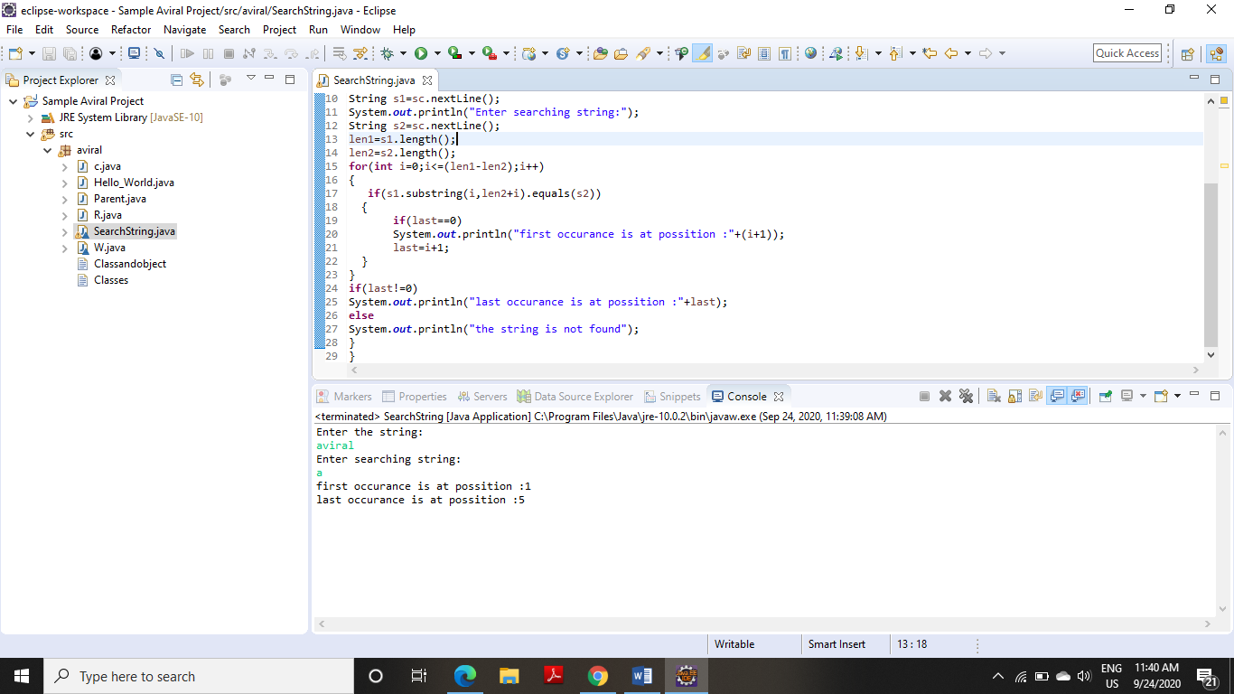

**2. Write a program that converts all characters of a string in capital letters. (Use StringBuffer to store a string). Don’t use inbuilt function.**

**CODE**

**package** aviral;

**import** java.io.*;

**public** **class** StringUpper

{

**public** **static** **void** main(String args[]) **throws** IOException

{

StringBuffer s=**new** StringBuffer("Aviral Mehra");

String str = "";

**for**(**int** x=0; x<s.length(); x++)

{

**char** ch = s.charAt(x);

**if**(ch >= 'a' && ch <= 'z')

str += "" + (**char**)(ch - 32);

**else**

str += "" + ch;

}

System.***out***.println("Final String :"+str);

}

}

**OUTPUT**

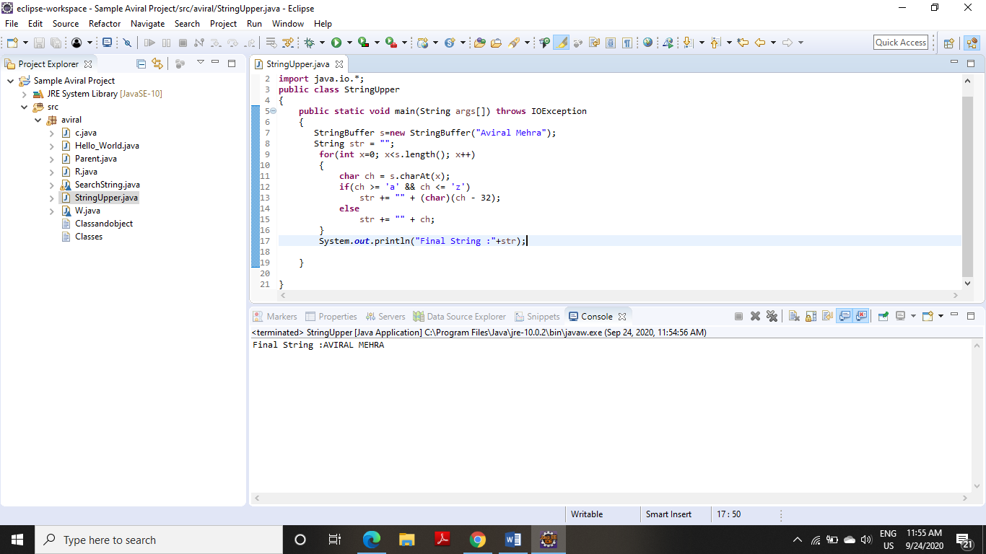

**3.Write a program in Java to read a statement from console, convert it into upper case and again print on console. (Don’t use inbuilt function)**

**CODE**

**package** aviral;

**import** java.io.*;

**public** **class** Console

{

**public** **static** **void** main(String a[]) **throws** IOException

{

DataInputStream in=**new** DataInputStream(System.***in***);

System.***out***.println("Enter file Statement:");

String s1=in.~~readLine~~();

System.***out***.println(s1.toUpperCase());

}

}

**OUTPUT**

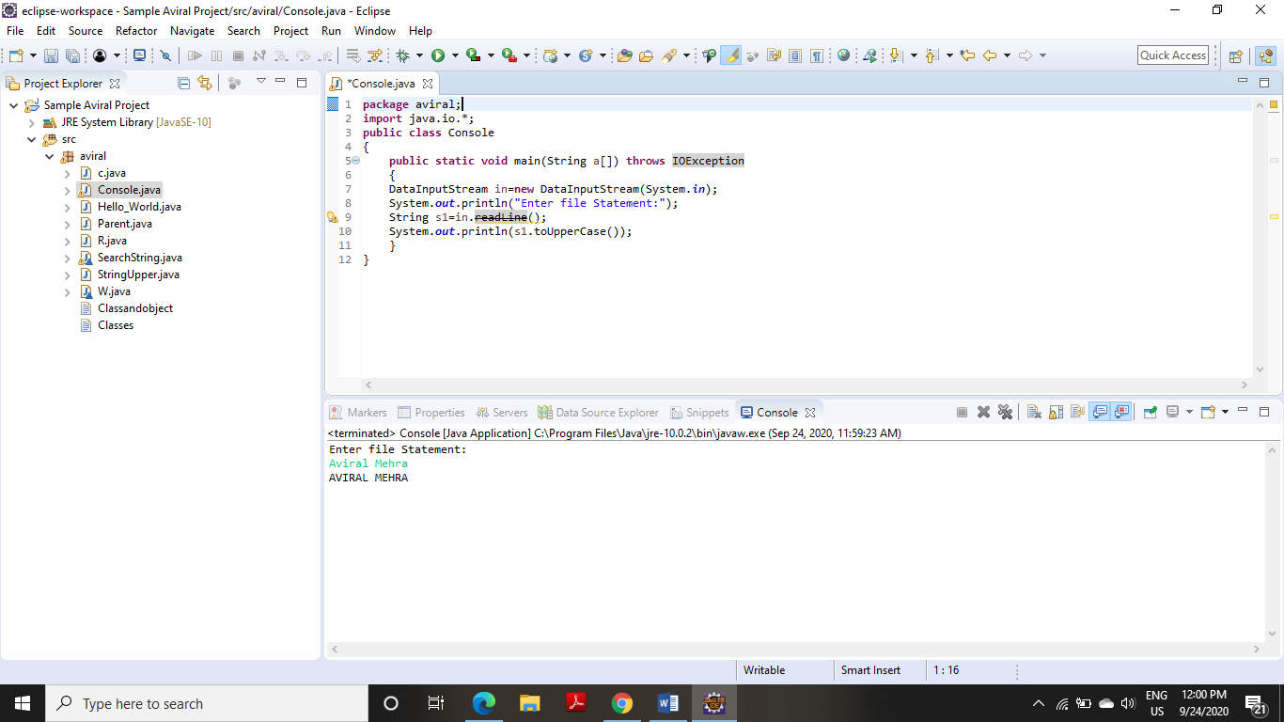

**4. Write a program in Java to create a String object. Initialize this object with your name. Find the length of your name using the appropriate String method. Find whether the character ‘a’ is in your name or not; if yes find the number of times ‘a’ appears in your name. Print locations of occurrences of ‘a’ .Try the same for different String object**

**CODE**

**package** aviral;

**public** **class** DataString

{

**public** **static** **void** main(String args[])

{

Data d1=**new** Data("aviral mehra");

d1.disp();

Data d2=**new** Data("aman mehra");

d2.disp();

}

}

**class** Data

{

String name;

Data(String n)

{

name=n;

}

**void** disp()

{

System.***out***.println("Name :"+name);

**int** c=0;

**int** len=name.length();

**for**(**int** i=0;i<len;i++)

**if**(name.charAt(i)=='A'||name.charAt(i)=='a')

{

c++;

System.***out***.println("number of occurance :"+c);

System.***out***.println("Possition :"+(i+1));

}

**if**(c==0)

System.***out***.println("there is no 'A' available in the string");

}

}

**OUTPUT**

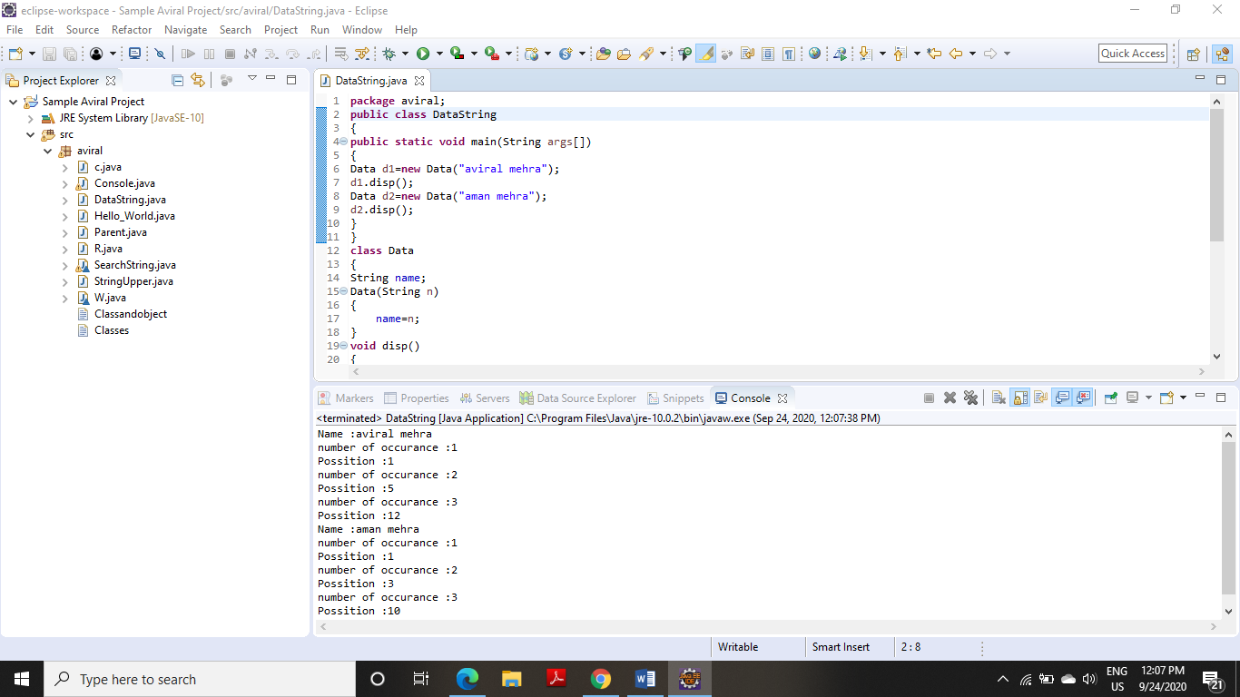

**EXPERIMENT NO-6**

**TITLE:** Package

**1. Write a Java program to implement the concept of importing classes from user defined package and created packages**.

**package** p;

**public** **class** A {

**public** **void** display()

{

System.***out***.println("inside package p and the class is A");

}

}

**package** p;

**public** **class** C{

**public** **void** display()

{

System.***out***.println("inside package p and the class is C");

}

}

**package** q;

**import** p.*;

**public** **class** B{

**private** **void** disp()

{

System.***out***.println("inside package q and class is B");

}

**public** **static** **void** main(String[] args) {

B o=**new** B();

o.disp();

C ob=**new** C();

ob.display();

A obj=**new** A();

obj.display();

}

}

**OUTPUT**

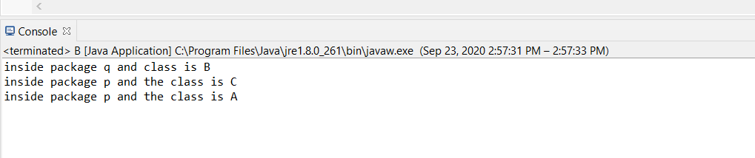

**2. Write a program to make a package Balance. This has an Account class with Display_Balance method. Import Balance package in another program to access Display_Balance method of Account class**.

**package** Balance;

**public** **class** Account {

**public** **void** Display_Balance()

{

System.***out***.print("You have accessed the Display_Balance function of class Account");

}

}

**package** q;

**import** Balance.Account;

**public** **class** Access {

**public** **static** **void** main(String[] args) {

Account obj=**new** Account();

obj.Display_Balance();

System.***out***.println(" from class Access located in different package!");

}

}

**OUTPUT**

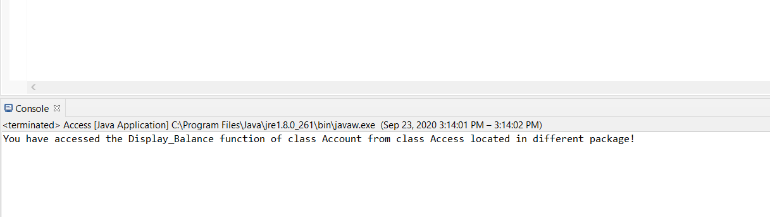

**EXPERIMENT NO – 7**

**TITLE**: Exceptions

**1. Write a program in Java to display the names and roll numbers of students. Initialize respective array variables for 10 students. Handle ArrayIndexOutOfBoundsExeption, so that any such problem doesn’t cause illegal termination of program.**

**CODE**

**package** aviral;

**import** java.io.*;

**class** student

{

String name,grade;

**int** reg,m1,m2,m3;

**void** read()**throws** Exception

{

DataInputStream in=**new** DataInputStream(System.***in***);

System.***out***.println("Enter the register no:");

reg=Integer.*parseInt*(in.~~readLine~~());

System.***out***.println("Enter name :");

name=in.~~readLine~~();

System.***out***.println("Enter marks 1:");

m1=Integer.*parseInt*(in.~~readLine~~());

System.***out***.println("Enter marks 2:");

m2=Integer.*parseInt*(in.~~readLine~~());

System.***out***.println("Enter marks 3:");

m3=Integer.*parseInt*(in.~~readLine~~());

}

**void** disp_grade()

{

**int** total=m1+m2+m3;

**if**(total>=250) grade="A";

**else** **if**(total>=200) grade="B";

**else** **if**(total>=150) grade="C";

**else** **if**(total>=100) grade="D";

**else** grade="E";

System.***out***.println("Grade : "+grade);

}

**void** disp()

{

System.***out***.println("Marks of students");

System.***out***.println("Register No:"+reg);

System.***out***.println("Name :"+name);

System.***out***.println("Marks 1:"+m1);

System.***out***.println("Marks 2:"+m2);

System.***out***.println("Marks 3:"+m3);

disp_grade();

}

}

**public** **class** Inheritance1

{

**public** **static** **void** main(String args[])

{

**int** n=0;

student s=**new** student();

**try**

{

DataInputStream in=**new** DataInputStream(System.***in***);

System.***out***.println("Enter number of students:");

n=Integer.*parseInt*(in.~~readLine~~());

**for**(**int** x=0;x<n;x++);

s.read();

}

**catch**(ArrayIndexOutOfBoundsException e)

{

System.***out***.println("Maximum no of students is 10\n");

n=10;

}

**catch**(Exception e)

{

System.***out***.println(e);

}

**for**(**int** x=0;x<n;x++);

s.disp();

}

}

**OUTPUT**

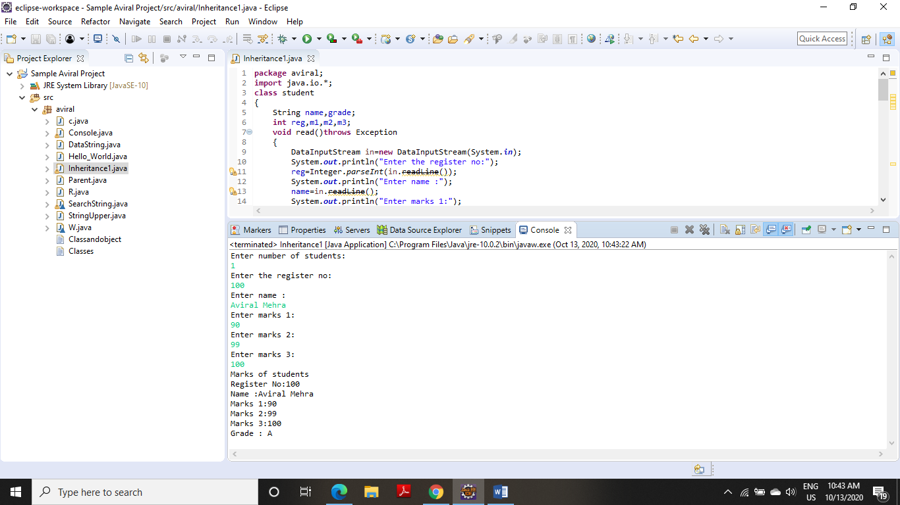

**2. Write a Java program to enable the user to handle any chance of divide by zero exception.**

**CODE**

**package** aviral;

**public** **class** Exception2

{

**public** **static** **void** main(String ar[])

{

**int** no=0,m=10,result=0;

**try**

{

result=m/no;

}

**catch**(ArithmeticException e)

{

System.***out***.println(" division by zero ");

System.***out***.println(" value of result has been set as one");

result=1;

}

**catch**(Exception e)

{

System.***out***.println(e);

}

System.***out***.println(" Result :"+result);

}

}

**OUTPUT**

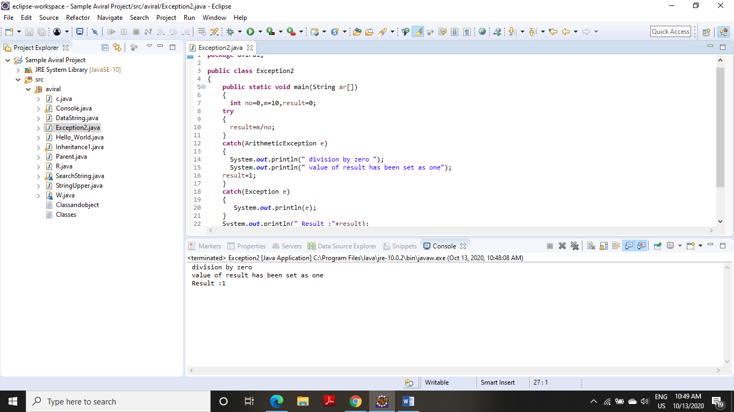

**3. Create an exception class, which throws an exception if operand is nonnumeric in calculating modules. (Use command line arguments).**

**CODE**

package aviral;

import java.io.*;

import java.util.*;

class Numb

{

public static void main(String args[])

{

int i,j;

float add,sub,mul,div;

System.out.println("CALCULATOR:");

System.out.println("Enter two Operands:");

Scanner in=new Scanner(System.in);

try

{

i=in.nextInt();

j=in.nextInt();

add=i+j;

sub=i-j;

mul=i*j;

div=i/j;

System.out.println("Addition ="+add);

System.out.println("Subtraction ="+sub);

System.out.println("Multiplication ="+mul);

System.out.println("Division ="+div);

}

catch(InputMismatchException e)

{

System.out.println("Program Is Terminated Exception Caught");

}

}

}

**OUTPUT**

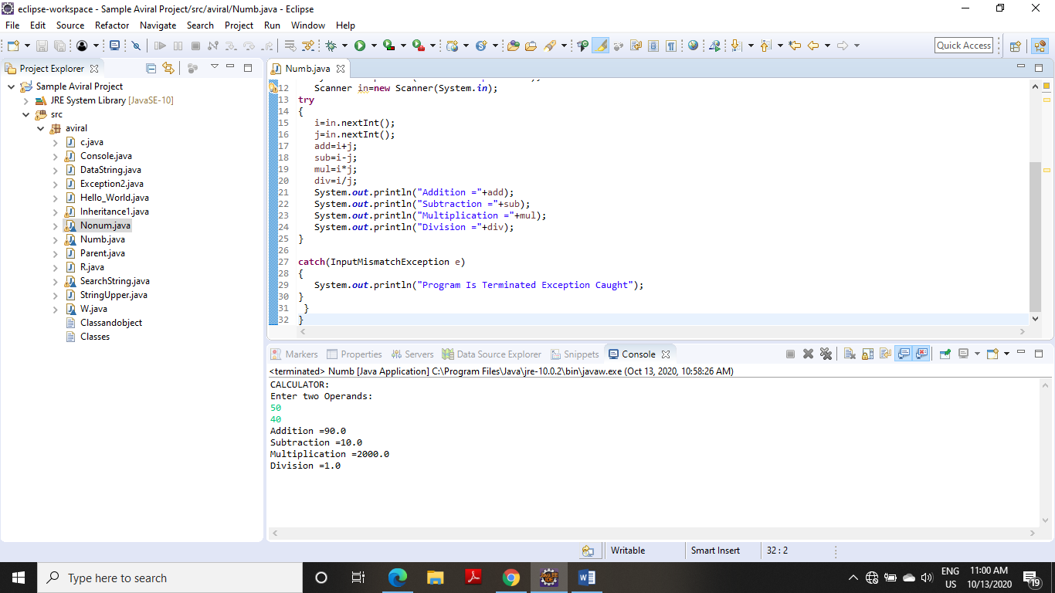

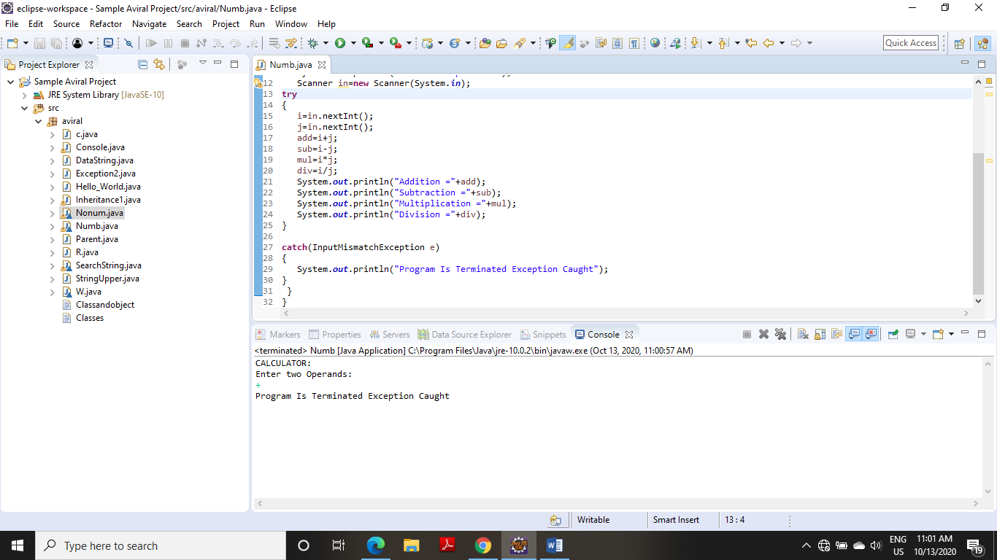

**4. On a single track two vehicles are running. As vehicles are going in same direction there is no problem. If the vehicles are running in different direction there is a chance of collision. To avoid collisions write a Java program using exception handling. You are free to make necessary assumptions.**

**CODE**

**package** aviral;

**import** java.io.*;

**class** collision **extends** Exception

{

collision(String s)

{

**super**(s);

}

}

**class** coll

{

**public** **static** **void** main(String args[])

{

String t1=**null**,t2=**null**;

**try**

{

DataInputStream in= **new** DataInputStream(System.***in***);

System.***out***.println("enter the direction of vehicle1:(left/right):");

t1=in.~~readLine~~();

System.***out***.println("enter the direction of vehicle2:(left/right):");

t2=in.~~readLine~~();

**if**(!t1.equals(t2))

**throw** **new** collision("truck2 has to go on "+ t1 +" direction");

}

**catch**(collision e)

{

System.***out***.println(e);

t2=t1;

System.***out***.println("the collision has been avoided by redirection truck2");

}

**catch**(Exception e)

{

System.***out***.println(e);

}

System.***out***.println("direction of truck1 :"+t1);

System.***out***.println("direction of truck2 :"+t2);

}

}

**OUTPUT**

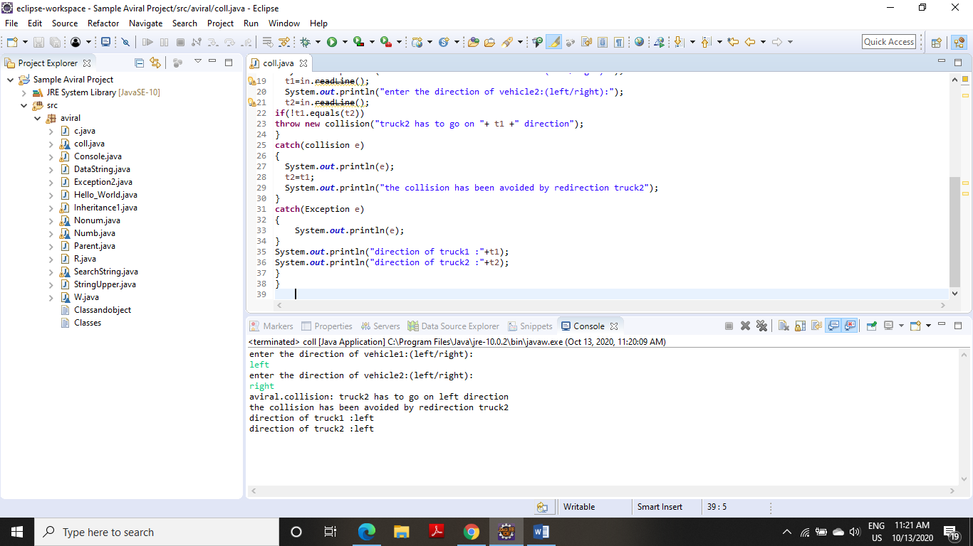

**5. Write a java program to throw an exception for an employee details.** · **If an employee name is a number, a name exception must be thrown.** · **If an employee age is greater than 50, an age exception must be thrown.** · **Or else an object must be created for the entered employee details**

**CODE**

**package** aviral;

**import** java.io.*;

**import** java.util.*;

**class** Numx

{

**public** **static** **void** main(String args[])

{

String name;

**int** age;

System.***out***.println("-----ENTER EMPLOYEE DETAILS-----");

System.***out***.println("Enter Name and Age:");

Scanner sc=**new** Scanner(System.***in***);

**try**

{

**if**(!(sc.nextLine().matches("[a-zA-Z]+")))

{

**throw** **new** IOException();

}

age=sc.nextInt();

**if**(age>50)

{

System.***out***.println("Age greater than 50 Exception");

**throw** **new** Exception();

}

Numx x=**new** Numx();

System.***out***.println("-----Object Created-----");

}

**catch**(Exception e)

{

System.***out***.println("Exception");

}

}

}

**OUTPUT**

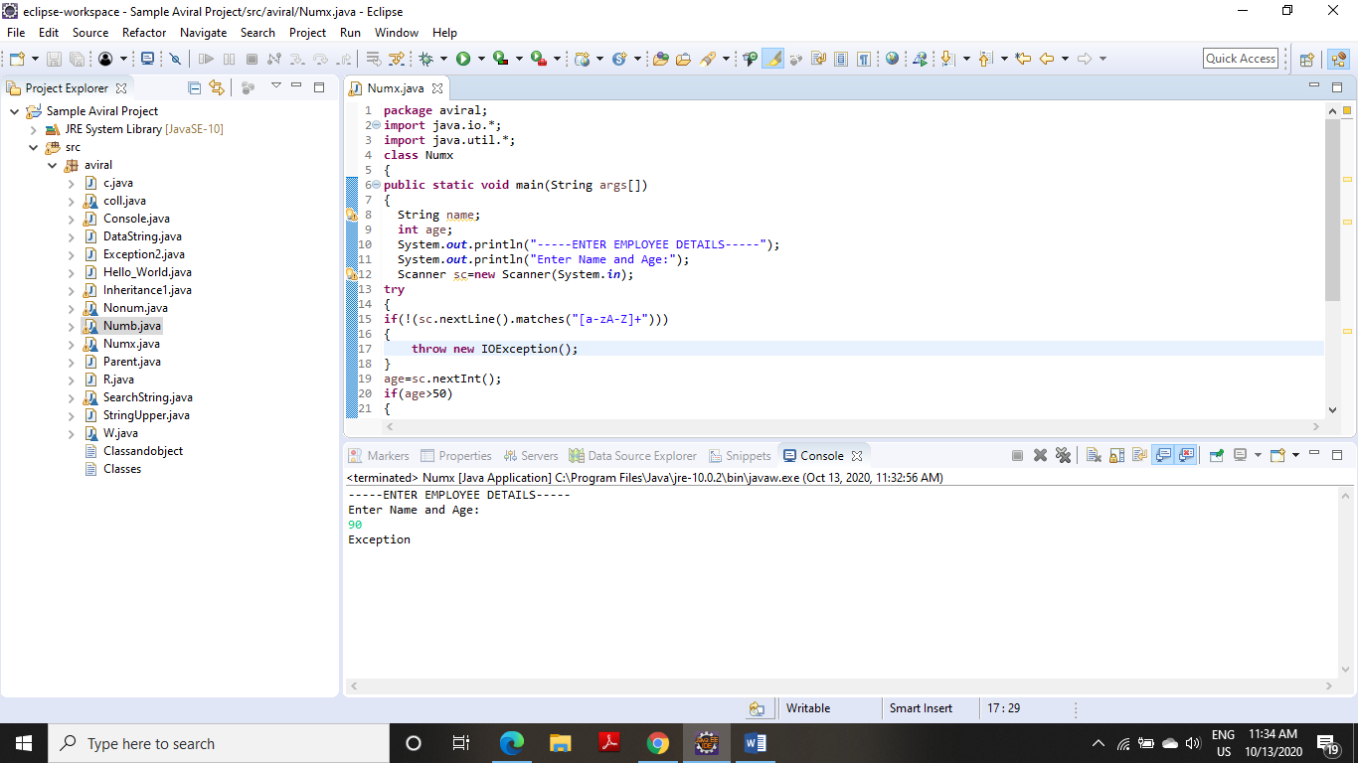

**EXPERIMENT NO – 9**

**TITLE**: Threads

**1. Write a program to implement the concept of threading by extending Thread Class and Runnable interface.**

### **Java Thread Example by extending Thread class**

**CODE**

**package** aviral;

**class** Multi1 **extends** Thread

{

**public** **void** run()

{

System.***out***.println("thread is running...");

}

**public** **static** **void** main(String args[])

{

Multi1 t1=**new** Multi1();

t1.start();

}

}

**OUTPUT**

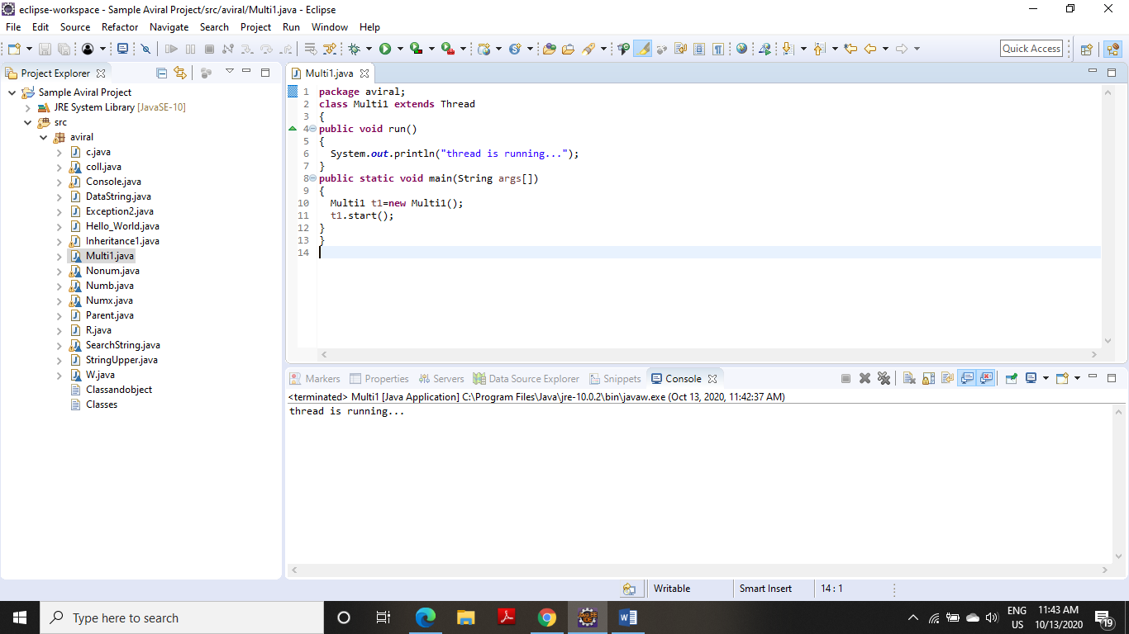

### **Java Thread Example by implementing Runnable interface**

**CODE**

**package** aviral;

**class** Multi2 **implements** Runnable

{

**public** **void** run()

{

System.***out***.println("thread is running...");

}

**public** **static** **void** main(String args[])

{

Multi2 m1=**new** Multi2();

Thread t1 =**new** Thread(m1);

t1.start();

}

}

**OUTPUT**

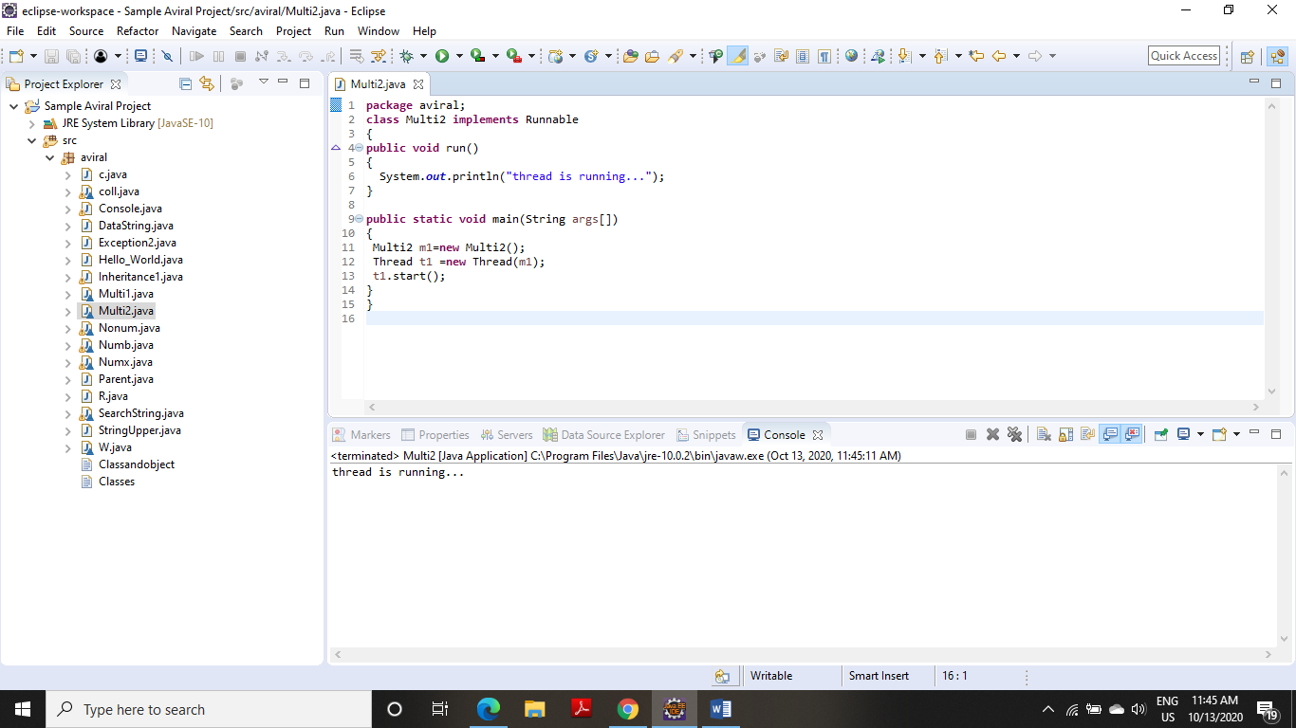

**2) Write a program for generating 2 threads, one for printing even numbers and the other for printing odd numbers**.

**CODE**

**package** aviral;

**class** even **extends** Thread

{

Thread t=**null**;

even()

{

t=**new** Thread(**this**);

start();

}

**public** **void** run()

{

**try**

{

**for**(**int** i=2;i<50;i+=2)

System.***out***.print(i+" ");

Thread.*sleep*(100);

}

**catch**(Exception e)

{

System.***out***.println("thread interepted");

}

}

}

**class** odd **extends** Thread

{

Thread t=**null**;

odd()

{

t=**new** Thread(**this**);

start();

}

**public** **void** run()

{

**try**

{

**for**(**int** i=1;i<50;i+=2)

System.***out***.print(i+" ");

Thread.*sleep*(100);

}

**catch**(Exception e)

{

System.***out***.println("thread interepted");

}

}

}

**class** GenThreads

{

**public** **static** **void** main(String arg[])

{

even e=**new** even();

odd o=**new** odd();

}

}

**OUTPUT**

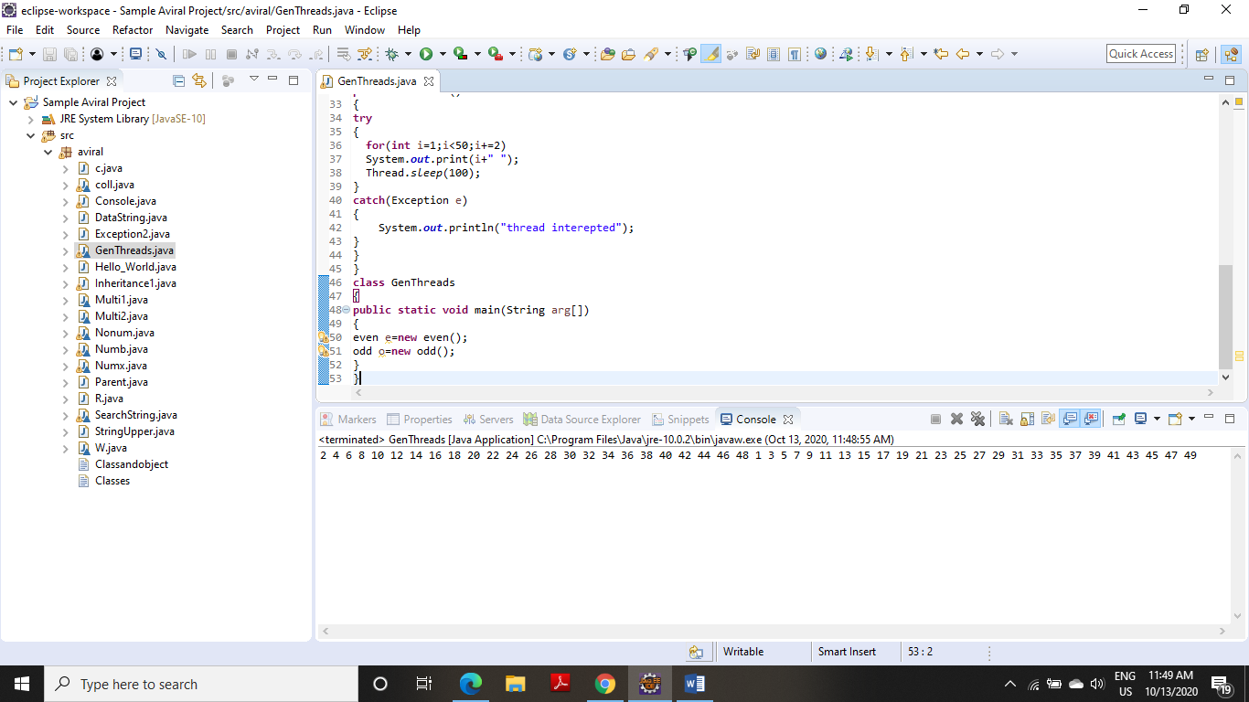

**3. Write a Java program to create five threads with different priorities. Send two threads of the highest priority to sleep state. Check the aliveness of the threads and mark which thread is long lasting.**

**CODE**

**package** aviralmehra;

**public** **class** fivethreads **implements** Runnable

{

**public** **static** **void** main(String args[]) **throws** InterruptedException

{

Thread T1=**new** Thread();

Thread T2=**new** Thread();

Thread T3=**new** Thread();

Thread T4=**new** Thread();

Thread T5=**new** Thread();

T1.setPriority(7);

T2.setPriority(2);

T3.setPriority(10);

T4.setPriority(5);

T5.setPriority(8);

T1.*sleep*(1500);

**if** (T1.isAlive())

System.***out***.println("Thread 1 is alive");

**else**

System.***out***.println("Thread 1 is not alive");

T2.start();

**if** (T2.isAlive())

System.***out***.println("Thread 2 is alive");

**else**

System.***out***.println("Thread 2 is not alive");

T3.*sleep*(1000);

**if** (T3.isAlive())

System.***out***.println("Thread 3 is alive");

**else**

System.***out***.println("Thread 3 is not alive");

T4.start();

**if** (T4.isAlive())

System.***out***.println("Thread 4 is alive");

**else**

System.***out***.println("Thread 4 is not alive");

T5.start();

**if** (T5.isAlive())

System.***out***.println("Thread 5 is alive");

**else**

System.***out***.println("Thread 5 is not alive");

}

}

**OUTPUT**

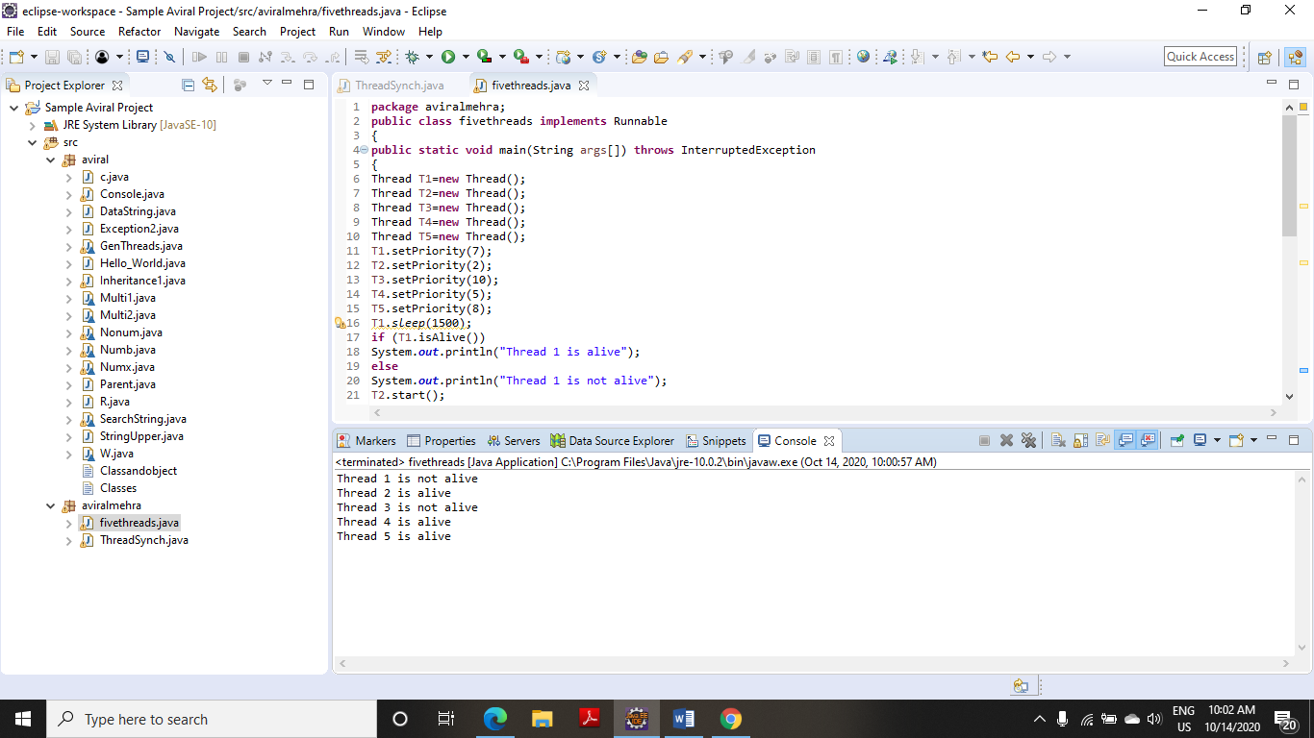

**4. Write a program to launch 10 threads. Each thread increments a counter variable. Run the program with synchronization.**

**CODE**

**package** aviralmehra;

**class** ThreadSynch

{

**public** **static** **void** main(String arg[])**throws** Exception

{

data d1=**new** data();

data d2=**new** data();

data d3=**new** data();

data d4=**new** data();

data d5=**new** data();

data d6=**new** data();

data d7=**new** data();

data d8=**new** data();

data d9=**new** data();

data d10=**new** data();

System.***out***.println(d10.*count*);

}

}

**class** item

{

**static** **int** *count*=0;

}

**class** data **extends** item **implements** Runnable

{

item d=**this**;

Thread t;

data()

{

t=**new** Thread(**this**);

t.start();

}

**public** **void** run()

{

d=syn.*increment*(d);

}

}

**class** syn

{

**synchronized** **static** item increment(item i)

{

i.*count*++;

**return**(i);

}

}

**OUTPUT**

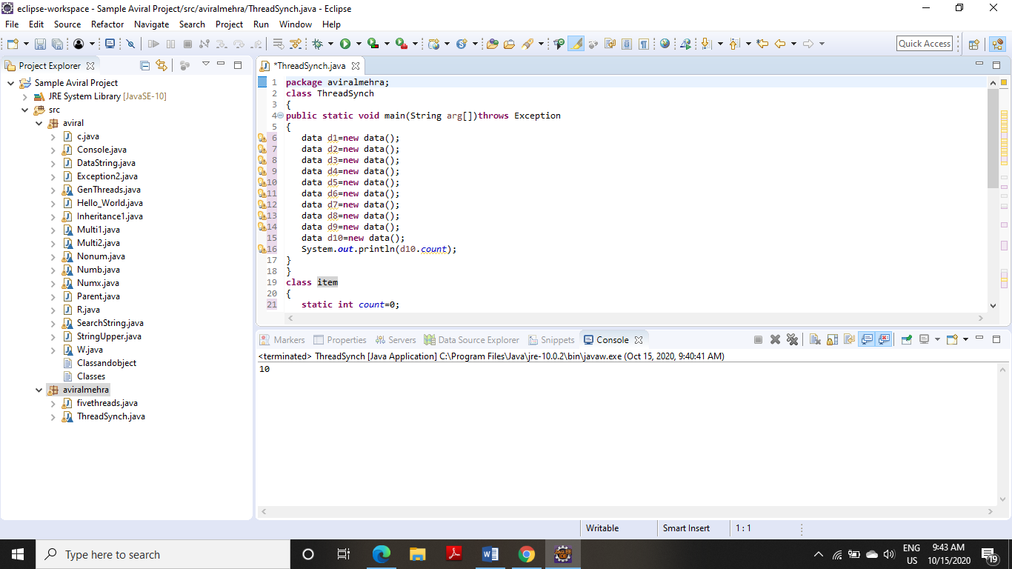

**TITLE:** Collections

**1. Write a program for the following:**

**(i) Read all elements from ArrayList by using Iterator.**

**CODE**

**package** aviral;

**import** java.util.ArrayList;

**import** java.util.Iterator;

**public** **class** ArrayListIterator

{

**public** **static** **void** main(String args[])

{

ArrayList<String> arrl = **new** ArrayList<String>();

arrl.add("First");

arrl.add("Second");

arrl.add("Third");

arrl.add("Random");

Iterator<String> itr = arrl.iterator();

**while**(itr.hasNext())

{

System.***out***.println(itr.next());

}

}

}

**OUTPUT**

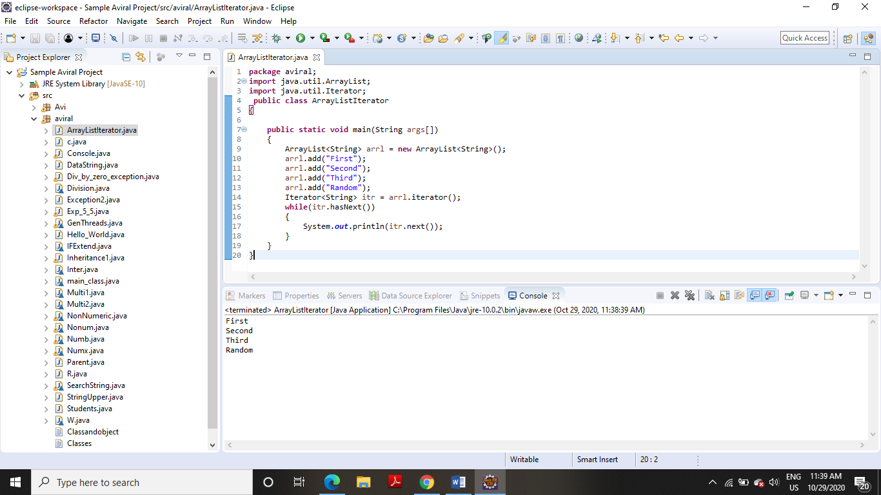

**(ii) Create duplicate object of an ArrayList instance**.

**CODE**

**package** aviral;

**import** java.io.*;

**import** java.util.ArrayList;

**public** **class** DuplicateObject

{

**public** **static** **void** main(String args[])

{

ArrayList<Integer>list= **new** ArrayList<Integer>();

list.add(10);

list.add(20);

list.add(30);

list.add(40);

list.add(50);

System.***out***.println("First ArrayList: "+ list);

ArrayList sec_list = **new** ArrayList();

sec_list = (ArrayList)list.clone();

System.***out***.println("Second ArrayList is: "+ sec_list);

}

}

**OUTPUT**

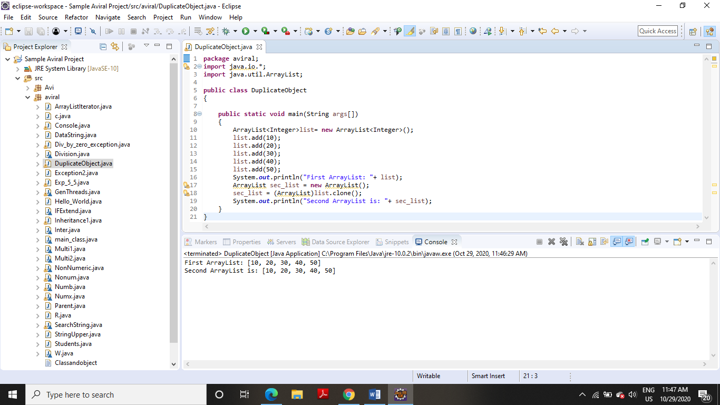

**(iii) Reverse ArrayList content.**

**CODE**

**package** aviral;

**import** java.util.ArrayList;

**import** java.util.Collections;

**public** **class** ArrayListReverse

{

**public** **static** **void** main(String a[])

{

ArrayList<String> list = **new** ArrayList<String>();

list.add("Java");

list.add("Cric");

list.add("Play");

list.add("Watch");

list.add("Glass");

Collections.*reverse*(list);

System.***out***.println("Results after reverse operation:");

**for**(String str: list)

{

System.***out***.println(str);

}

}

}

**OUTPUT**

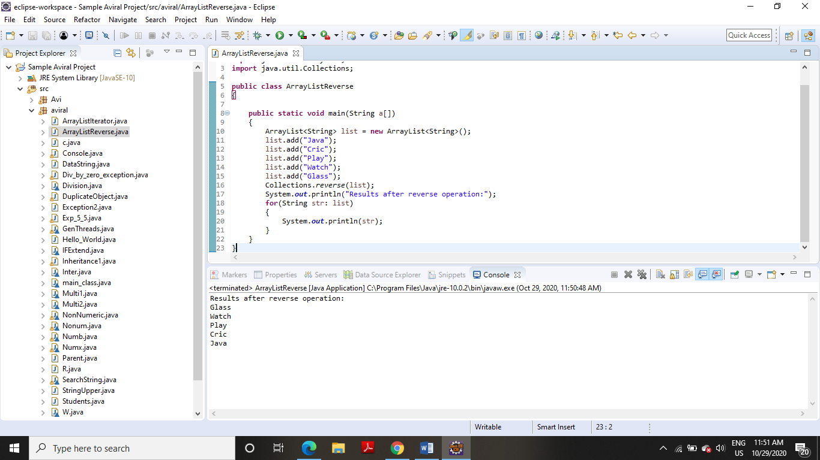

**2. Write a program for the following HashMap:**

**(i) find whether specified key exists or not**.

**CODE**

**package** aviral;

**import** java.util.*;

**public** **class** GFG

{

**public** **static** **void** main(String[] args)

{

HashMap<Integer, String> map = **new** HashMap<>();

map.put(1, "Hi");

map.put(2, "Hello");

map.put(3, "How are you");

**int** keyToBeChecked = 2;

System.***out***.println("HashMap: "+ map);

Iterator<Map.Entry<Integer, String> >iterator = map.entrySet().iterator();

**boolean** isKeyPresent = **false**;

**while** (iterator.hasNext())

{

Map.Entry<Integer, String>entry=iterator.next();

**if** (keyToBeChecked == entry.getKey())

{

isKeyPresent = **true**;

}

}

System.***out***.println("Does key "+ keyToBeChecked + " exists: "+ isKeyPresent);

}

}

**OUTPUT**

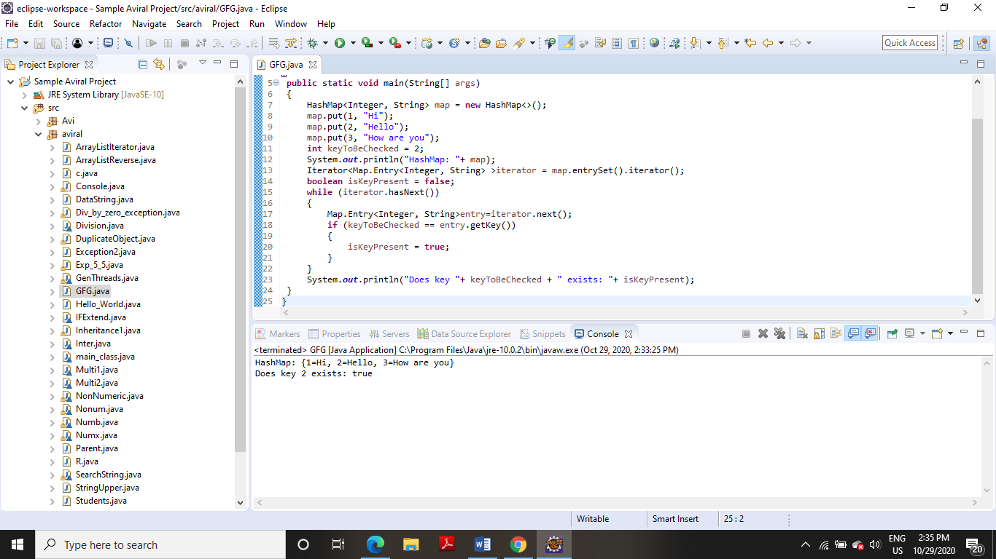

**(ii) find whether specified value exists or not**

**CODE**

**package** aviral;

**import** java.util.HashMap;

**public** **class** CheckValue

{

**public** **static** **void** main(String[] args)

{

HashMap<Integer, String> hashmap = **new** HashMap<Integer, String>();

hashmap.put(11,"Aviral");

hashmap.put(22,"Mehra");

hashmap.put(33,"Singh");

hashmap.put(44,"Rajesh");

hashmap.put(55,"Kate");

**boolean** flag = hashmap.containsValue("Avi");

System.***out***.println("String Singh exists in HashMap? : " + flag);

}

}

**OUTPUT**

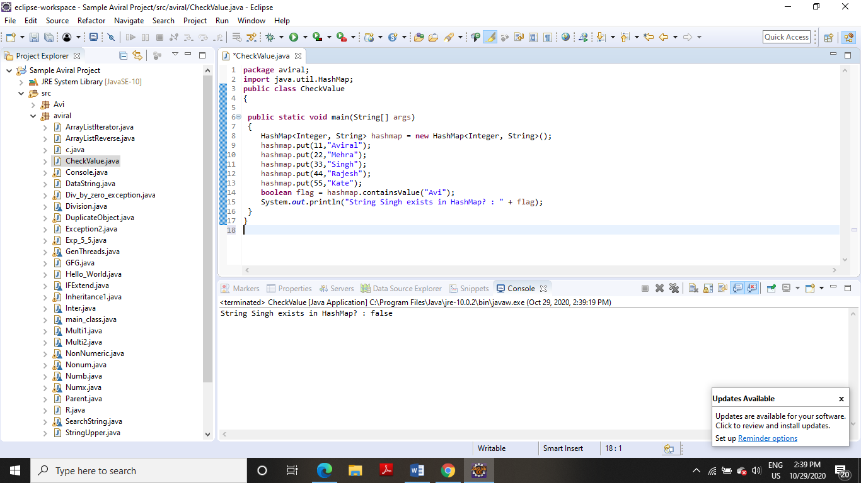

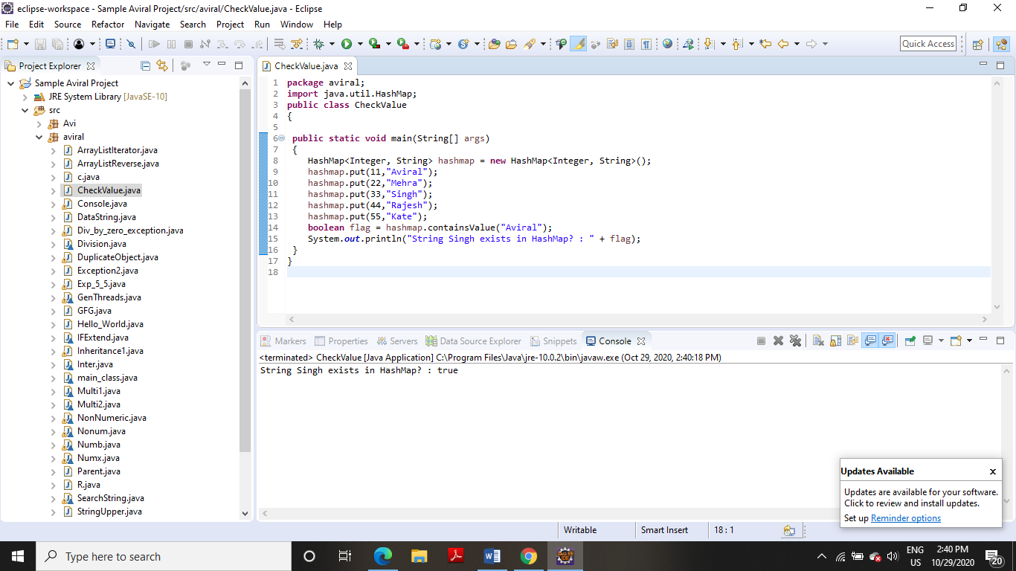

**(iii) get all keys from the given HashMap**

**package** aviral;

**import** java.util.HashMap;

**import** java.util.Set;

**public** **class** HashMapKeys

{

**public** **static** **void** main(String a[])

{

HashMap<String, String> hm = **new** HashMap<String, String>();

hm.put("first", "FIRST INSERTED");

hm.put("second", "SECOND INSERTED");

hm.put("third","THIRD INSERTED");

System.***out***.println(hm);

Set<String> keys = hm.keySet();

**for**(String key: keys)

{

System.***out***.println(key);

}

}

}

**OUTPUT**

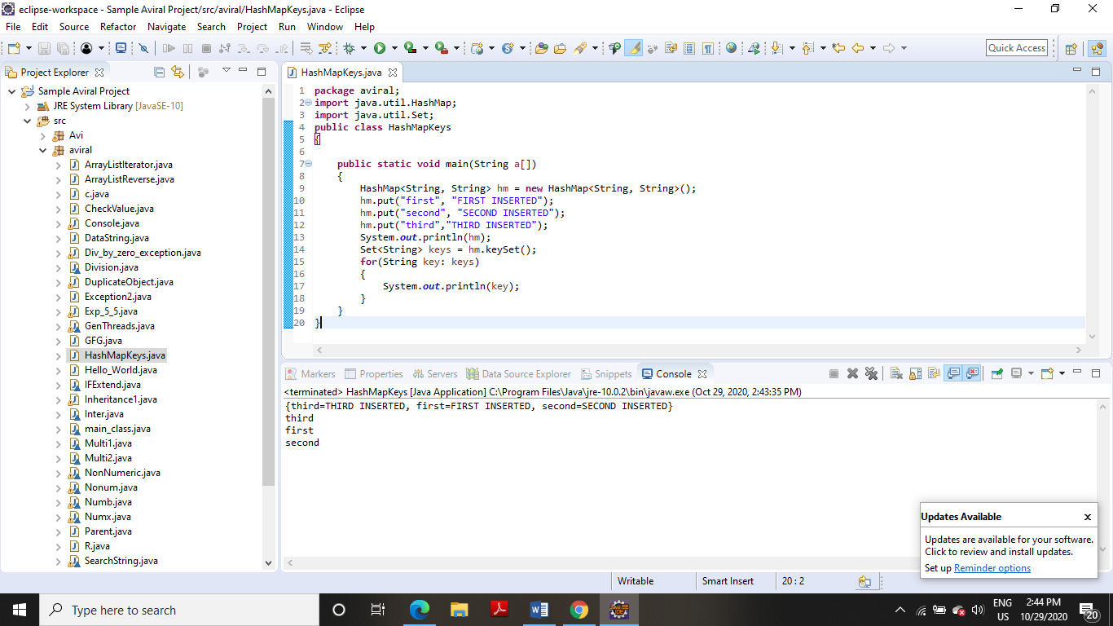

**(iv) get all key-value pair as Entry objects**

**CODE**

**package** aviral;

**import** java.util.HashMap;

**import** java.util.Map.Entry;

**import** java.util.Set;

**public** **class** HashEntrySet

{

**public** **static** **void** main(String a[])

{

HashMap<String, String> hm = **new** HashMap<String, String>();

hm.put("first", "FIRST INSERTED");

hm.put("second", "SECOND INSERTED");

hm.put("third","THIRD INSERTED");

System.***out***.println(hm);

Set<Entry<String, String>> entires = hm.entrySet();

**for**(Entry<String,String> ent:entires)

{

System.***out***.println(ent.getKey()+" ==> "+ent.getValue());

}

}

}

**OUTPUT**

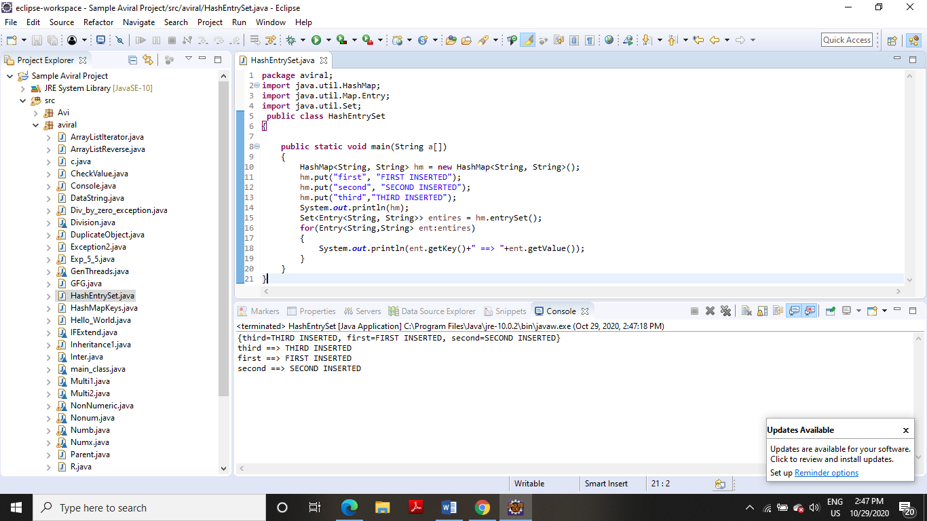

**3. Write a program for the following:**

**(i) HashSet copy another collection object to HashSet object.**

**CODE**

**package** aviral;

**import** java.util.HashSet;

**public** **class** HashSetCopy

{

**public** **static** **void** main(String a[])

{

HashSet<String> hs = **new** HashSet<String>();

hs.add("first");

hs.add("second");

hs.add("third");

System.***out***.println(hs);

HashSet<String> subSet = **new** HashSet<String>();

subSet.add("s1");

subSet.add("s2");

hs.addAll(subSet);

System.***out***.println("HashSet content after adding another collection:");

System.***out***.println(hs);

}

}

**OUTPUT**

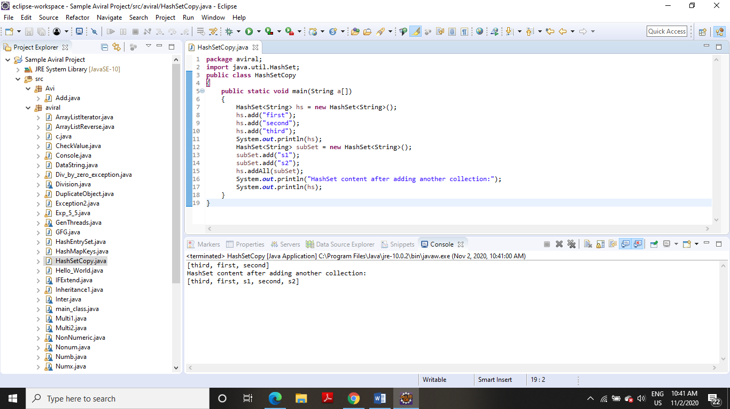

**(ii) delete all entries at one call from HashSet**

**CODE**

**package** aviral;

**import** java.util.HashSet;

**public** **class** HashSetClear

{

**public** **static** **void** main(String a[])

{

HashSet<String> hs = **new** HashSet<String>();

hs.add("first");

hs.add("second");

hs.add("third");

System.***out***.println("My HashSet content:");

System.***out***.println(hs);

System.***out***.println("Clearing HashSet:");

hs.clear();

System.***out***.println("Content After clear:");

System.***out***.println(hs);

}

}

**OUTPUT**

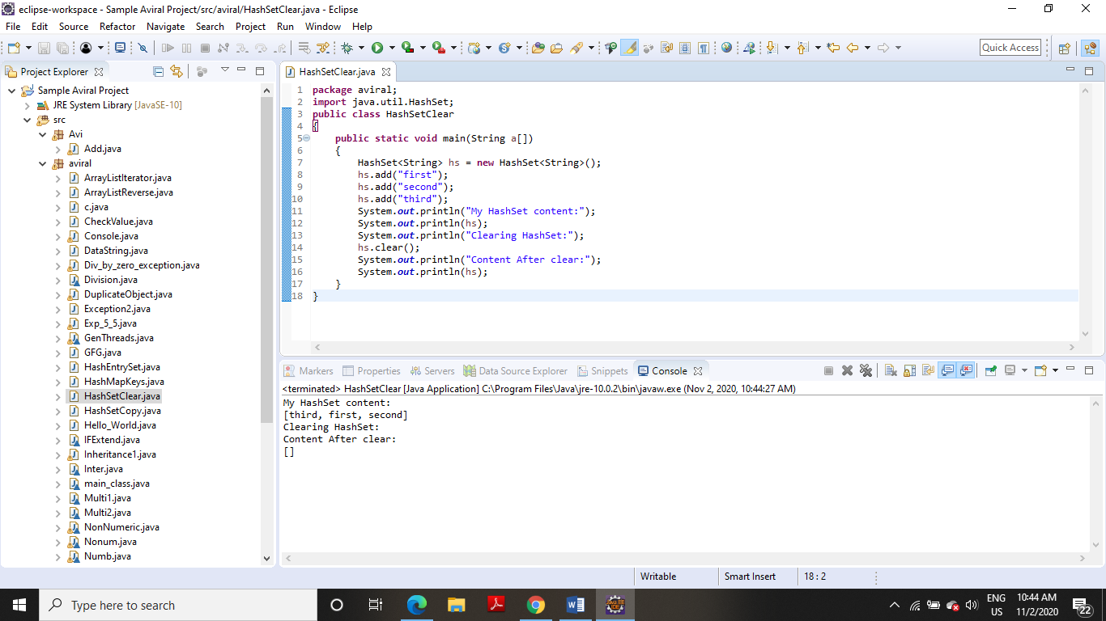

**(iii) search user defined objects from HashSet**

**CODE**

**package** aviral;

**import** java.util.HashSet;

**public** **class** HashSetSearchObject

{

**public** **static** **void** main(String a[])

{

HashSet<Price> lhs = **new** HashSet<Price>();

lhs.add(**new** Price("Banana", 20));

lhs.add(**new** Price("Apple", 40));

lhs.add(**new** Price("Orange", 30));

**for**(Price pr:lhs)

{

System.***out***.println(pr);

}

Price key = **new** Price("Banana", 20);

System.***out***.println("Does set contains key? "+lhs.contains(key));

}

}

**class** Price

{

**private** String item;

**private** **int** price;

**public** Price(String itm, **int** pr)

{

**this**.item = itm;

**this**.price = pr;

}

**public** **int** hashCode()

{

System.***out***.println("In hashcode");

**int** hashcode = 0;

hashcode = price*20;

hashcode += item.hashCode();

**return** hashcode;

}

**public** **boolean** equals(Object obj)

{

System.***out***.println("In equals");

**if** (obj **instanceof** Price)

{

Price pp = (Price) obj;

**return** (pp.item.equals(**this**.item) && pp.price == **this**.price);

} **else**

{

**return** **false**;

}

}

**public** String getItem()

{

**return** item;

}

**public** **void** setItem(String item)

{

**this**.item = item;

}

**public** **int** getPrice()

{

**return** price;

}

**public** **void** setPrice(**int** price)

{

**this**.price = price;

}

**public** String toString()

{

**return** "item: "+item+" price: "+price;

}

}

**OUTPUT**

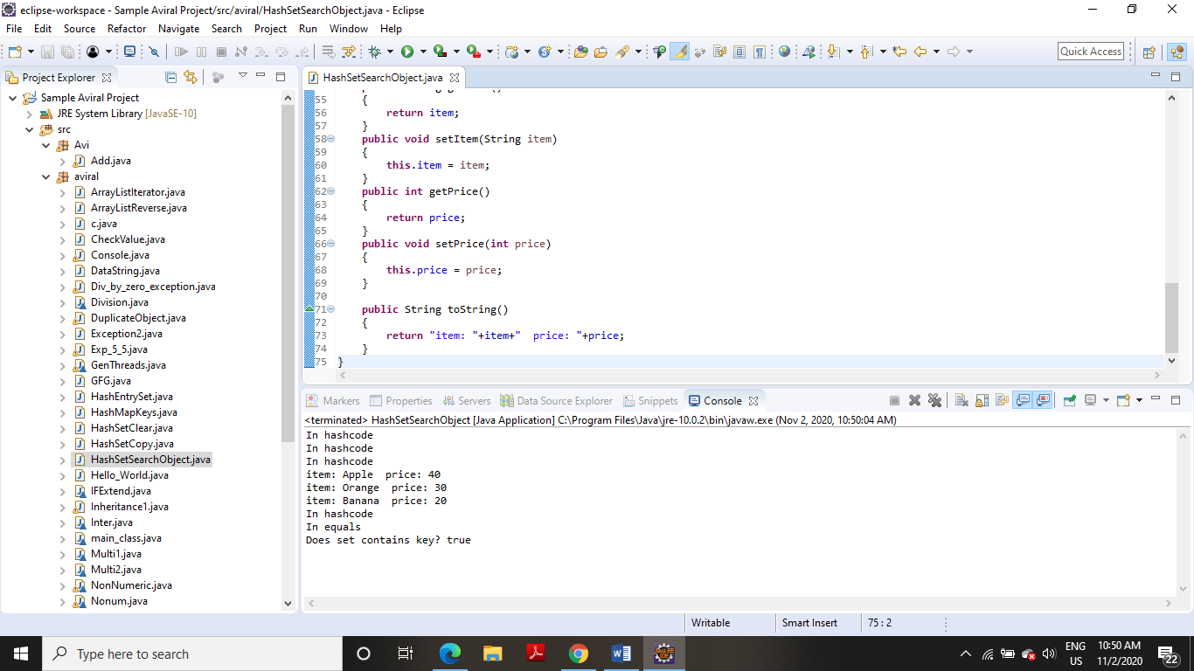

**EXPERIMENT NO-5**

**Title:** Interface

**1. Write a program to create interface named test. In this interface the member function is square. Implement this interface in arithmetic class. Create one new class called ToTestInt. In this class use the object of arithmetic class**.

**CODE:**

**package** aviral;

**interface** test

{

**int** square();

}

**class** arithmetic **implements** test

{

**int** b;

arithmetic(**int** x)

{

b = x;

}

**public** **int** square()

{

**return** (b*b);

}

}

**class** ToTestInt

{

**public** **int** return_ans(**int** x)

{

arithmetic a=**new** arithmetic(x);

**return** a.square();

}

}

**class** main_class

{

**public** **static** **void** main(String []args)

{

ToTestInt x= **new** ToTestInt();

System.***out***.println("\nThe square of 64 is "+x.return_ans(64));

}

}

**OUTPUT**

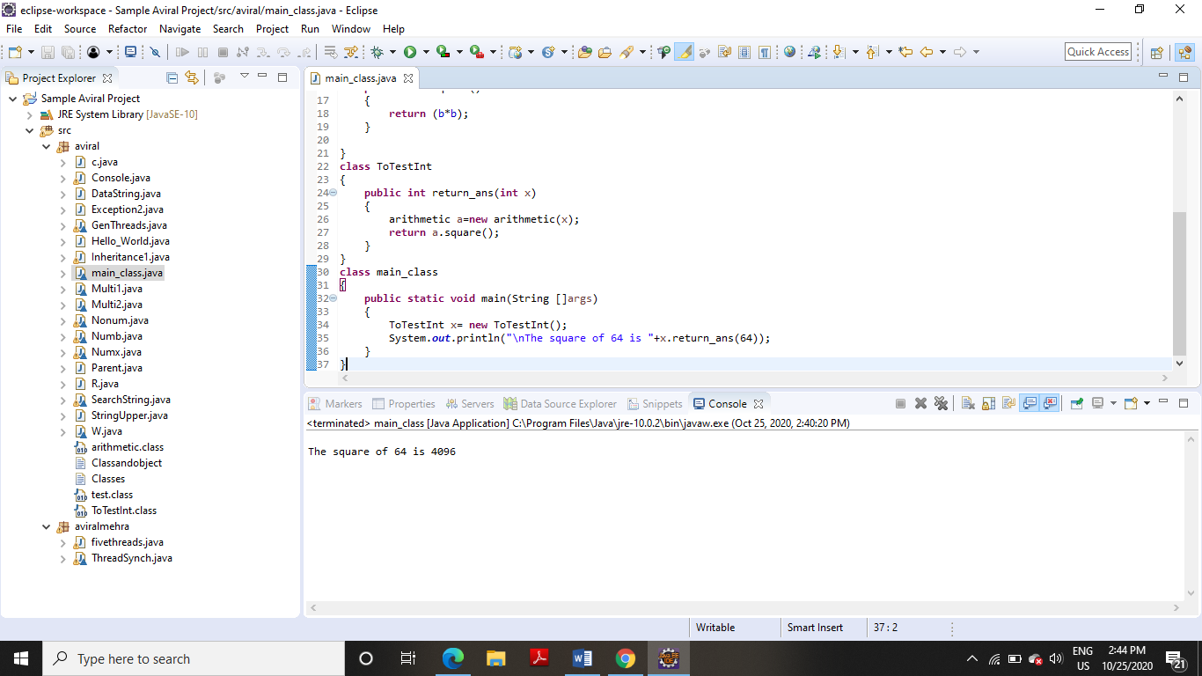

**2. Write a program to create interface A, in this interface we have two method meth1 and meth2. Implements this interface in another class named MyClass.**

**CODE**

**package** aviral;

**interface** A

{

**void** meth1();

**void** meth2();

}

**interface** B **extends** A

{

**void** meth3();

}

**class** MyClass **implements** B

{

**public** **void** meth1 ( )

{

System.***out***.println("Implement meth1().");

}

**public** **void** meth2()

{

System.***out***.println ("Implement meth2().");

}

**public** **void** meth3()

{

System.***out***.println ("Implement meth()." );

}

}

**class** IFExtend

{

**public** **static** **void** main(String arg[])

{

MyClass ob = **new** MyClass();

ob.meth1();

ob.meth2();

ob.meth3();

}

}

**OUTPUT**

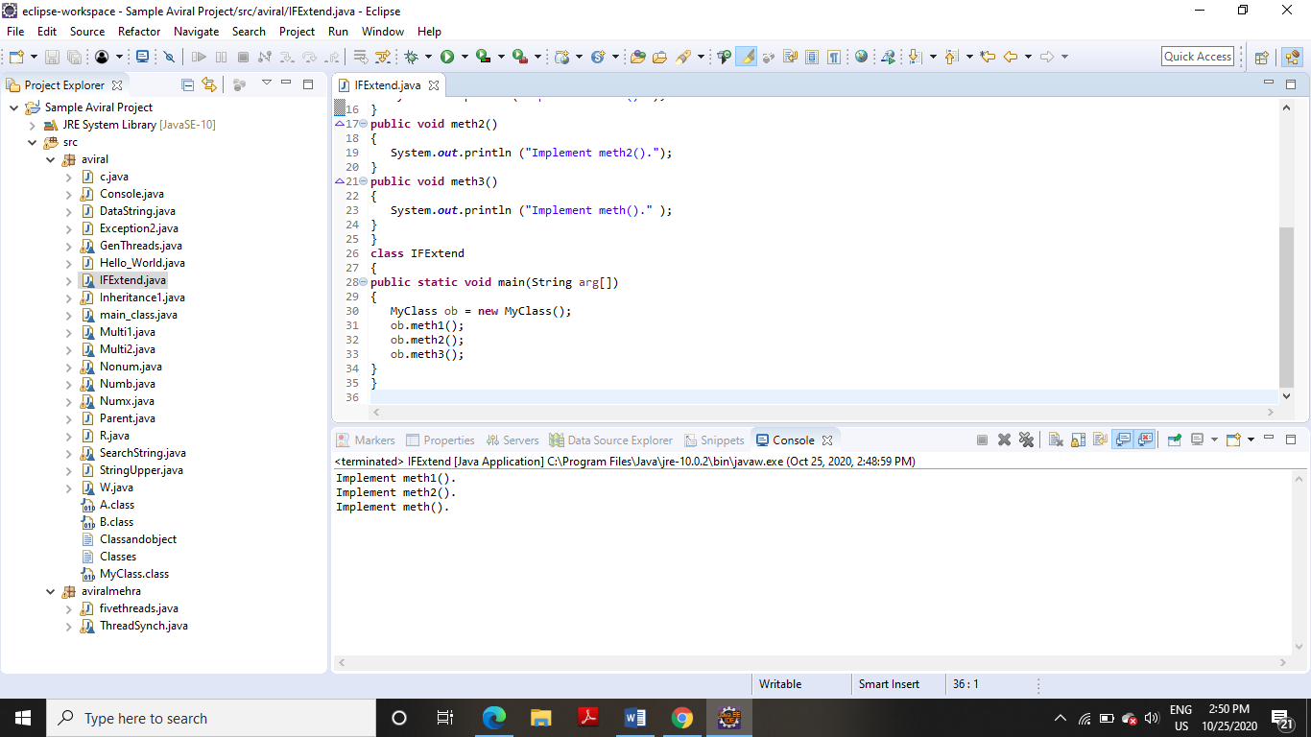

**3. Write a program in Java to show the usefulness of Interfaces as a place to keep constant value of the program**

**CODE**

**package** aviral;

**interface** area

{

**static** **final** **float** ***pi***=3.142f;

**float** compute(**float** x,**float** y);

}

**class** rectangle **implements** area

{

**public** **float** compute(**float** x,**float** y)

{

**return**(x*y);

}

}

**class** circle **implements** area

{

**public** **float** compute(**float** x,**float** y)

{

**return**(***pi***\*x*x);

}

}

**class** Inter

{

**public** **static** **void** main(String args[])

{

rectangle rect=**new** rectangle();

circle cr=**new** circle();

area ar;

ar=rect;

System.***out***.println("Area of the rectangle= "+ar.compute(10,20));

ar=cr;

System.***out***.println("Area of the circle= "+ar.compute(10,0));

}

}

**OUTPUT**

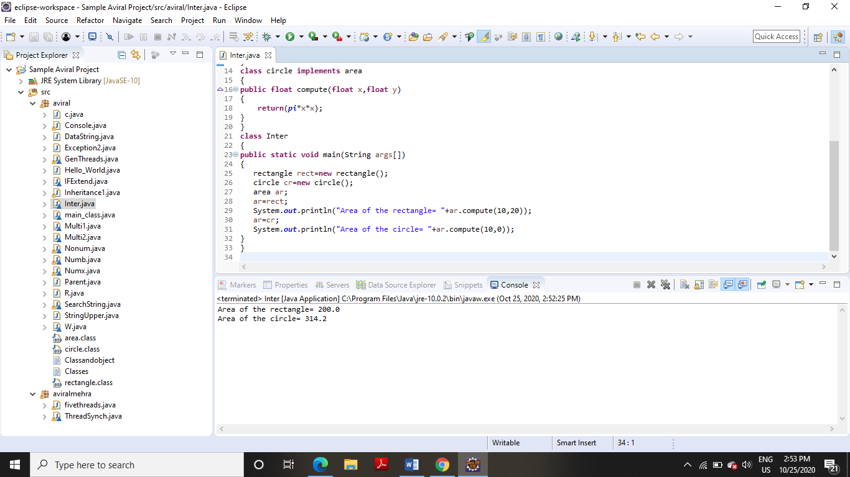

**4. Write a program to create an Interface having two methods division and modules. Create a class, which overrides these methods**.

**CODE**

**package** aviral;

**interface** course

{

**void** division(**int** a);

**void** modules(**int** b);

}

**class** stud **implements** course

{

String name;

**int** div,mod;

**void** name(String n)

{

name=n;

}

**public** **void** division(**int** a)

{

div=a;

}

**public** **void** modules(**int** b)

{

mod=b;

}

**void** disp()

{

System.***out***.println("Name :"+name);

System.***out***.println("Division :"+div);

System.***out***.println("Modules :"+mod);

}

}

**class** Division

{

**public** **static** **void** main(String args[])

{

stud s=**new** stud();

s.name("Arun");

s.division(5);

s.modules(15);

s.disp();

}

}

**OUTPUT**

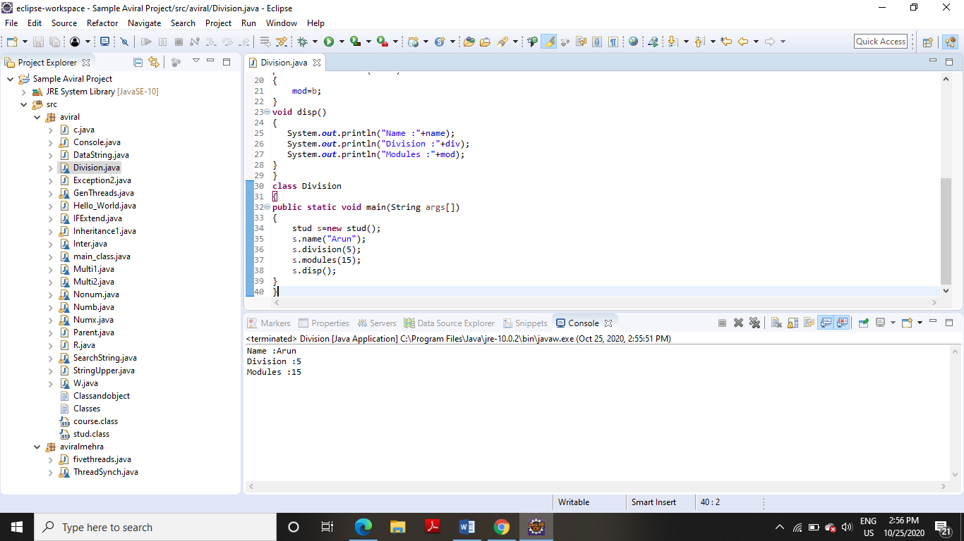

**EXPERIMENT NO-10**

**TITLE:** JDBC

**1. Create a database table to store the records of employee in a company. Use getConnection function to connect the database. The statement object uses executeUpdate function to create a table**.

**CODE**

**package** aviral;

**import** java.sql.*;

**class** JDBC

{

**public** **static** **void** main(String args[])

{

**try**

{

Class.*forName*("com.mysql.cj.jdbc.Driver");

Connection conn=DriverManager.*getConnection*("jdbc:mysql://localhost:3306","root","aviral08");

System.***out***.println("Connection Successful");

Statement stmt = conn.createStatement();

stmt.execute("use student");

stmt.executeUpdate("create table Employees(empid varchar(10) primary key,empname varchar(45),city varchar(45),salary varchar(45))");

System.***out***.println("table is created");

stmt.executeUpdate("insert into Employees values('R110219031','Aviral Mehra','Dehradun','25000')");

stmt.executeUpdate("insert into Employees values('R110217685','Rajesh','Delhi','35000')");

System.***out***.println("value is Update");

ResultSet rs=stmt.executeQuery("select * from Employees");

**while**(rs.next()) {

String mempid=rs.getString(1);

String mempname=rs.getString(2);

String mcity=rs.getString(3);

String msalary=rs.getString(4);

System.***out***.println(mempid+ " "+mempname+" "+mcity+" "+msalary);

}

conn.close();

}

**catch**(SQLException e){

System.***out***.println(e);

}

**catch**(ClassNotFoundException e) {

System.***out***.println(e);

}

}

}

**OUTPUT**

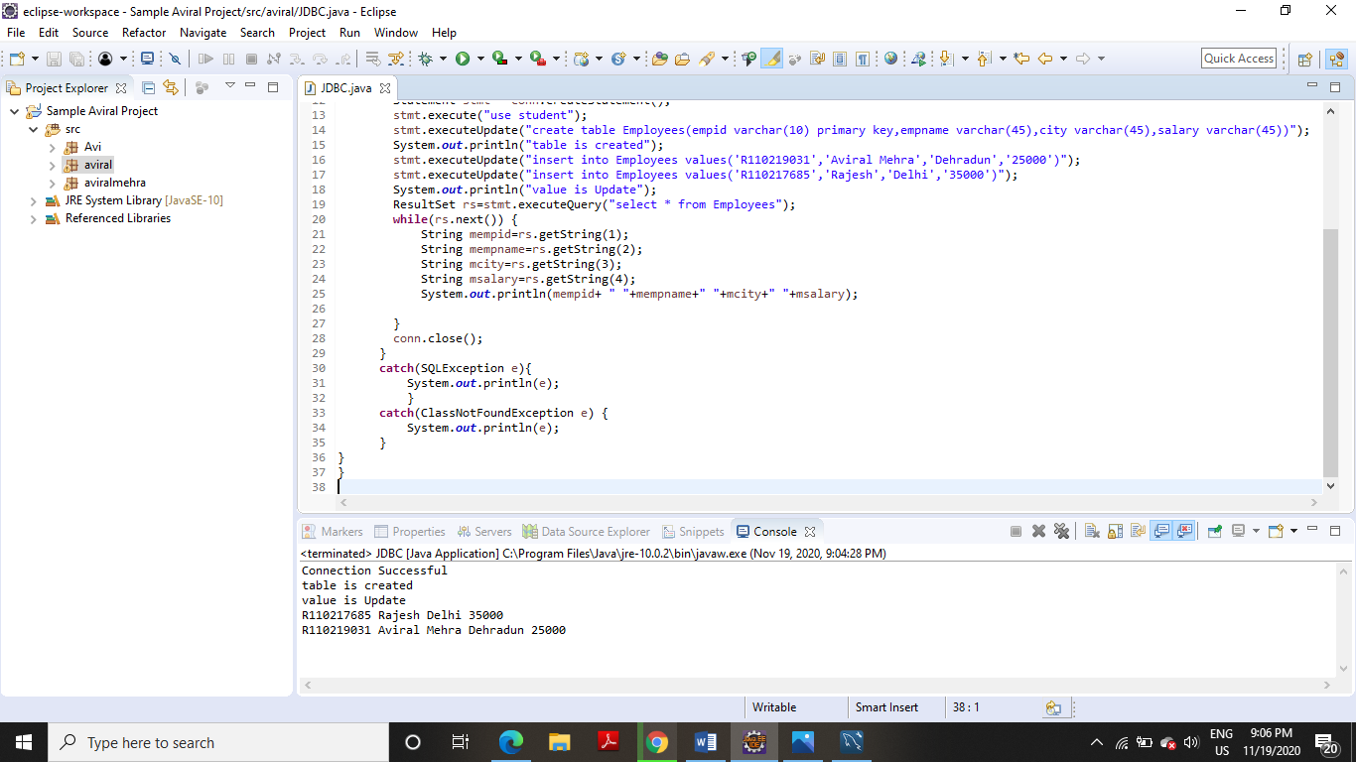

**2**. **Create a database of employee of company in mysql and then use java program to access the database for inserting information of employees in database. The SQL statement can be used to view the details of the data of employees in the database.**

**package** aviral;

**import** java.sql.*;

**class** Employee2

{

**public** **static** **void** main(String s[])

{

**try**

{

Class.*forName*("com.mysql.cj.jdbc.Driver");

Connection conn=DriverManager.*getConnection*("jdbc:mysql://localhost:3306","root","aviral08");

System.***out***.println("Connection Successful");

Statement stmt = conn.createStatement();

stmt.execute("use student");

stmt.executeUpdate("insert into employees1 values('435325','Mohan','Allahabad','25000')");

stmt.executeUpdate("insert into employees1 values('435326','sohan','Allahabad','35000')");

System.***out***.println("value is Update");

conn.close();

}

**catch**(SQLException e){

System.***out***.println(e);

}

**catch**(ClassNotFoundException e) {

System.***out***.println(e);

}

}

}

**OUTPUT**

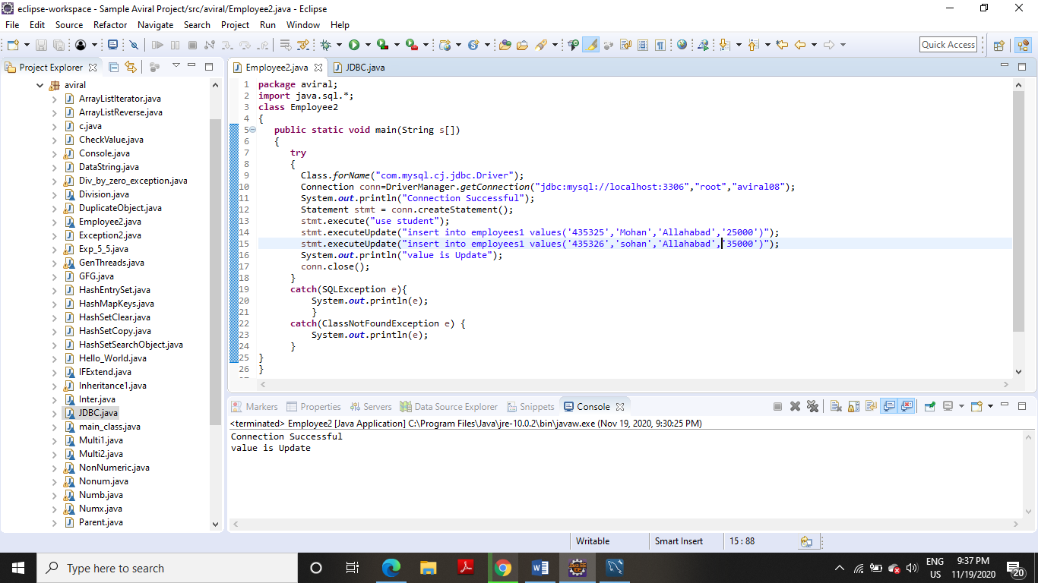

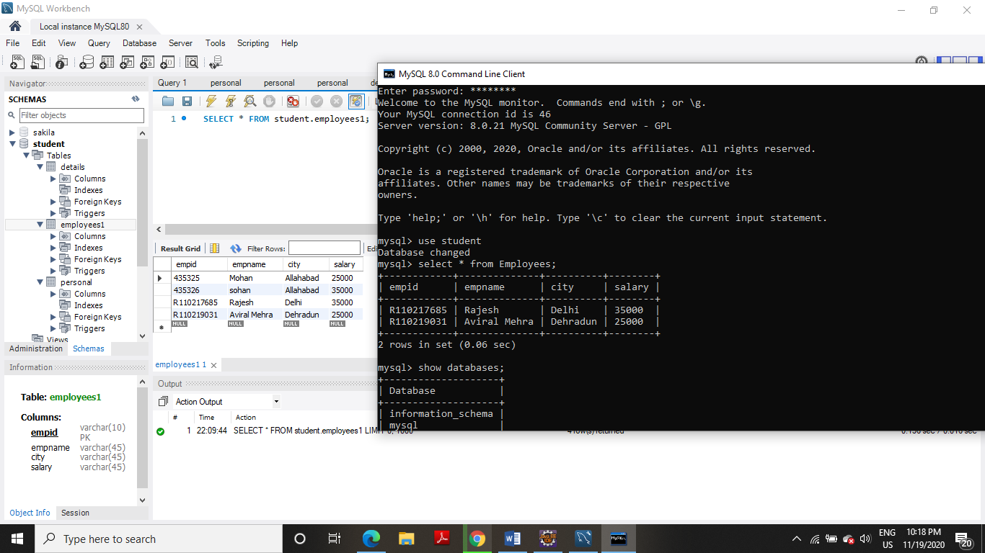

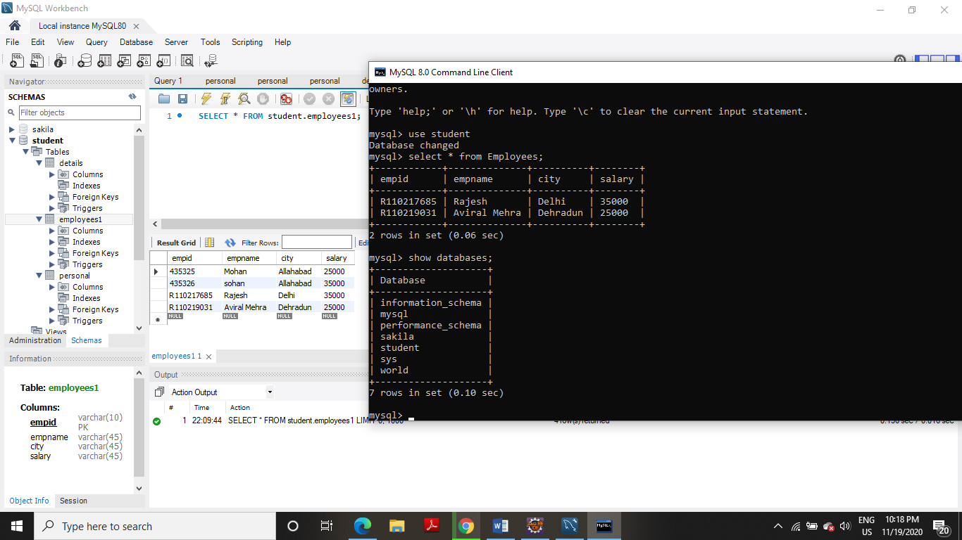

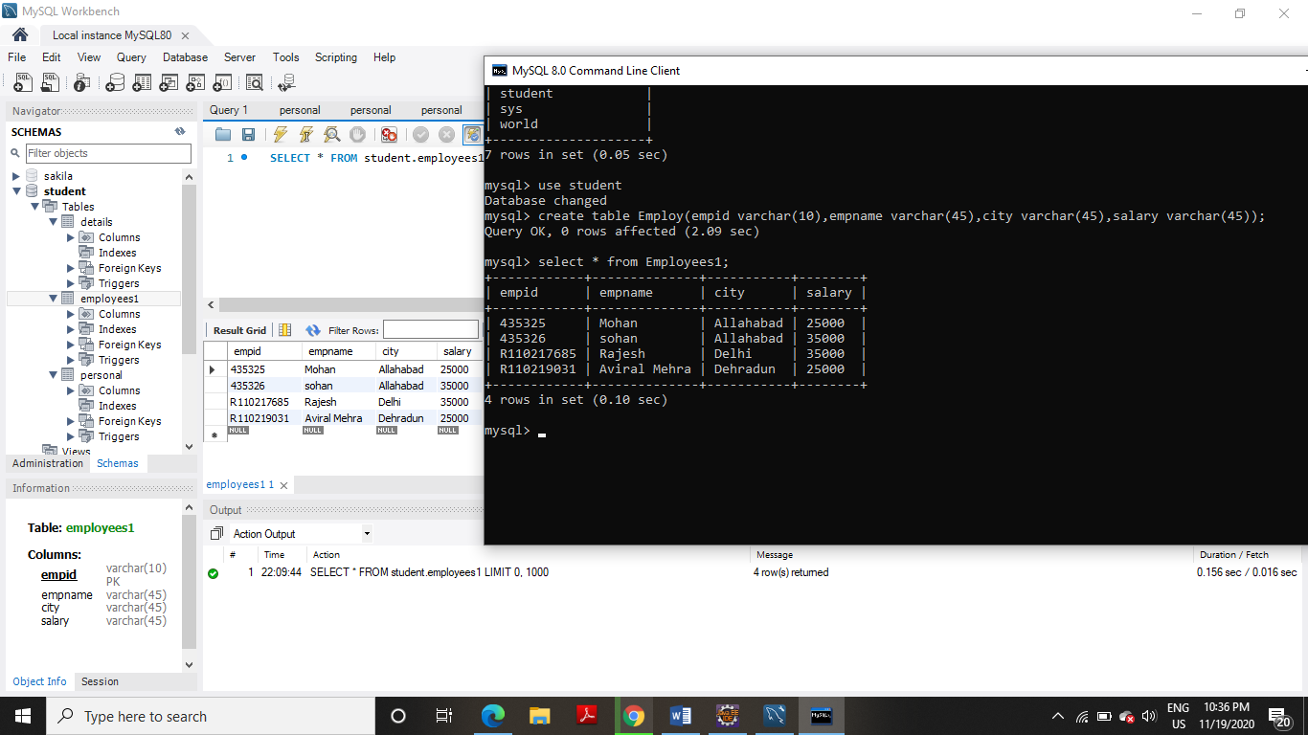

**EXPERIMENT NO-11**

**TITLE:** Servlet

**1. Servlet: a) ServletContext interface b)getParameterValues( ) of Servlet Request.**

**(a)**

**CODE:**

**SERVLET**

**import** java.io.*;

**import** javax.servlet.*;

**import** javax.servlet.http.*;

**public** **class** Scontext **extends** HttpServlet{

**public** **void** doGet(HttpServletRequest req,HttpServletResponse res)

**throws** ServletException,IOException

{

res.setContentType("text/html");

PrintWriter pw=res.getWriter();

//creating ServletContext object

ServletContext context=getServletContext();

//Getting the value of the initialization parameter and printing it

String driverName=context.getInitParameter("dname");

pw.println("Name of student is: "+driverName);

pw.close();

}}

**Web.xml**

<?xml version=*"1.0"* encoding=*"UTF-8"*?>

<web-app xmlns:xsi=*"http://www.w3.org/2001/XMLSchema-instance"* xmlns=*"http://java.sun.com/xml/ns/javaee"* xsi:schemaLocation=*"http://java.sun.com/xml/ns/javaee http://java.sun.com/xml/ns/javaee/web-app_3_0.xsd"* id=*"WebApp_ID"* version=*"3.0"*>

<display-name>avi</display-name>

<welcome-file-list>

<welcome-file>index.html</welcome-file>

<welcome-file>index.htm</welcome-file>

<welcome-file>index.jsp</welcome-file>

<welcome-file>default.html</welcome-file>

<welcome-file>default.htm</welcome-file>

<welcome-file>default.jsp</welcome-file>

</welcome-file-list>

<servlet>

<servlet-name>Scontext</servlet-name>

<servlet-class>Scontext</servlet-class>

</servlet>

<context-param>

<param-name>dname</param-name>

<param-value>Aviral Mehra</param-value>

</context-param>

<servlet-mapping>

<servlet-name>Scontext</servlet-name>

<url-pattern>/Scontext</url-pattern>

</servlet-mapping>

</web-app>

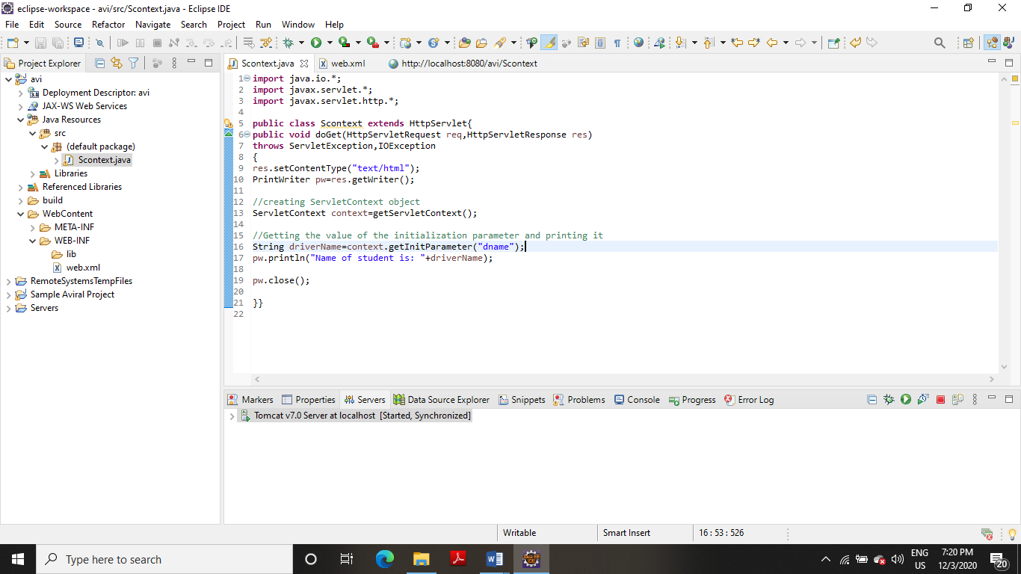

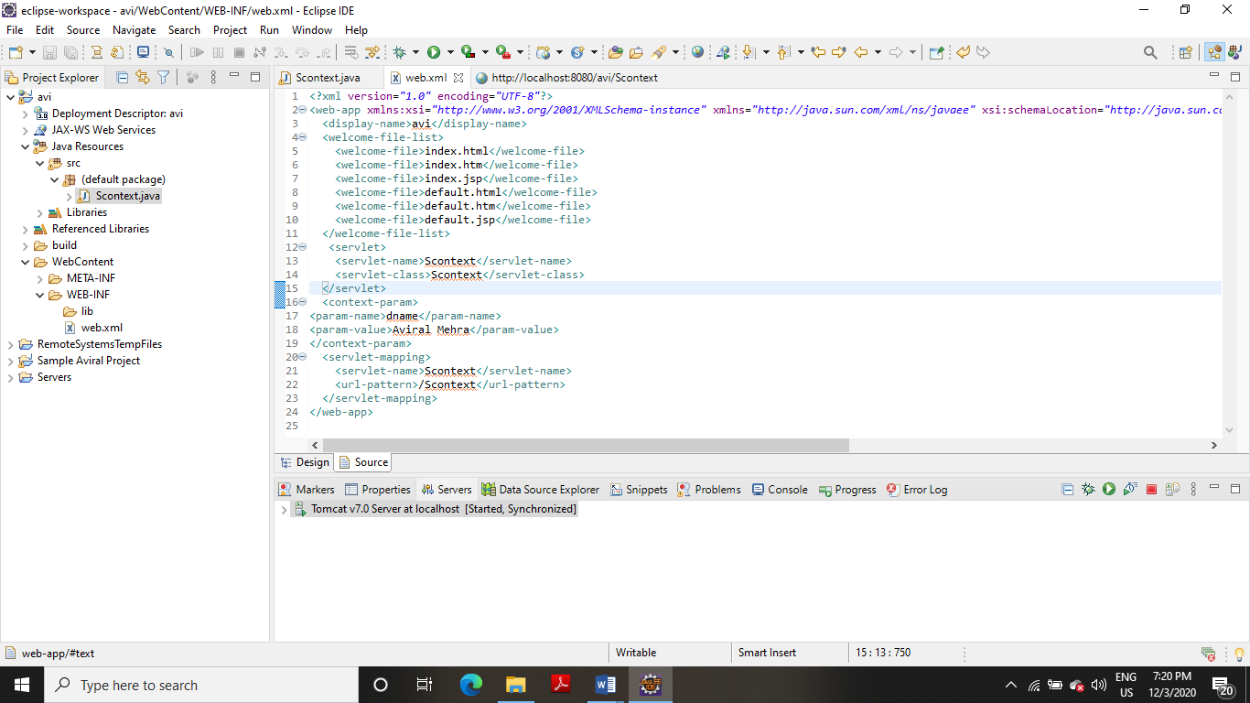

**OUTPUT**

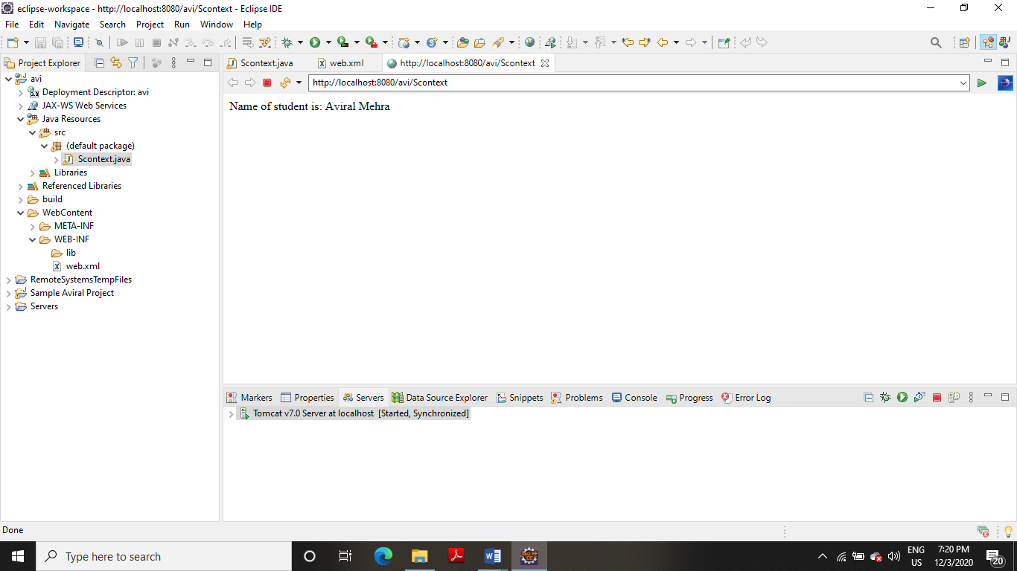

**(b)**

**CODE:**

**SERVLET**

**import** javax.servlet.http.*;

**import** javax.servlet.*;

**import** java.io.*;

**public** **class** Scontext **extends** HttpServlet

{

**public** **void** doGet(HttpServletRequest req,HttpServletResponse res)

**throws** ServletException,IOException

{

res.setContentType("text/html");

PrintWriter pwriter=res.getWriter();

String name = req.getParameter("uname");

String age = req.getParameter("uage");

pwriter.println("Name: "+name);

pwriter.println("Age: "+age);

pwriter.close();

}

}

**Web.xml**

<?xml version=*"1.0"* encoding=*"UTF-8"*?>

<web-app xmlns:xsi=*"http://www.w3.org/2001/XMLSchema-instance"* xmlns=*"http://java.sun.com/xml/ns/javaee"* xsi:schemaLocation=*"http://java.sun.com/xml/ns/javaee http://java.sun.com/xml/ns/javaee/web-app_3_0.xsd"* id=*"WebApp_ID"* version=*"3.0"*>

<display-name>avi</display-name>

<welcome-file-list>

<welcome-file>index.html</welcome-file>

<welcome-file>index.htm</welcome-file>

<welcome-file>index.jsp</welcome-file>

<welcome-file>default.html</welcome-file>

<welcome-file>default.htm</welcome-file>

<welcome-file>default.jsp</welcome-file>

</welcome-file-list>

<servlet>

<servlet-name>BeginnersBook</servlet-name>

<servlet-class>Scontext</servlet-class>

</servlet>

<servlet-mapping>

<servlet-name>BeginnersBook</servlet-name>

<url-pattern>/details</url-pattern>

</servlet-mapping>

</web-app>

**Index.html**

<!DOCTYPE html>

<html>

<head>

<meta charset=*"ISO-8859-1"*>

<title>Insert title here</title>

</head>

<body>

<form action=*"details"* method=*"get"*>

User Name: <input type=*"text"* name=*"uname"*><br>

User Age: <input type=*"text"* name=*"uage"*><br>

<input type=*"submit"* value=*"submit"*>

</form>

</body>

</html>

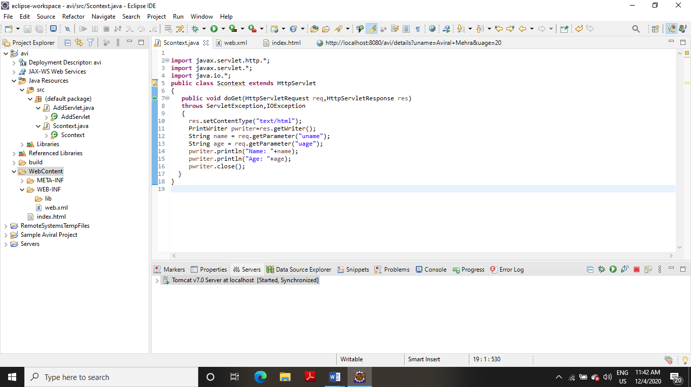

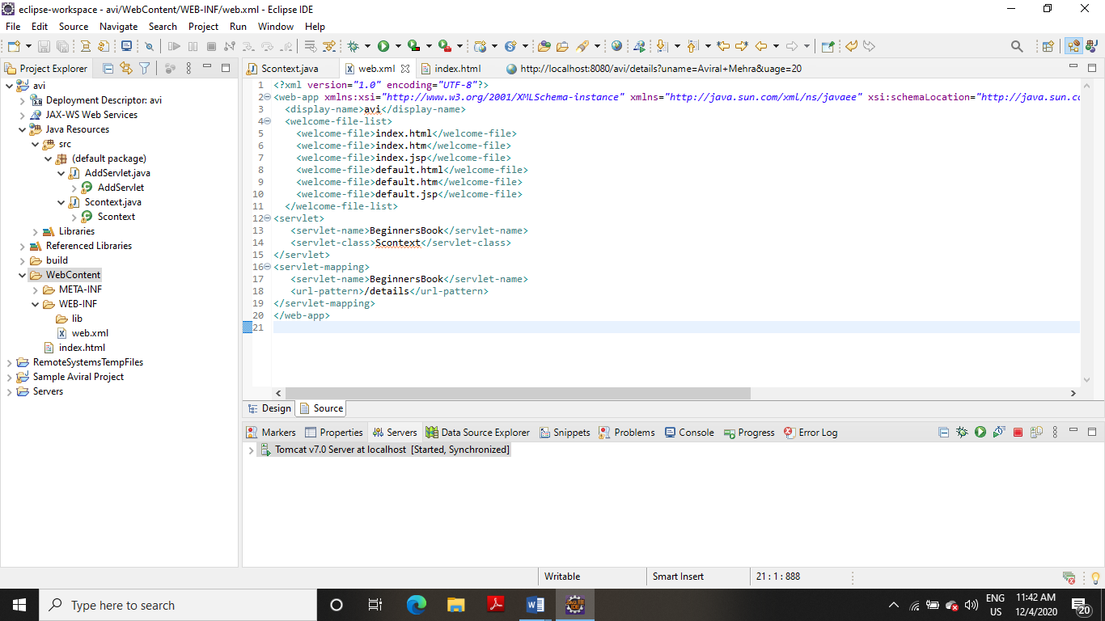

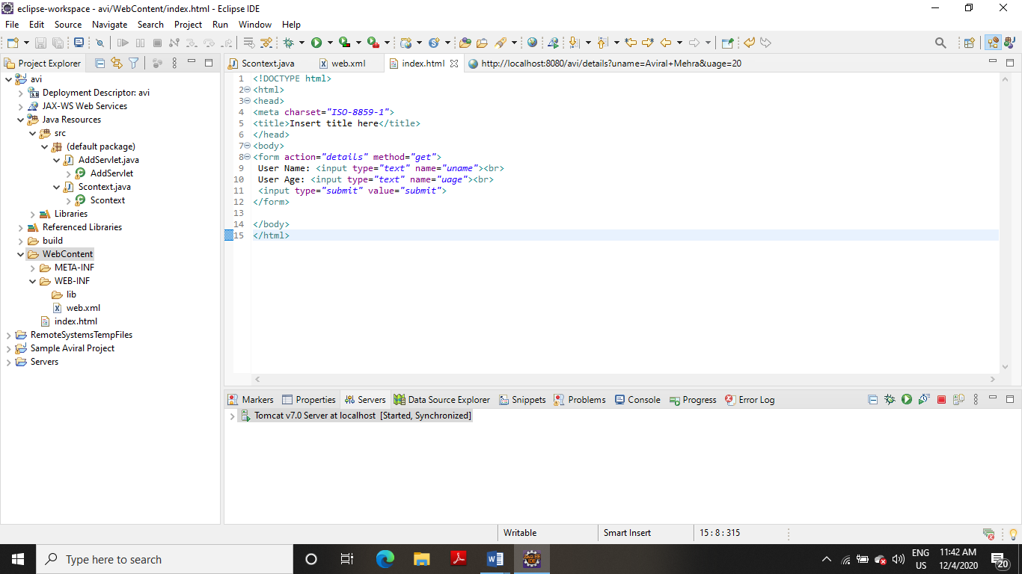

**OUTPUT**

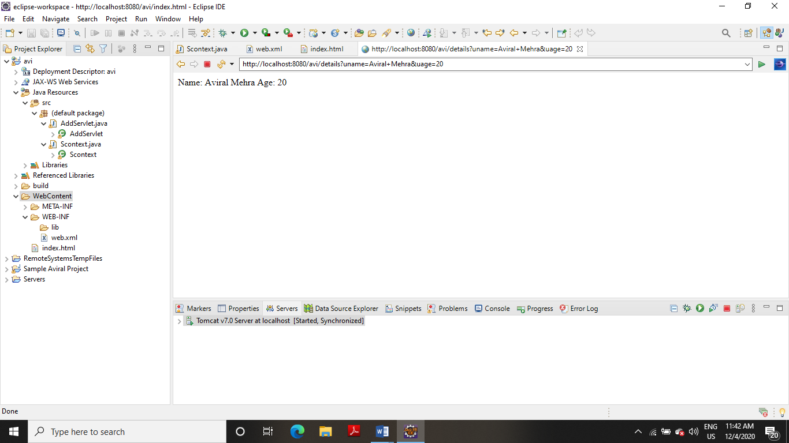

**2. Write a Servlet page to display current date of the server.**

**CODE:**

**SERVLET**

**import** java.io.*;

**import** javax.servlet.*;

**public** **class** Date1 **extends** GenericServlet{

**public** **void** service(ServletRequest req, ServletResponse res)

**throws** IOException, ServletException

{

res.setContentType("text/html");

PrintWriter pw = res.getWriter();

java.util.Date date = **new** java.util.Date();

pw.println("Current Date " +date.toString());

pw.close();

}

}

**Web.xml**

<?xml version=*"1.0"* encoding=*"UTF-8"*?>

<web-app xmlns:xsi=*"http://www.w3.org/2001/XMLSchema-instance"* xmlns=*"http://java.sun.com/xml/ns/javaee"* xsi:schemaLocation=*"http://java.sun.com/xml/ns/javaee http://java.sun.com/xml/ns/javaee/web-app_3_0.xsd"* id=*"WebApp_ID"* version=*"3.0"*>

<display-name>avi</display-name>

<welcome-file-list>

<welcome-file>index.html</welcome-file>

<welcome-file>index.htm</welcome-file>

<welcome-file>index.jsp</welcome-file>

<welcome-file>default.html</welcome-file>

<welcome-file>default.htm</welcome-file>

<welcome-file>default.jsp</welcome-file>

</welcome-file-list>

<servlet>

<servlet-name>Date1</servlet-name>

<servlet-class>Date1</servlet-class>

</servlet>

<servlet-mapping>

<servlet-name>Date1</servlet-name>

<url-pattern>/Date1</url-pattern>

</servlet-mapping>

</web-app>

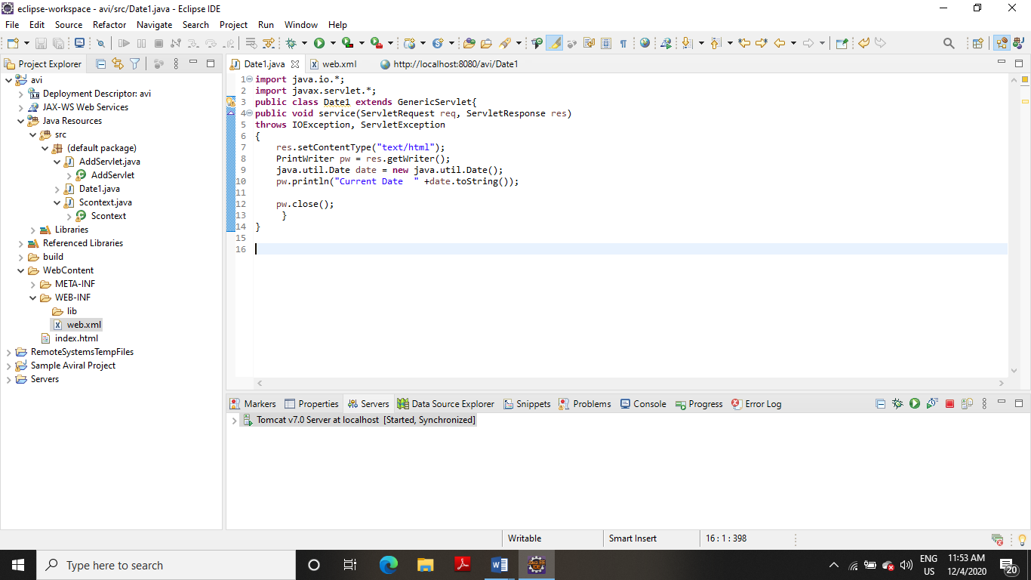

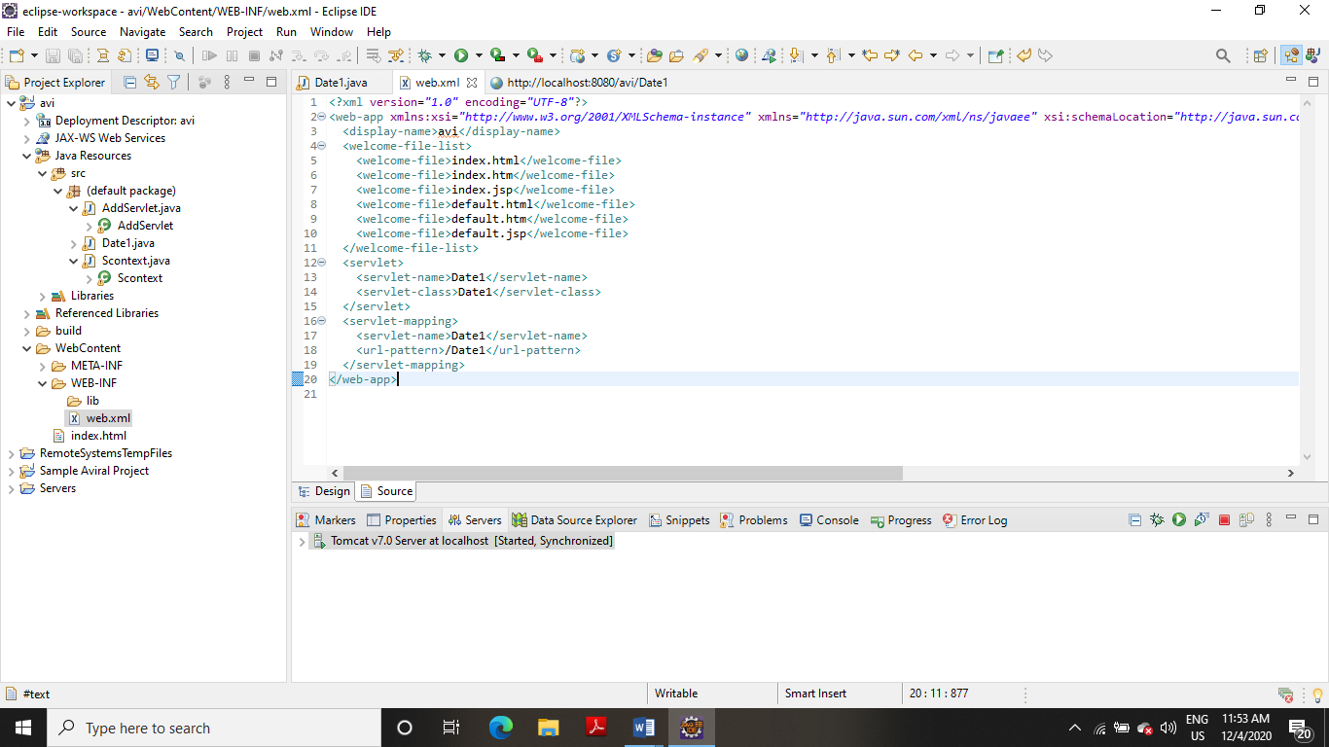

**OUTPUT**

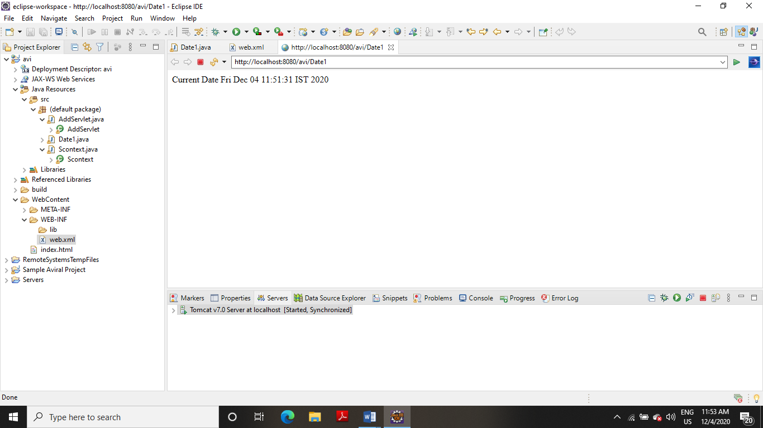

**3. Write a Servlet page to which include the two other Servlet page through of include directives feature provided in Servlet.**

**CODE:**

**SERVLET**

**first.jsp**

<%@ page language=*"java"* contentType=*"text/html; charset=ISO-8859-1"*

pageEncoding=*"ISO-8859-1"*%>

<!DOCTYPE html PUBLIC "-//W3C//DTD HTML 4.01 Transitional//EN" "http://www.w3.org/TR/html4/loose.dtd">

<html>

<head>

<meta http-equiv=*"Content-Type"* content=*"text/html; charset=ISO-8859-1"*>

<title>Insert title here</title>

</head>

<body>

<p align=*"center"*>

This is my first file of jsp.

</p>

</body>

</html>

**Second.jsp**

<%@ page language=*"java"* contentType=*"text/html; charset=ISO-8859-1"*

pageEncoding=*"ISO-8859-1"*%>

<!DOCTYPE html PUBLIC "-//W3C//DTD HTML 4.01 Transitional//EN" "http://www.w3.org/TR/html4/loose.dtd">

<html>

<head>

<meta http-equiv=*"Content-Type"* content=*"text/html; charset=ISO-8859-1"*>

<title>Insert title here</title>

</head>

<body>

<p align=*"center"*>

This is my second file of jsp.

</p>

</body>

</html>

**Final.jsp**

<%@ page language=*"java"* contentType=*"text/html; charset=ISO-8859-1"*

pageEncoding=*"ISO-8859-1"*%>

<!DOCTYPE html PUBLIC "-//W3C//DTD HTML 4.01 Transitional//EN" "http://www.w3.org/TR/html4/loose.dtd">

<html>

<head>

<meta http-equiv=*"Content-Type"* content=*"text/html; charset=ISO-8859-1"*>

<title>Insert title here</title>

</head>

<body>

<%@ include file=*"first.jsp"* %>

<h3>joining two jsp file </h3>

<%@ include file=*"second.jsp"* %>

</body>

</html>

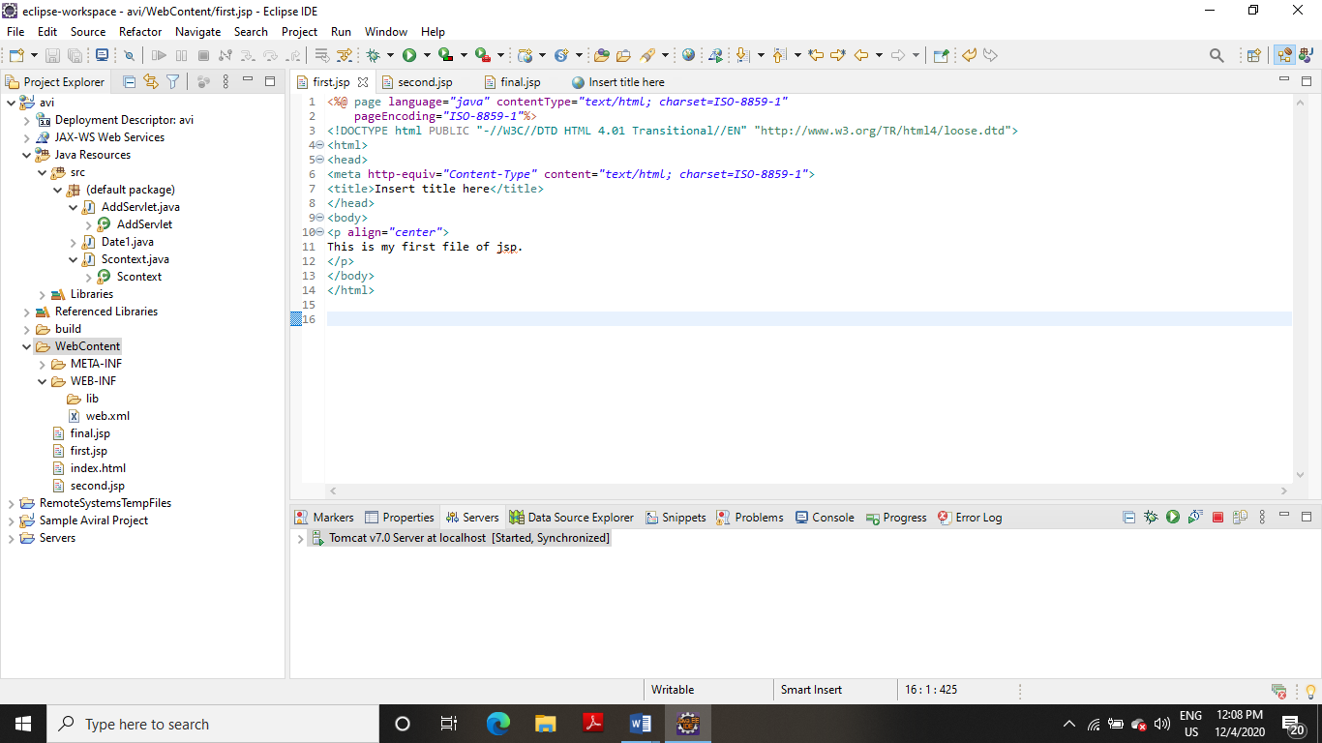

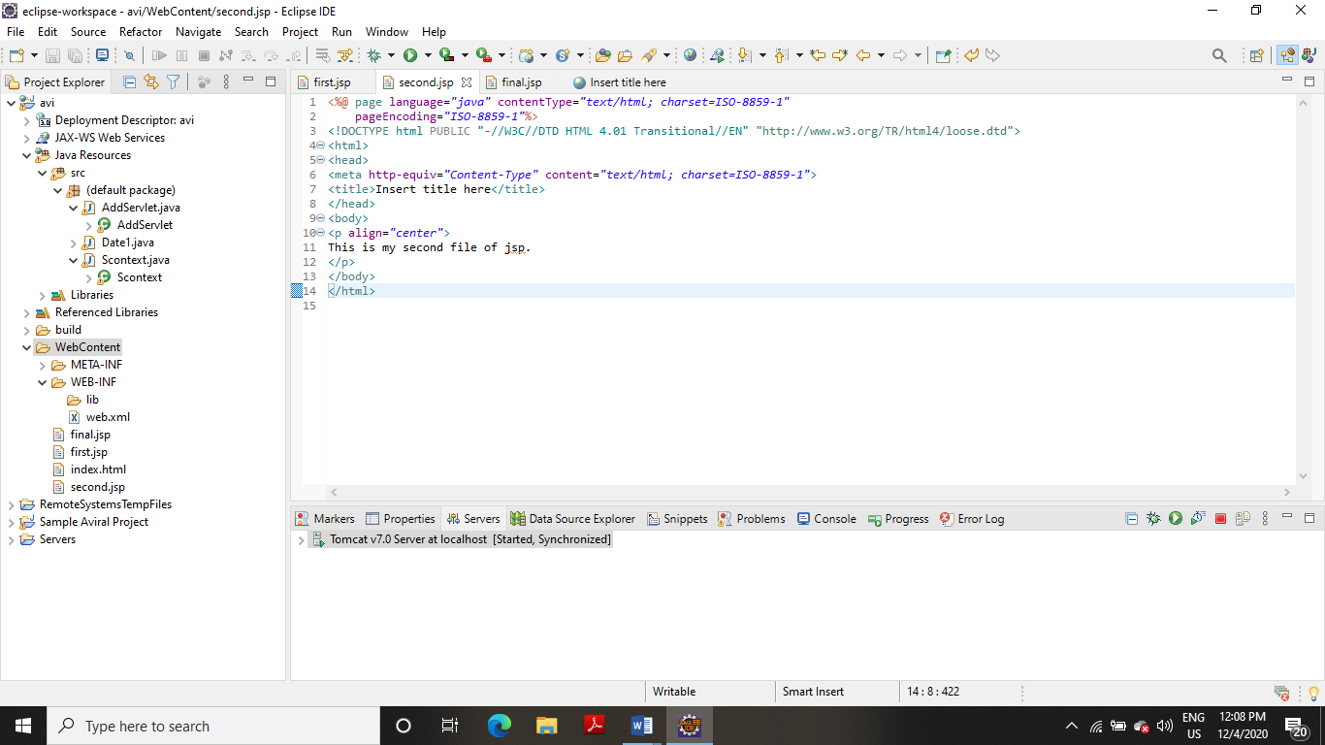

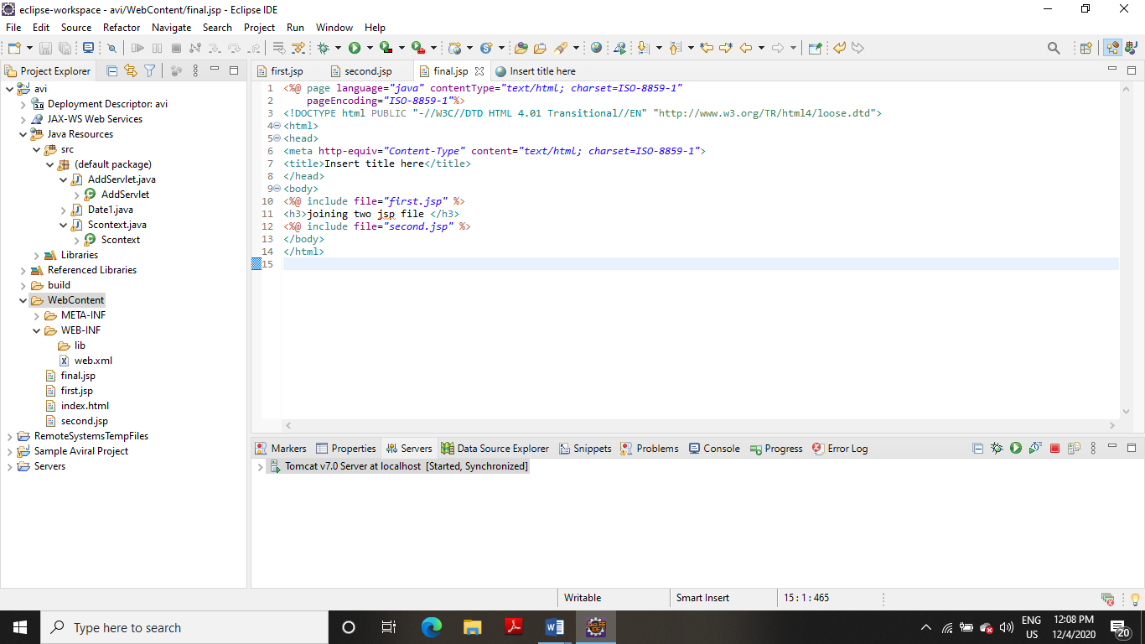

**OUTPUT**

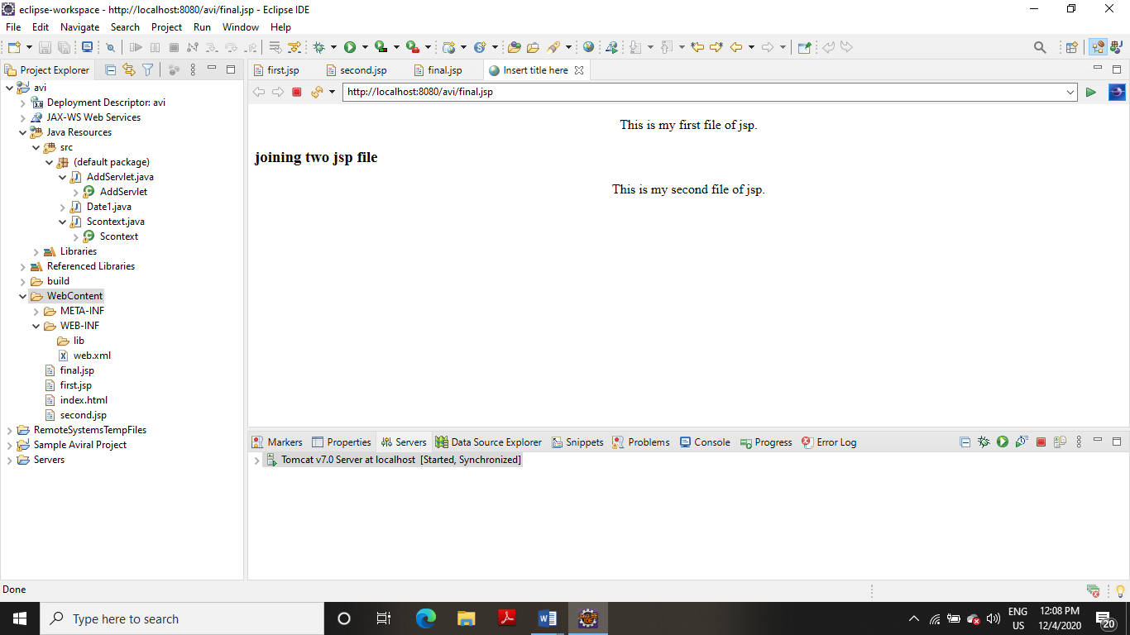

**4. Write a Servlet page to create a simple calculator.**

**CODE**

**SERVLET**

**import** java.io.*;

**import** javax.servlet.ServletException;

**import** javax.servlet.http.HttpServlet;

**import** javax.servlet.http.HttpServletRequest;

**import** javax.servlet.http.HttpServletResponse;

**public** **class** Calculator **extends** HttpServlet

{

**protected** **void** processRequest(HttpServletRequest request, HttpServletResponse response)

**throws** ServletException, IOException {

response.setContentType("text/html;charset=UTF-8");

}

**protected** **void** doGet(HttpServletRequest request, HttpServletResponse response)

**throws** ServletException, IOException

{

PrintWriter out = response.getWriter();

String n1 = request.getParameter("txt1");

String n2 = request.getParameter("txt2");

String op = request.getParameter("op");

**switch** (op)

{

**case** "Addition":

out.println("Answer = "+(Integer.*parseInt*(n1) + Integer.*parseInt*(n2)));

**break**;

**case** "Subtraction":

out.println("Answer = "+(Integer.*parseInt*(n1) - Integer.*parseInt*(n2)));

**break**;

**case** "multiplication":

out.println("Answer = "+(Integer.*parseInt*(n1) * Integer.*parseInt*(n2)));

**break**;

**default**:

out.println("Answer = "+(Integer.*parseInt*(n1) / Integer.*parseInt*(n2)));

**break**;

}

}

}

**Web.xml**

<?xml version=*"1.0"* encoding=*"UTF-8"*?>

<web-app xmlns:xsi=*"http://www.w3.org/2001/XMLSchema-instance"* xmlns=*"http://java.sun.com/xml/ns/javaee"* xsi:schemaLocation=*"http://java.sun.com/xml/ns/javaee http://java.sun.com/xml/ns/javaee/web-app_3_0.xsd"* id=*"WebApp_ID"* version=*"3.0"*>

<display-name>avi</display-name>

<welcome-file-list>

<welcome-file>index.html</welcome-file>

<welcome-file>index.htm</welcome-file>

<welcome-file>index.jsp</welcome-file>

<welcome-file>default.html</welcome-file>

<welcome-file>default.htm</welcome-file>

<welcome-file>default.jsp</welcome-file>

</welcome-file-list>

<servlet>

<servlet-name>Calculator</servlet-name>

<servlet-class>Calculator</servlet-class>

</servlet>

<servlet-mapping>

<servlet-name>Calculator</servlet-name>

<url-pattern>/Calculator</url-pattern>

</servlet-mapping>

<welcome-file-list>

<welcome-file>index.html</welcome-file>

</welcome-file-list>

</web-app>

**Index.html**

<!DOCTYPE html>

<html>

<head>

<meta charset=*"ISO-8859-1"*>

<title>Insert title here</title>

</head>

<body>

<form action=*"Calculator"* method=*"get"* name=*"frm"*>

Enter num1:

<input name=*"txt1"* type=*"text"* /></br></br>

Enter num2:

<input name=*"txt2"* type=*"text"* /></br></br>

Operator

<select name=*"op"*>

<option value=*"Addition"*>Addition</option>

<option value=*"Subtraction"*>Subtraction</option>

<option value=*"multiplication"*>multiplication</option>

<option value=*"division"*>division</option>

</select>

<input type=*"submit"* value=*"submit"* />

</form>

</body>

</html>

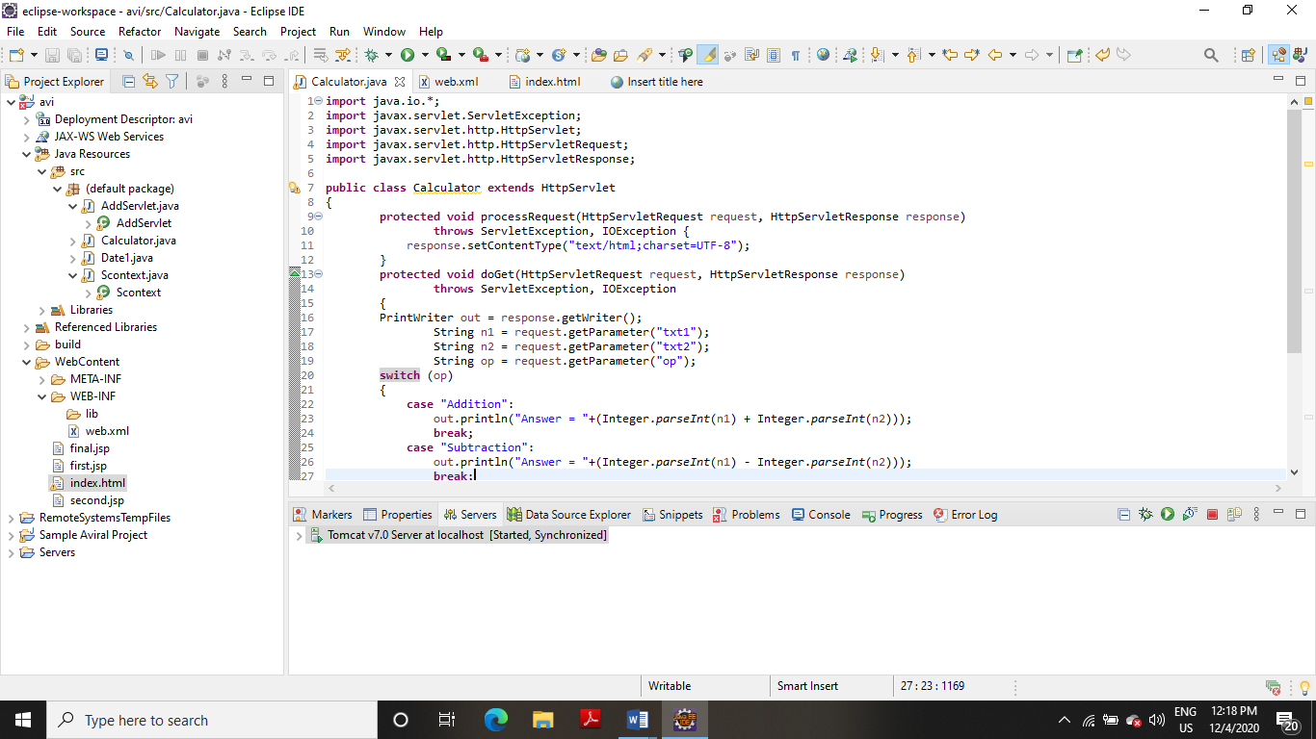

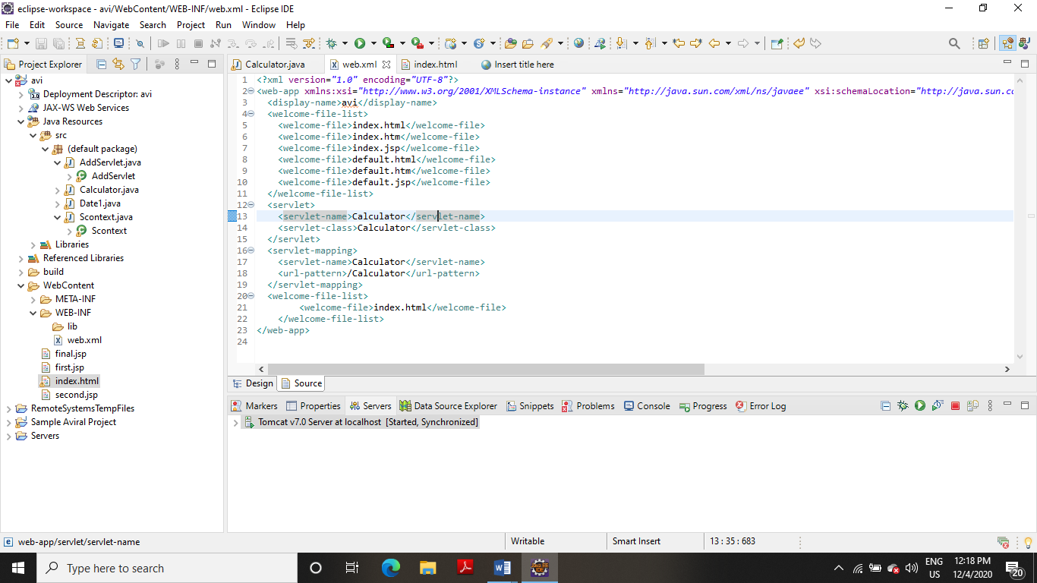

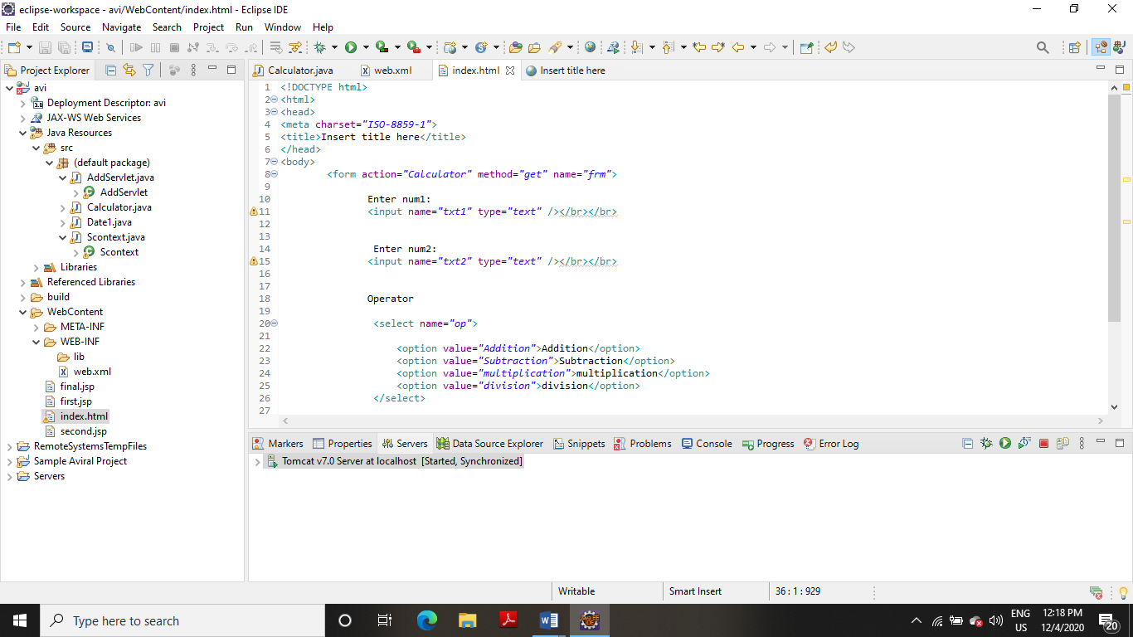

**OUTPUT:**

**(a) Addition**

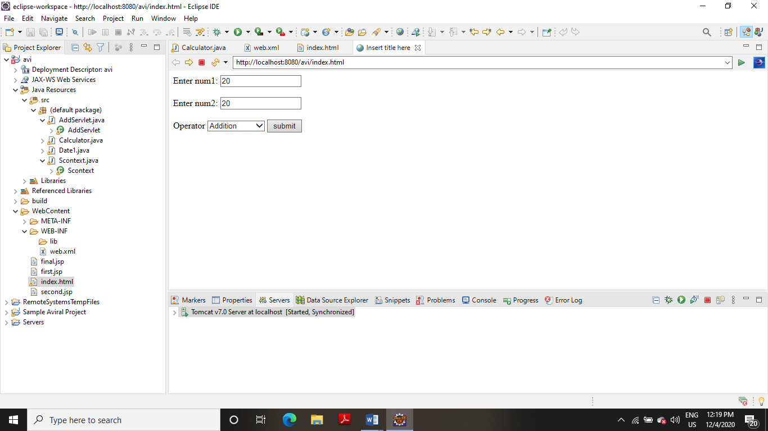

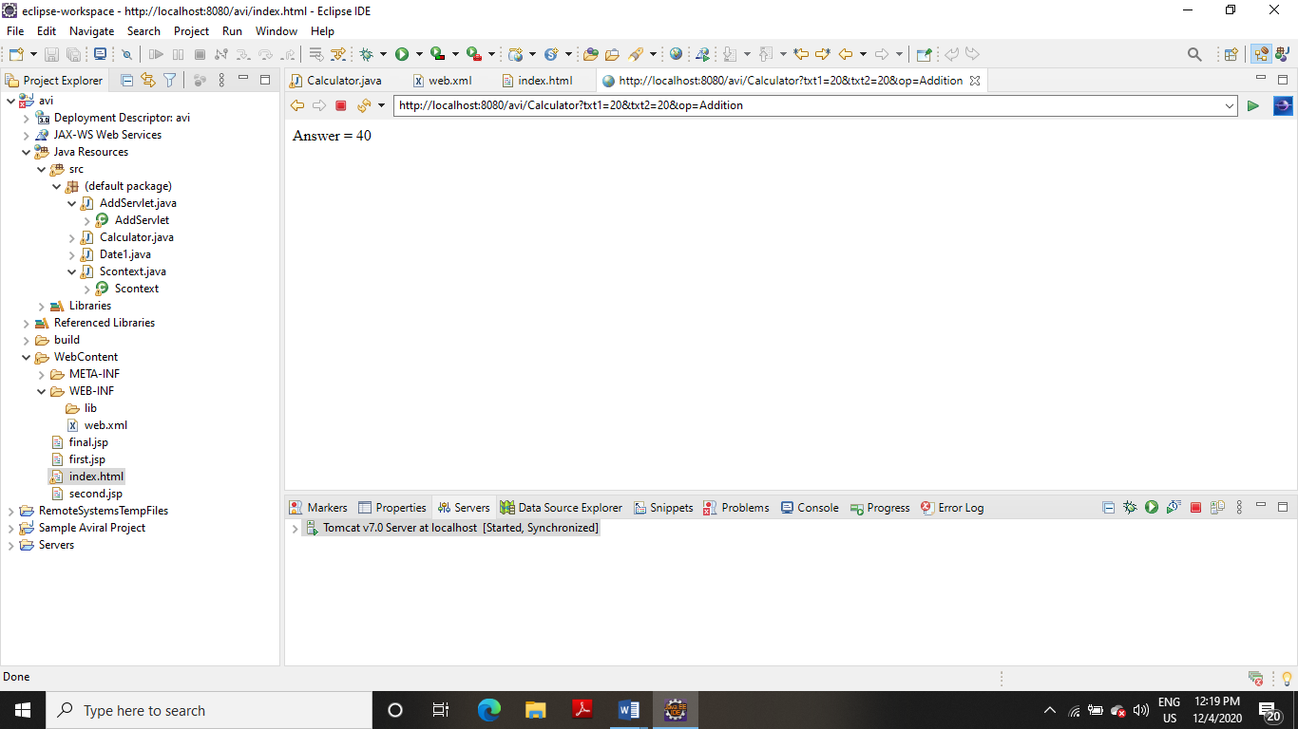

**(b) Subtraction**

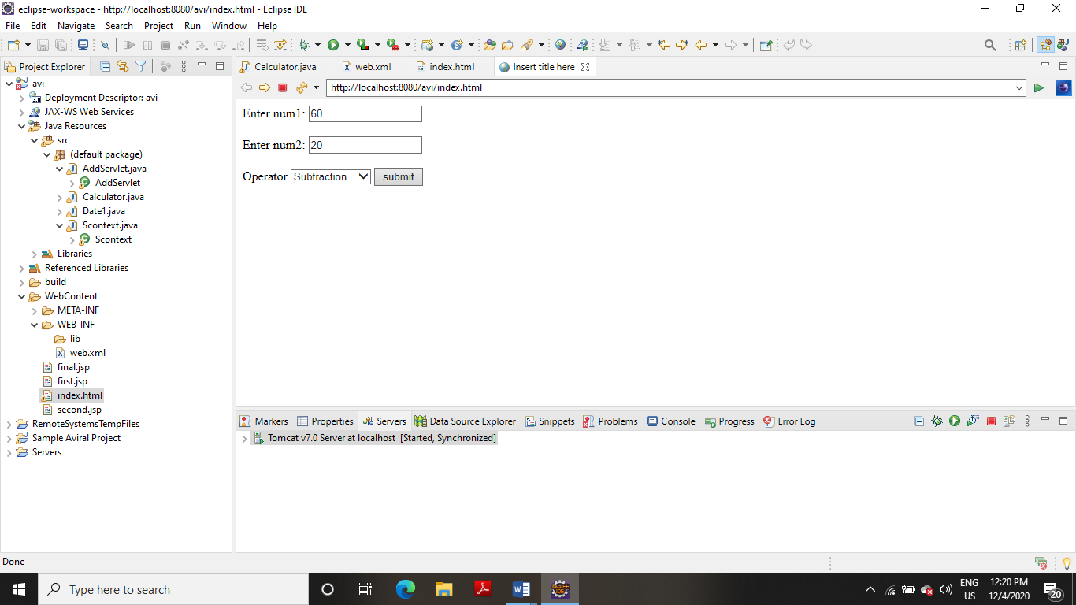

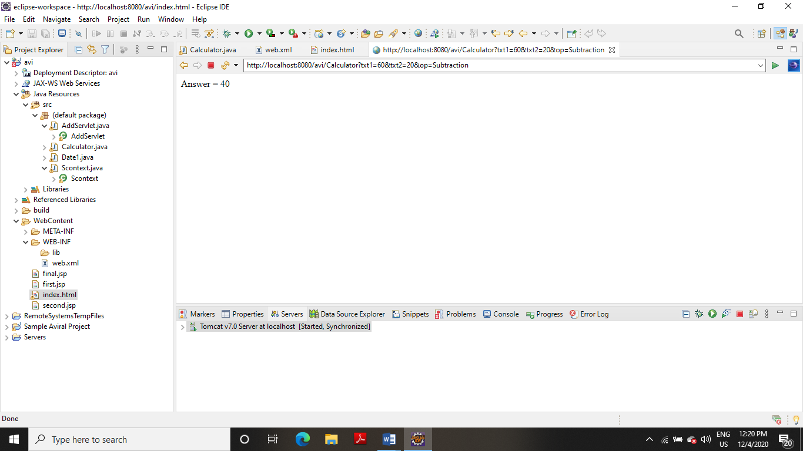

**(c) Multiplication**

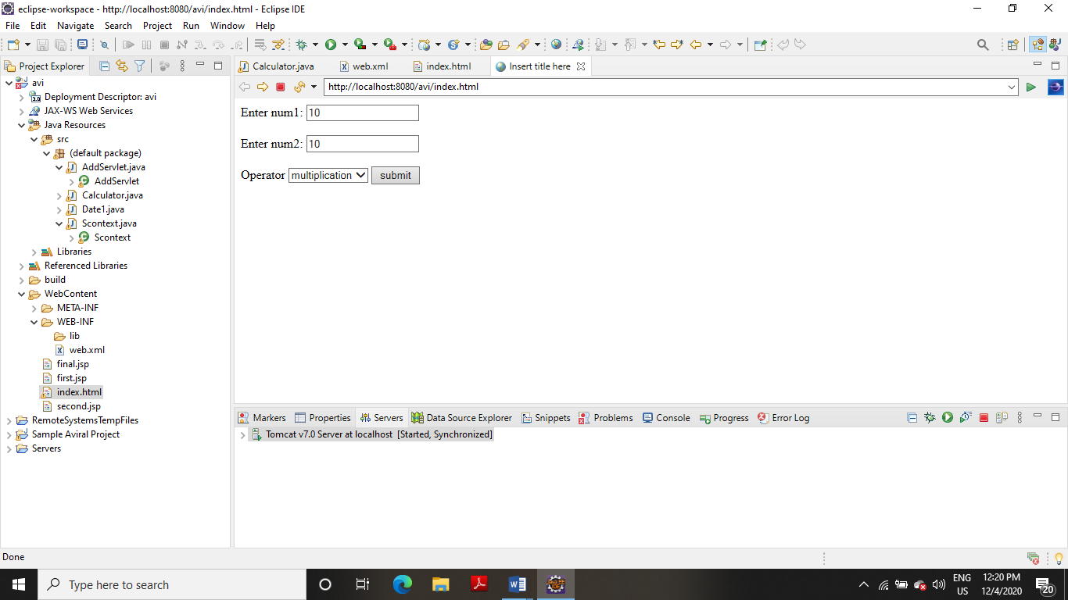

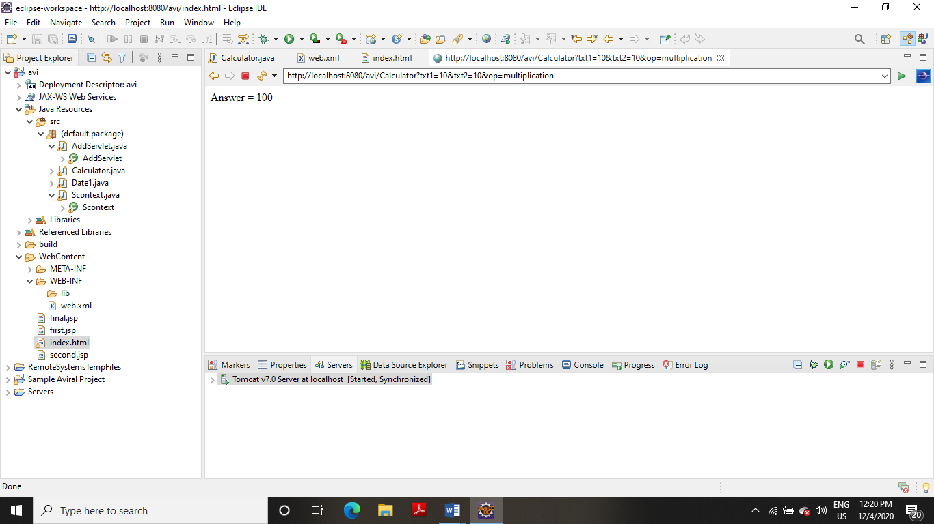

**(d) Division**

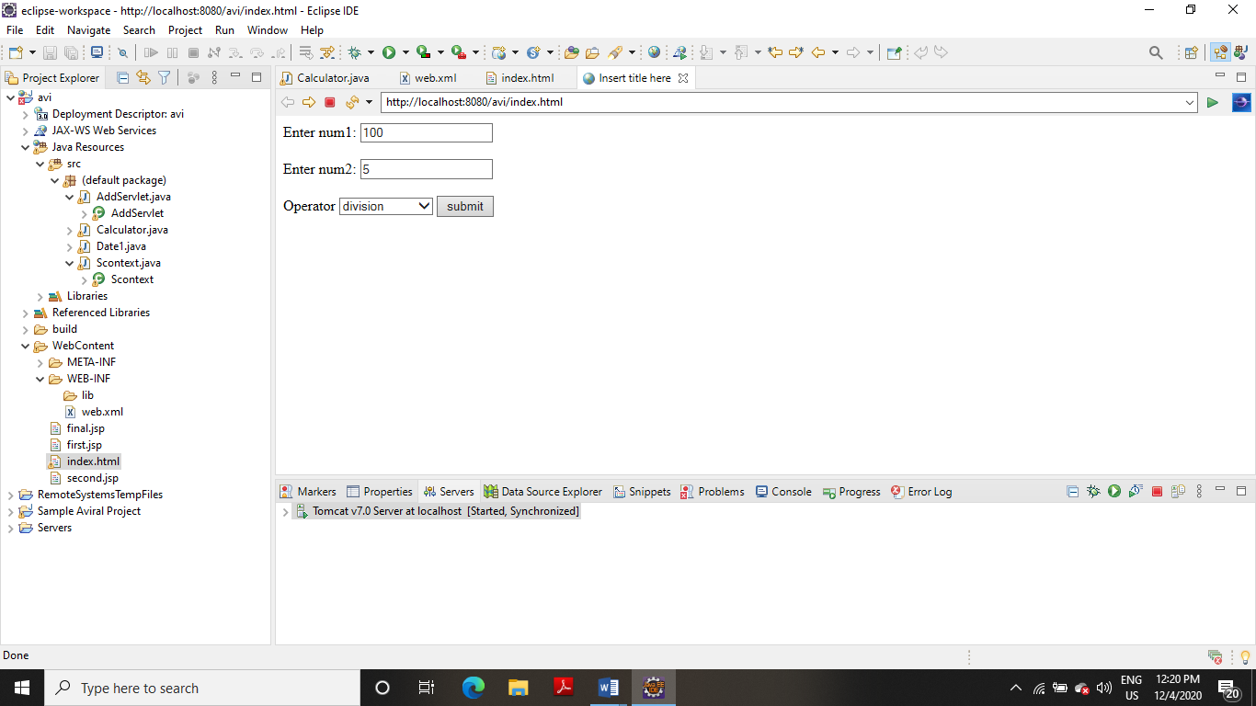

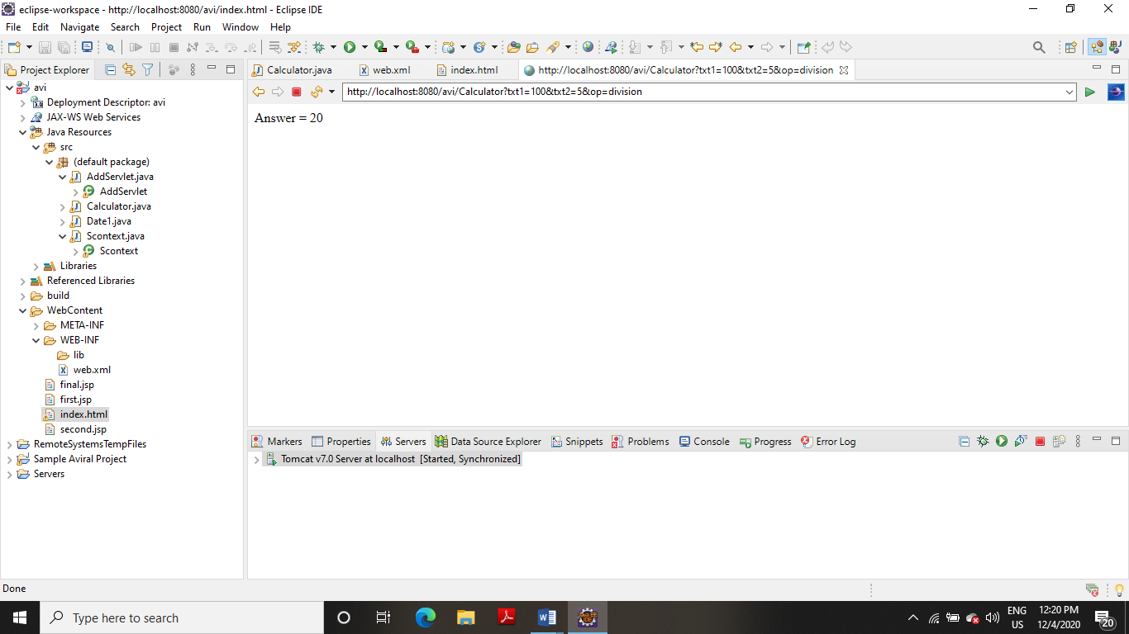

**EXPERIMENT NO-12**

**TITLE:** JSP

**1. Write a JSP page to access the data of a student from the student table**.

**CODE**

<%@ page import = *"java.io.*,java.util.*,java.sql.*"*%>

<%@ page import = *"javax.servlet.http.*,javax.servlet.*"* %>

<%@ taglib uri=*"http://java.sun.com/jsp/jstl/core"* prefix = *"c"*%>

<%@ taglib uri=*"http://java.sun.com/jsp/jstl/sql"* prefix = *"sql"*%>

<%@page import=*"java.sql.DriverManager"*%>

<%@page import=*"java.sql.ResultSet"*%>

<%@page import=*"java.sql.Statement"*%>

<%@page import=*"java.sql.Connection"*%>

<%

String id = request.getParameter("userid");

String driver = "com.mysql.jdbc.Driver";

String connectionUrl = "jdbc:mysql://127.0.0.1:3306/student";

String database = "student";

String userid = "root";

String password = "aviral08";

**try**

{

Class.forName("com.mysql.jdbc.Driver");

} **catch** (ClassNotFoundException e)

{

e.printStackTrace();

}

Connection connection = **null**;

Statement statement = **null**;

ResultSet resultSet = **null**;

%>

<!DOCTYPE html>

<html>

<body>

<h1>Retrieve data from database in jsp</h1>

<table border=*"1"*>

<tr>

<td>ID</td>

<td>AGE</td>

<td>First Name</td>

<td>Last Name</td>

</tr>

<%

**try**

{

connection = DriverManager.getConnection(connectionUrl,userid,password);

statement=connection.createStatement();

String sql ="SELECT * FROM avi";

resultSet = statement.executeQuery(sql);

**while**(resultSet.next())

{

%>

<tr>

<td><%=resultSet.getString("id") %></td>

<td><%=resultSet.getString("age") %></td>

<td><%=resultSet.getString("first") %></td>

<td><%=resultSet.getString("last") %></td>

</tr>

<%

}

connection.close();

} **catch** (Exception e)

{

e.printStackTrace();

}

%>

</table>

</body>

</html>

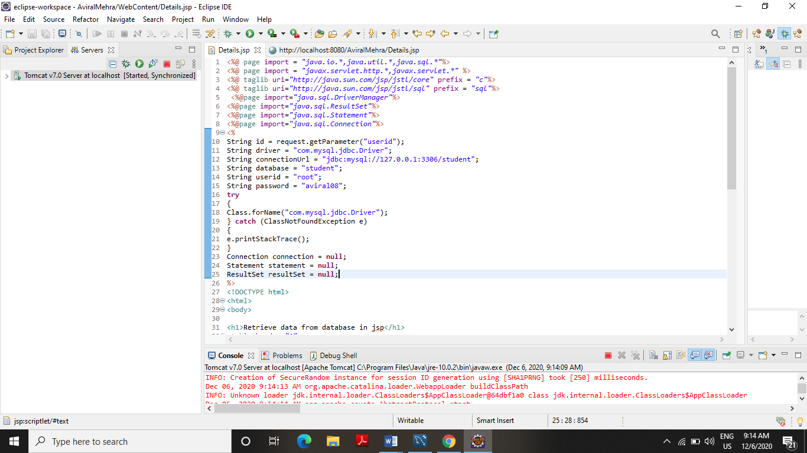

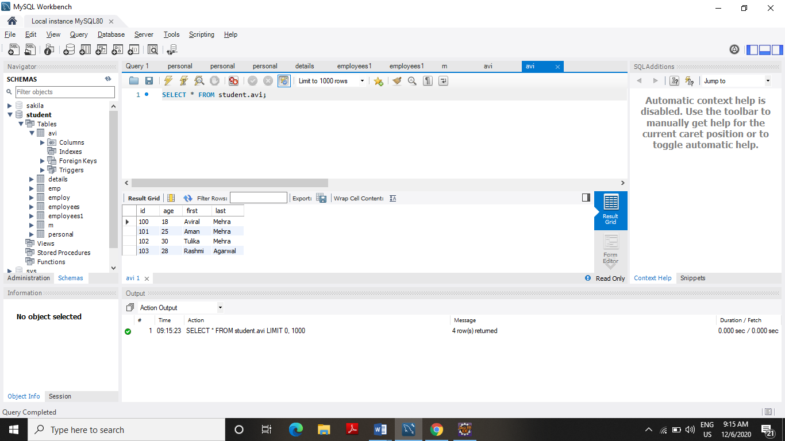

**OUTPUT**

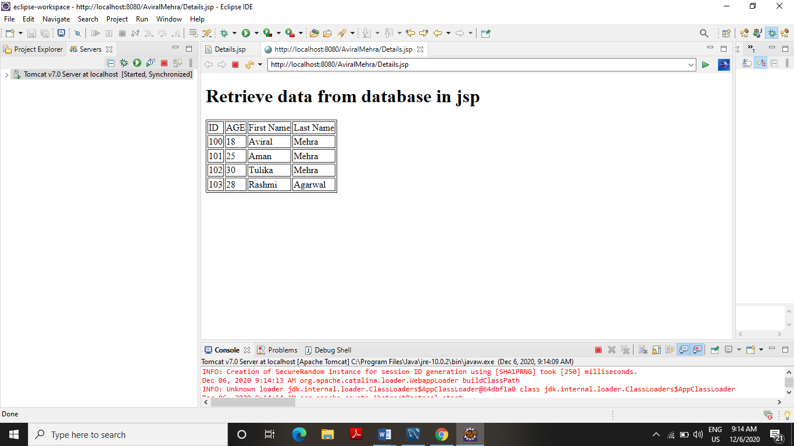

**2. Write a JSP Login page to enter the username and password entered by user and display the welcome page on successful login otherwise display wrong authentication page.**

**CODE**

**Register_1.jsp**

<%@ page language=*"java"* contentType=*"text/html; charset=ISO-8859-1"*

pageEncoding=*"ISO-8859-1"*%>

<!DOCTYPE html PUBLIC "-//W3C//DTD HTML 4.01 Transitional//EN" "http://www.w3.org/TR/html4/loose.dtd">

<html>

<head>

<meta http-equiv=*"Content-Type"* content=*"text/html; charset=ISO-8859-1"*>

<title>Registration Form</title>

</head>

<body>

<h1>Registration Form</h1>

<form action=*"register"* method=*"post"*>

<table style="with: *50%*">

<tr>

<td>First Name</td>

<td><input type=*"text"* name=*"first_name"* /></td>

</tr>

<tr>

<td>Last Name</td>

<td><input type=*"text"* name=*"last_name"* /></td>

</tr>

<tr>

<td>UserName</td>

<td><input type=*"text"* name=*"username"* /></td>

</tr>

<tr>

<td>Password</td>

<td><input type=*"password"* name=*"password"* /></td>

</tr>

<tr>

<td>Address</td>

<td><input type=*"text"* name=*"address"* /></td>

</tr>

<tr>

<td>Contact No</td>

<td><input type=*"text"* name=*"contact"* /></td>

</tr></table>

<input type=*"submit"* value=*"Submit"* /></form>

</body>

</html>

**Register.java**

**import** java.io.IOException;

**import** javax.servlet.RequestDispatcher;

**import** javax.servlet.ServletException;

**import** javax.servlet.http.HttpServlet;

**import** javax.servlet.http.HttpServletRequest;

**import** javax.servlet.http.HttpServletResponse;

/**

* Servlet implementation class register

*/

**public** **class** register **extends** HttpServlet

{

**private** **static** **final** **long** ***serialVersionUID*** = 1L;

**protected** **void** doPost(HttpServletRequest request, HttpServletResponse response) **throws** ServletException, IOException

{

String first_name = request.getParameter("first_name");

String last_name = request.getParameter("last_name");

String username = request.getParameter("username");

String password = request.getParameter("password");

String address = request.getParameter("address");

String contact = request.getParameter("contact");

**if**(first_name.isEmpty() || last_name.isEmpty() || username.isEmpty() ||

password.isEmpty() || address.isEmpty() || contact.isEmpty())

{

RequestDispatcher req = request.getRequestDispatcher("Register_1.jsp");

req.include(request, response);

}

**else**

{

RequestDispatcher req = request.getRequestDispatcher("Register_2.jsp");

req.forward(request, response);

}

}

}

**Register_2.jsp**

<%@ page language=*"java"* contentType=*"text/html; charset=ISO-8859-1"*

pageEncoding=*"ISO-8859-1"*%>

<!DOCTYPE html PUBLIC "-//W3C//DTD HTML 4.01 Transitional//EN" "http://www.w3.org/TR/html4/loose.dtd">

<html>

<head>

<meta http-equiv=*"Content-Type"* content=*"text/html; charset=ISO-8859-1"*>

<title>Success Page</title>

</head>

<body>

<a><b>WELCOME AVIRAL MEHRA!!!!</b></a>

</body>

</html>

**Registration_3.jsp**

<%@ page language=*"java"* contentType=*"text/html; charset=ISO-8859-1"*

pageEncoding=*"ISO-8859-1"*%>

<!DOCTYPE html PUBLIC "-//W3C//DTD HTML 4.01 Transitional//EN" "http://www.w3.org/TR/html4/loose.dtd">

<html>

<head>

<meta http-equiv=*"Content-Type"* content=*"text/html; charset=ISO-8859-1"*>

<title>LOGIN PAGE</title>

</head>

<body>

<form action=*"Login"* method=*"post"*>

<table style="with: *50%*">

<tr>

<td>UserName</td>

<td><input type=*"text"* name=*"username"* /></td>

</tr>

<tr>

<td>Password</td>

<td><input type=*"password"* name=*"password"* /></td>

</tr>

</table>

<input type=*"submit"* value=*"Login"* /></form>

</body>

</html>

**Login.java**

**import** java.io.IOException;

**import** javax.servlet.RequestDispatcher;

**import** javax.servlet.ServletException;

**import** javax.servlet.http.HttpServlet;

**import** javax.servlet.http.HttpServletRequest;

**import** javax.servlet.http.HttpServletResponse;

/**

* Servlet implementation class Login

*/

**public** **class** Login **extends** HttpServlet {

**public** Login() {

**super**();

// **TODO** Auto-generated constructor stub

}

**protected** **void** doPost(HttpServletRequest request, HttpServletResponse response) **throws** ServletException, IOException

{

// **TODO** Auto-generated method stub

String username = request.getParameter("username");

String password = request.getParameter("password");

**if**(username.isEmpty() || password.isEmpty() )

{

RequestDispatcher req = request.getRequestDispatcher("Registration_3.jsp");

req.include(request, response);

}

**else**

{

RequestDispatcher req = request.getRequestDispatcher("Register_4.jsp");

req.forward(request, response);

}

}

}

**Register_4.jsp**

<%@ page language=*"java"* contentType=*"text/html; charset=ISO-8859-1"*

pageEncoding=*"ISO-8859-1"*%>

<!DOCTYPE html PUBLIC "-//W3C//DTD HTML 4.01 Transitional//EN" "http://www.w3.org/TR/html4/loose.dtd">

<html>

<head>

<meta http-equiv=*"Content-Type"* content=*"text/html; charset=ISO-8859-1"*>

<title>Aviral Mehra Logged In</title>

</head>

<body>

<table style="with: *50%*">

<tr><td>

<% String username = request.getParameter("username"); %>

<a>Welcome <% out.println(username); %> User!!!! You have logged in.</a></td></tr>

<tr></tr><tr><td></td><td></td><td><a href=*"Registration_3.jsp"*><b>Logout</b></a></td></tr>

</table>

</body>

</html>

**OUTPUT**

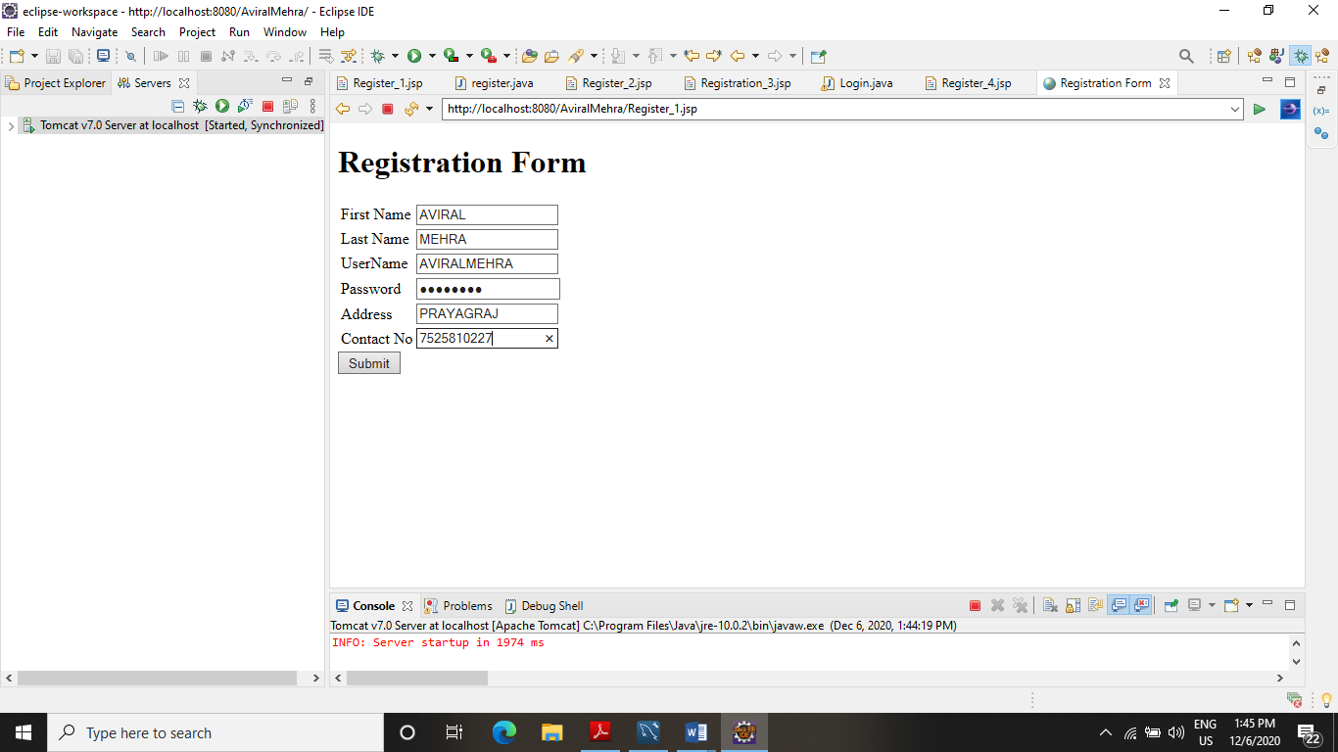

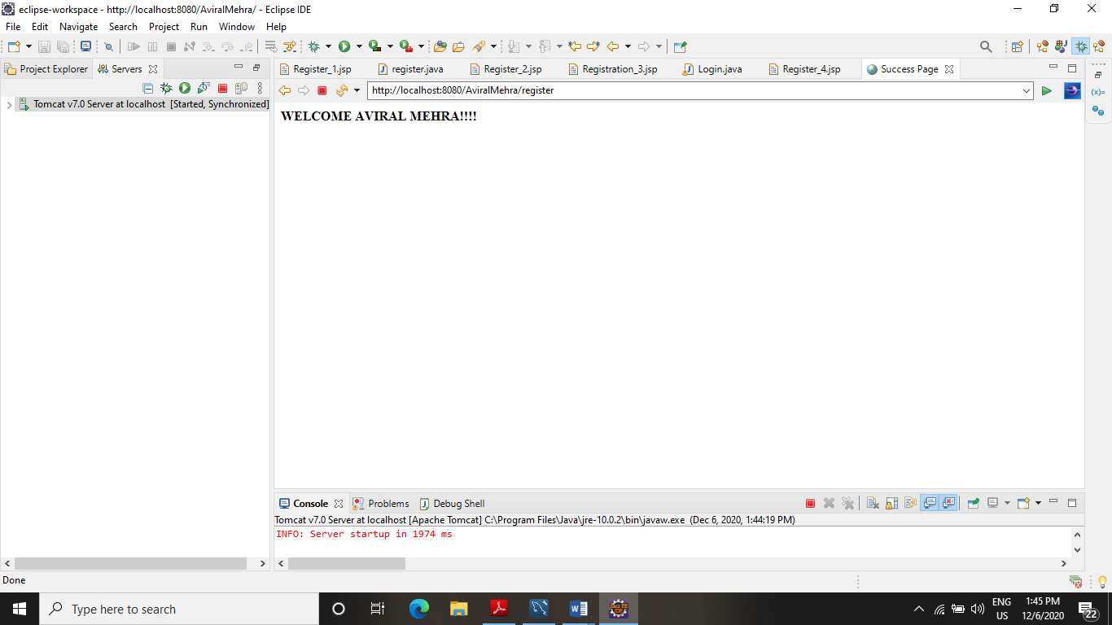

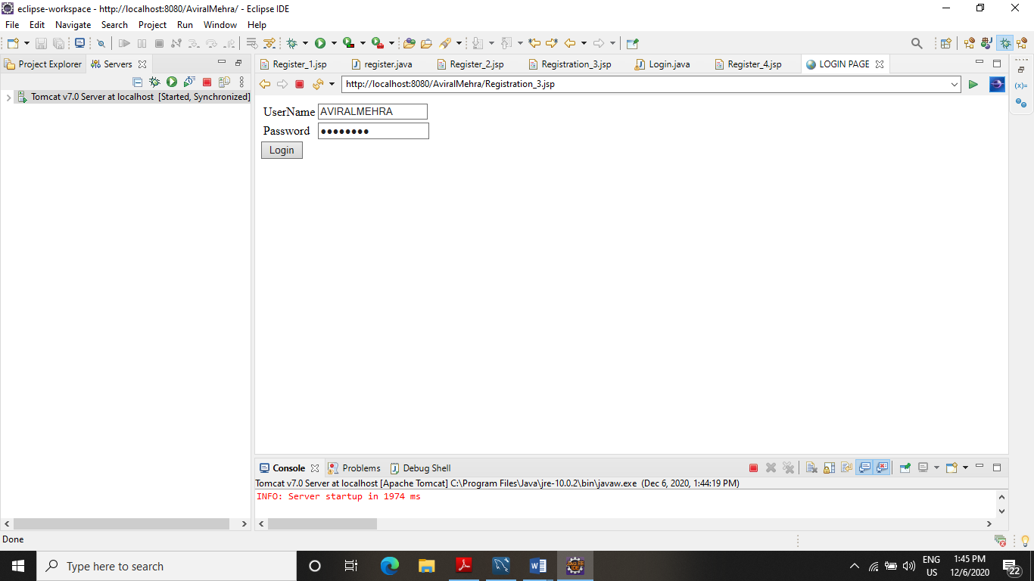

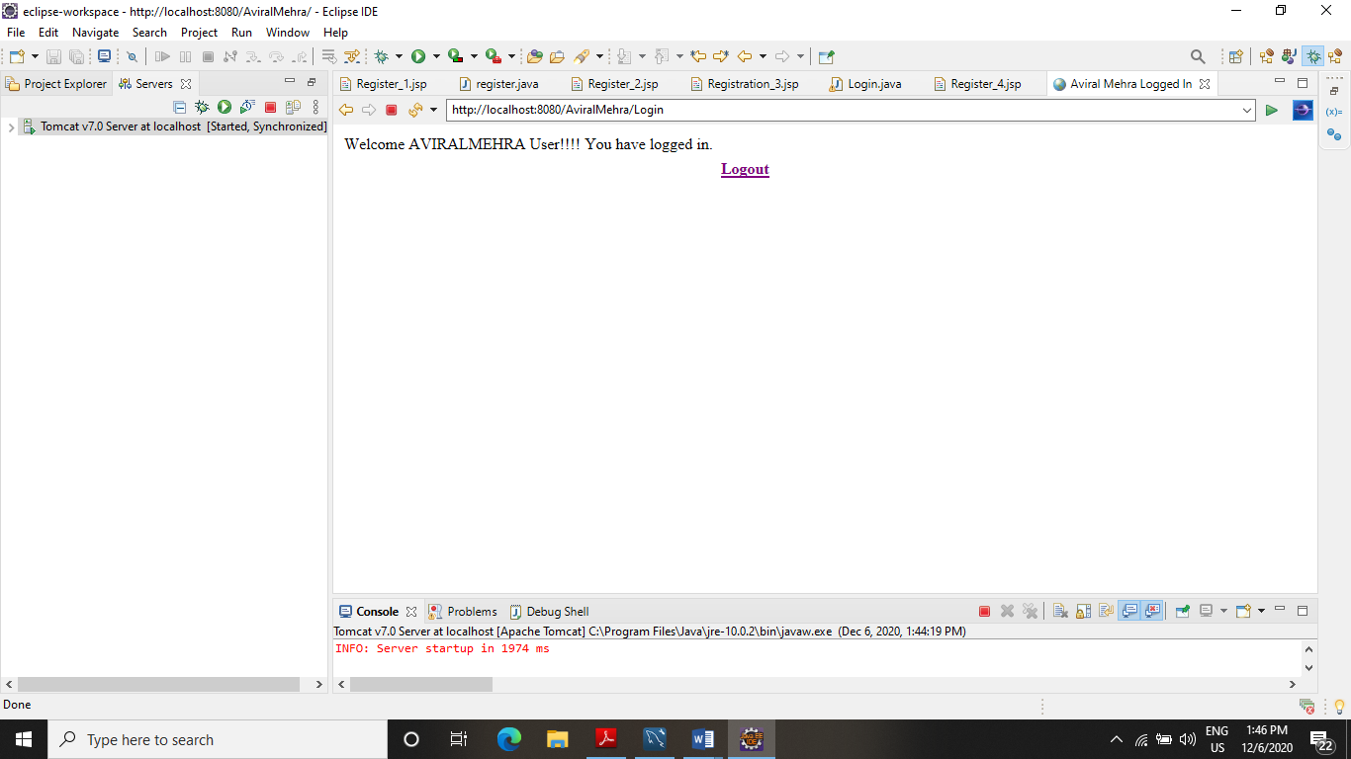

**END**